**MARKETING MIX MODELLING**

The Complete Guide

A Comprehensive Tutorial for Beginners and Practitioners

From First Principles to Advanced Implementation

Mark Stent

Includes 40+ Colour Diagrams, Full Worked Example,

Complete Python Code, and Practical Templates

# Table of Contents

Table of Contents 2

Preface: Who This Book Is For 15

Chapter 1: What is Marketing Mix Modelling? 17

The Basic Idea 17

A Simple Analogy 17

Why Not Just Use Platform Reporting? 17

The Privacy Advantage 18

Chapter 2: The MMM Framework 19

The Fundamental Equation 19

Baseline 19

Media Effects 19

Seasonality 19

Other Factors (Controls) 20

Noise 20

Chapter 3: How MMM Compares to Other Approaches 21

Multi-Touch Attribution (MTA) 21

How It Works 21

Pros 21

Cons 21

Experiments (Incrementality Testing) 21

How It Works 21

Pros 21

Cons 21

Where MMM Fits 22

Chapter 4: What Data Do You Need? 24

The Outcome Variable (What You Are Trying to Explain) 24

KPIs by Industry 24

Media Variables (What You Spent on Advertising) 24

The POE Framework: Paid, Owned, and Earned Media 25

How to Group Channels 25

Control Variables (Other Things That Affect Sales) 25

Promotions and Pricing 25

Distribution 25

External Factors 26

How Much Data Do You Need? 26

Data Frequency: Daily, Weekly, or Monthly? 26

Chapter 5: Preparing Your Data 27

First: Align Time Periods 27

Common Issues 27

Step 1: Identify and Handle Outliers 28

How to Find Them 28

What to Do 28

Step 2: Handle Missing Data 29

Options 29

Step 3: Scale Your Variables 29

Why Scale? 29

How to Scale 29

Step 4: Create Derived Variables 29

Chapter 6: Why Correlation Matters (Multicollinearity) 31

The Problem 31

How to Check for Correlation 31

Interpreting Correlations 31

What To Do About High Correlation 31

Option 1: Combine Channels 31

Option 2: Use Stronger Priors 32

Option 3: Add Data 32

Option 4: Use Experimental Data 32

Chapter 7: Adstock and Carryover Effects 34

Why Carryover Matters 34

The Psychology Behind Carryover 34

The Geometric Adstock Formula 34

Understanding Half-Life 35

Typical Decay Rates by Channel 35

Fast Decay (lambda = 0.1 to 0.4) 35

Medium Decay (lambda = 0.4 to 0.7) 35

Slow Decay (lambda = 0.7 to 0.9) 35

Lag Effects: When There is a Delay Before Effects Start 37

Why Lags Exist 37

Typical Lags by Channel 37

How to Model Lag 37

Chapter 8: Alternative Adstock Functions 39

Geometric Adstock (Review) 39

Weibull Adstock (Delayed Peak) 39

Which Should You Use? 40

Chapter 9: Saturation and Diminishing Returns 41

Why Diminishing Returns Exist 41

The Hill Function: An Intuitive Explanation 41

The Formula 41

Parameter K: The Half-Saturation Point 41

Parameter S: The Shape 42

Reading a Response Curve 43

The Transformation Pipeline 43

What Saturation Means for Budget Decisions 43

Chapter 10: Modelling Seasonality 45

Types of Seasonality 45

The Danger of Unmodeled Seasonality 45

Fourier Features: A Clever Solution 45

How It Works 46

Example: What Your Data Looks Like 46

How Many Harmonics? 47

Why Not Just Use Monthly Dummies? 47

Example: What Monthly Dummies Look Like 47

Chapter 11: Baseline and Trend 48

What Makes Up Baseline? 48

Why Baseline Matters 48

Modelling Trend 48

A Caution About Baseline 48

Chapter 12: Why Bayesian Methods? 50

The Fundamental Difference 50

Why This Matters for MMM 50

Reason 1: Honest Uncertainty 50

Reason 2: Incorporating Prior Knowledge 50

Reason 3: Handling Complexity 51

What You Get from Bayesian MMM 51

Chapter 13: Understanding Priors 53

A Simple Analogy 53

Types of Priors 53

Informative Prior 53

Weakly Informative Prior (Recommended) 53

Non-Informative (Flat) Prior 54

Common Prior Distributions 54

Normal Distribution: Normal(mean, std) 55

Half-Normal Distribution: HalfNormal(std) 55

Beta Distribution: Beta(a, b) 55

LogNormal Distribution: LogNormal(mu, sigma) 56

Exponential Distribution: Exponential(rate) 56

Chapter 14: Bayes' Theorem Made Simple 57

The Formula 57

Each Component 57

Prior: What we believed before 57

Likelihood: How well data fits 57

Posterior: What we believe now 57

How Prior and Data Combine 57

Chapter 15: How MCMC Works (Without the Math) 58

The Problem MCMC Solves 58

The Solution: Random Sampling 58

The Mountain Hiking Analogy 58

Warmup (Burn-in): Finding the Mountain 59

Multiple Chains: Checking We Found the Right Answer 60

What You Get at the End 60

Chapter 16: Checking Convergence 61

What Convergence Means 61

Why Check Convergence? 61

Diagnostic 1: R-hat (Gelman-Rubin Statistic) 61

What R-hat Measures 61

When to Use R-hat 62

Interpreting R-hat 62

Diagnostic 2: ESS (Effective Sample Size) 63

What ESS Measures 63

Why ESS Matters 63

When to Use ESS 63

Interpreting ESS 64

Diagnostic 3: Trace Plots 64

Good Trace Plots ('Fuzzy Caterpillar') 65

Bad Trace Plots and What They Mean 66

What To Do If Convergence Fails 66

Common Fixes 66

Chapter 17: The Complete Model Structure 69

The Big Picture 69

The Full Equation 69

y: Sales (the outcome) 69

alpha: Intercept 69

trend: Long-term direction 69

seasonality: Repeating patterns 69

media_effects: The key part 70

controls: Other factors 70

noise: Random variation 70

Why We Scale Data 70

Scaling Sales to Mean 1 70

Scaling Media Spend 71

Specifying Each Parameter 71

Intercept (alpha) 71

Trend (beta_trend) 71

Seasonality (beta_sin, beta_cos) 72

Media Effect (beta_media) 73

Decay Rate (lambda) 73

Saturation K (Half-Saturation Point) 74

Saturation S (Shape Parameter) 75

Noise (sigma) 75

Summary: Prior Selection Checklist 76

How It All Fits Together 76

Chapter 18: Time-Varying Effects 78

What Can Change Over Time? 78

Creative Fatigue 78

Market Changes 78

Channel Maturation 78

How to Detect Time-Varying Effects 79

How to Model Time-Varying Effects 79

Chapter 19: Hierarchical Models (Advanced) 81

The Problem 81

Three Approaches 81

No Pooling: Separate model per region 81

Complete Pooling: One model for all regions 81

Partial Pooling (Hierarchical): Best of both 81

When to Use Hierarchical Models 81

Pooled Regression: A Practical Alternative 82

What Is a Cross-Section? 82

Benefits of Pooling 82

Important: Normalisation 82

Chapter 20: Cross-Channel Interactions 83

What Are Interactions? 83

Example: TV + Search Synergy 83

Types of Interactions 83

Synergy (Positive Interaction) 83

Cannibalisation (Negative Interaction) 83

How to Model Interactions 83

The Endogeneity Problem 83

Nested Models: A Solution 84

Step 1: Model the intermediate channel 84

Step 2: Use predicted values in the main model 84

Step 3: Decompose attribution 84

A Word of Caution 84

Chapter 21: In-Sample Validation 86

What Is In-Sample Validation? 86

Metric 1: R-squared (Coefficient of Determination) 86

Metric 2: MAPE (Mean Absolute Percentage Error) 87

Metric 3: Residual Analysis 87

What Good Residuals Look Like 87

What Bad Residuals Look Like 88

The Durbin-Watson Test 88

Putting It All Together 88

Chapter 22: Out-of-Sample Validation 89

Why In-Sample Fit Is Not Enough 89

Method 1: Holdout Validation 89

Method 2: Rolling Window (Time Series Cross-Validation) 90

What Good Out-of-Sample Performance Looks Like 90

What To Do If Out-of-Sample Validation Fails 90

A Critical Reminder 91

Chapter 23: Posterior Predictive Checks 92

The Idea 92

What to Compare 92

Interpreting Results 93

Python Implementation 93

Chapter 24: Sensitivity Analysis 94

What to Test 94

Prior Sensitivity 94

Data Period Sensitivity 95

Model Specification Sensitivity 95

Interpreting Sensitivity 95

Chapter 25: Comparing Models (WAIC and LOO) 96

The Problem: Why Not Just Use R-squared? 96

The Key Concept: Expected Log Predictive Density (ELPD) 97

What ELPD Measures 97

Why 'Log' Probability? 97

Why ELPD Matters for Model Comparison 97

Understanding WAIC (Widely Applicable Information Criterion) 98

What WAIC Does 98

The Complexity Penalty: Why It Works 98

The WAIC Formula 98

Why 'Widely Applicable'? 98

Interpreting WAIC Values 99

Understanding LOO-CV (Leave-One-Out Cross-Validation) 99

The Gold Standard: True Cross-Validation 99

The Problem: Computational Cost 99

The Solution: PSIS-LOO (Pareto Smoothed Importance Sampling LOO) 99

How Importance Sampling Works 100

Pareto k Diagnostics: When to Trust LOO 100

Interpreting LOO Values 101

WAIC vs LOO: Which Should You Use? 101

Advantages of LOO 101

Advantages of WAIC 101

Recommendation 101

Practical Guide: Interpreting Model Comparison Results 101

Step 1: Check Diagnostics First 101

Step 2: Compare ELPD Differences 101

Step 3: Assess Statistical Significance 102

Rules of Thumb for ELPD Differences 102

Step 4: When Models Are Equivalent 102

Worked Example: Choosing Adstock Specification 102

Common Mistakes to Avoid 103

Mistake 1: Ignoring Standard Errors 103

Mistake 2: Over-Interpreting Small Differences 103

Mistake 3: Ignoring Pareto k Warnings 103

Mistake 4: Using WAIC/LOO as the Only Criterion 103

What WAIC and LOO Do NOT Tell You 103

Python Implementation 103

Chapter 25b: Commercial Evaluation 105

Why Commercial Evaluation Matters 105

Key Questions to Ask 105

Do the Results Match Business Intuition? 105

Are Response Curves Sensible? 105

Do Results Align with Known Facts? 105

What Do Stakeholders Think? 105

Common Red Flags 105

Chapter 26: Extracting Response Curves 108

What Is a Response Curve? 108

How to Read a Response Curve 108

Why Response Curves Have Uncertainty 109

How to Extract Response Curves from Your Model 109

Interpreting Uncertainty Bands 110

Common Patterns and What They Mean 110

Chapter 27: Marginal ROI 112

Understanding the Difference 112

Average ROI: Looking Backward 112

Marginal ROI: Looking Forward 112

Why They Differ: A Detailed Example 112

Why Marginal ROI Matters More for Decisions 113

How to Calculate Marginal ROI 113

The Key Insight for Optimisation 114

Presenting Marginal ROI to Stakeholders 114

Chapter 28: Budget Optimisation 115

The Optimisation Problem 115

The Solution: Equalise Marginal ROI 115

Step-by-Step Optimisation Process 116

Real-World Constraints 117

Minimum Spend Constraints 117

Maximum Spend Constraints 117

Strategic Constraints 117

A Worked Example 117

How to Present Optimisation Results 118

Important Caveats 118

Common Mistakes When Optimising 118

Mistake 1: Ignoring Uncertainty 118

Mistake 2: Extrapolating Beyond Data 118

Mistake 3: Ignoring Fixed Costs 119

Mistake 4: Annual Planning with Weekly Models 119

Mistake 5: Recommending 100% Shifts 119

Chapter 29: Long-term vs Short-term Effects 120

Short-term Effects (What Standard MMM Captures) 120

Long-term Effects (Often Missed) 120

Why This Matters 121

How to Address 121

Chapter 29b: Additional Metrics Beyond ROI 122

CPA: Cost Per Acquisition 122

When to Use CPA 122

CPA from MMM 122

Incremental Revenue 122

Effectiveness 122

Efficiency 122

Marginal CPA 123

Chapter 30: Incrementality Testing 125

Types of Experiments 125

Geo-Lift Experiments 125

Conversion Lift (Platform-Run) 125

Matched Market Tests 125

Using Experiments to Validate MMM 126

Using Lift Tests to Calibrate MMM: The Key Technique 126

Why Calibrate with Experiments? 127

The Intuition: Anchoring Your Model in Reality 127

How It Works: Step by Step 127

A Concrete Example 128

What If the Experiment and MMM Data Disagree? 128

How Tight Should the Experimental Prior Be? 128

Which Channels to Calibrate 129

Chapter 31: Common Mistakes and How to Avoid Them 131

Pitfall 1: Unrealistic ROI Estimates 132

Symptom 132

Causes 132

Solution 132

Pitfall 2: Seasonality Leakage 132

Symptom 132

Cause 132

Solution 132

Pitfall 3: Overfitting 132

Symptom 132

Cause 132

Solution 132

Pitfall 4: Ignoring Uncertainty 133

Symptom 133

Cause 133

Solution 133

Pitfall 5: Not Validating with Experiments 133

Symptom 133

Cause 133

Solution 133

Chapter 32: Troubleshooting Guide 134

Problem: Model Will Not Converge 134

Problem: Very Wide Credible Intervals 134

Problem: ROI Estimates Seem Wrong 134

Problem: Poor Out-of-Sample Performance 134

Problem: Residuals Show Patterns 135

Chapter 33: Communicating Results to Stakeholders 137

Know Your Audience 137

For Executives 137

For Finance 137

For Marketing 137

Handling Common Objections 138

'This contradicts what we have always believed' 138

'The ROI for [channel] seems too low' 138

'Can you just give me one number?' 138

Building Trust Over Time 138

Reporting Best Practices 138

Dynamic Dashboards Are Essential 138

Tell a Story 138

Tailor to Your Audience 139

Chapter 33b: Forecasting and Simulation 140

What Is MMM Forecasting? 140

The Forecasting Process 140

Types of Scenarios 140

Budget Reallocation 140

Budget Increase/Decrease 140

Channel Addition/Removal 140

Seasonal Planning 140

Forecasting Example 140

Forecast Uncertainty 141

Common Forecasting Mistakes 141

Chapter 34: Model Maintenance 142

When to Refresh Your Model 142

What to Check During Refresh 142

Versioning and Documentation 142

When to Rebuild From Scratch 142

Chapter 35: End-to-End MMM Process 144

Phase 1: Data Collection and Preparation (1-2 weeks) 144

Phase 2: Model Building (3-5 days) 145

Phase 3: Model Fitting (1-3 days) 145

Phase 4: Validation (2-3 days) 145

Phase 5: Analysis and Reporting (2-3 days) 145

Phase 6: Implementation and Monitoring (ongoing) 146

Appendix A: MMM Tool Comparison 148

PyMC-Marketing 148

Google Lightweight MMM 148

Meta Robyn 148

Custom PyMC 149

Recommendation for Beginners 149

Appendix B: Mathematical Reference 150

The Hill Function 150

Geometric Adstock 150

Fourier Features 150

Bayes' Theorem 150

R-hat (Gelman-Rubin) 150

Appendix C: Glossary 152

Appendix D: MMM Project Checklist 153

Before Starting 153

Data Preparation 153

Model Building 153

Model Fitting 153

Validation 153

Analysis 154

Deployment 154

Appendix E: Full Worked Example 155

The Scenario 155

Step 1: Examine Raw Data 155

Step 2: Apply Adstock 155

Step 3: Apply Saturation 156

Step 4: Model Results 157

Step 5: ROI Analysis 158

Step 6: Budget Optimisation 159

Summary 160

Appendix F: Complete Python Implementation 162

Installation 162

Data Preparation 162

Model Definition 162

Checking Convergence 163

Extracting Results 163

# Preface: Who This Book Is For

This book assumes you have never built a Marketing Mix Model before. You may have heard the term, seen a presentation with ROI numbers, or been told your company needs one. But you do not know how they actually work, how to build one, or how to tell if one is any good.

By the end of this book, you will understand MMM deeply enough to:

* Build a complete MMM from scratch using Python
* Explain every component to both technical and non-technical audiences
* Validate results and know when to trust them (and when not to)
* Make real budget decisions based on model outputs
* Avoid the common mistakes that lead to wrong conclusions

**What you need to get started:**

* Basic familiarity with Python (or willingness to learn)
* High school level math (algebra, basic statistics)
* Access to marketing spend and sales data
* Curiosity and patience

**What you do NOT need:**

* A PhD in statistics
* Prior experience with Bayesian methods
* Expensive software (everything here uses free, open-source tools)

This book is organised to build understanding progressively. Early chapters establish foundations. Middle chapters dive into methodology. Later chapters cover practical implementation, validation, and deployment. The final sections include a complete worked example and ready-to-use Python code.

Let us begin.

**PART I**

FOUNDATIONS

# Chapter 1: What is Marketing Mix Modelling?

## The Basic Idea

Marketing Mix Modelling answers a simple but crucial question: How much did each of our marketing activities contribute to sales?

Imagine you run a company that sells running shoes. Last year, you spent money on television ads, Google search ads, Facebook ads, and influencer partnerships. Your sales were $50 million. But how much of that $50 million came from each marketing channel? How much would you have sold with no marketing at all?

These questions matter because they determine how you should spend your marketing budget next year. If television ads generated $10 million in sales from $2 million in spend (a 5x return), while Facebook generated $3 million from $3 million in spend (a 1x return), you probably want to shift budget toward television.

MMM uses statistical analysis of historical data to estimate these contributions.

## A Simple Analogy

Think of your business like a garden. Your sales are the vegetables you harvest. Several factors affect your harvest:

* The quality of your soil (your brand, your product)
* The weather (economic conditions, seasonality)
* Water you provide (marketing spend)
* Fertiliser you add (promotions, discounts)

If you want to know how much the extra water helped, you cannot just look at your harvest and say 'the water did it.' You need to account for the soil, the weather, and the fertiliser too. Only then can you isolate the effect of watering.

MMM does exactly this for marketing. It separates the effect of each marketing channel from everything else that affects sales.

## Why Not Just Use Platform Reporting?

Facebook tells you how many conversions your ads drove. Google does too. Why not just use those numbers?

The problem is double-counting. Imagine a customer who:

1. Sees your TV ad on Monday
2. Sees your Facebook ad on Tuesday
3. Clicks your Google ad on Wednesday
4. Buys your product

Facebook will count this as a Facebook conversion. Google will count it as a Google conversion. But you only made one sale. If you add up all the platform-reported conversions, you will dramatically overcount your actual sales.

MMM solves this by modelling total sales and decomposing them into parts. The parts must add up to the whole, so there is no double-counting.

## The Privacy Advantage

MMM has another major advantage: it does not require tracking individual users.

With the decline of cookies, the rise of privacy regulations like GDPR, and Apple's App Tracking Transparency, individual-level tracking is becoming increasingly difficult and restricted. Multi-touch attribution (MTA), which tracks individual user journeys, is becoming impractical.

MMM works with aggregate data only. You need weekly totals of spend and sales, not information about any individual person. This makes it privacy-compliant by design.

# Chapter 2: The MMM Framework

## The Fundamental Equation

At its heart, MMM is a decomposition. We break down total sales into components:

**Sales = Baseline + Media Effects + Seasonality + Other Factors + Noise**

Let us understand each piece:

### Baseline

The baseline is what you would sell with zero marketing. It represents the fundamental demand for your product based on brand strength, product quality, distribution, and habitual purchasing.

For established brands, baseline is often 60-80% of total sales. This surprises many executives. Marketing's job is not to create all your sales; it is to add incremental sales on top of a strong baseline.

Example: A cereal brand might sell $80 million from baseline (people who buy it every week regardless of ads) and $20 million from marketing-driven incremental purchases.

### Media Effects

These are the incremental sales generated by each advertising channel. This is what we most want to measure.

Crucially, media effects are not simply proportional to spend. They have two important properties:

* Carryover: An ad today affects sales tomorrow, next week, and potentially next month. The effect decays over time.
* Saturation: The first $1 million in spend is more effective than the tenth $1 million. There are diminishing returns.

We will explore both properties in detail in later chapters.

### Seasonality

Many businesses have predictable patterns that repeat each year:

* Retail spikes during the holiday season (November-December)
* Ice cream sells more in summer
* Tax software sells in January-April
* Fitness products spike in January (New Year's resolutions)

If we do not model seasonality explicitly, the model might attribute a December sales spike to advertising rather than to Christmas shopping. This would overestimate advertising effectiveness.

### Other Factors (Controls)

Many things besides advertising affect sales:

* Promotions and discounts
* Price changes
* New product launches
* Distribution changes (new stores, new retailers)
* Competitor actions
* Economic conditions
* Weather (for some products)

We include these as 'control variables' to prevent them from being confused with media effects.

### Noise

Even after accounting for everything, some variation remains unexplained. This is noise: random fluctuations that no model can predict.

Good models have small noise. If your noise is large, you are probably missing important variables.

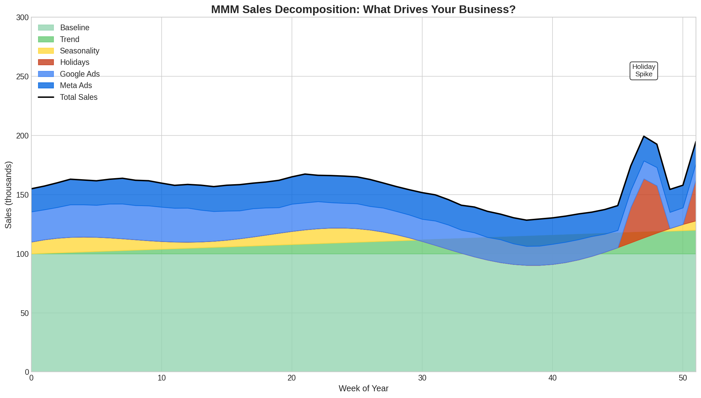

Figure 1: Sales decomposition showing each component's contribution

# Chapter 3: How MMM Compares to Other Approaches

MMM is not the only way to measure marketing effectiveness. Understanding the alternatives helps you appreciate what MMM does well and where it has limitations.

## Multi-Touch Attribution (MTA)

MTA tracks individual users across touchpoints and attributes conversions to the ads they saw.

### How It Works

MTA uses cookies, device IDs, and login data to follow a user's journey. If someone sees your Facebook ad, then your display ad, then clicks your search ad and converts, MTA tries to assign credit to each touchpoint.

### Pros

* Granular: Attributes at the user level
* Fast: Near real-time attribution
* Detailed: Can see user journeys

### Cons

* Privacy problems: Requires tracking individual users, increasingly difficult
* Digital only: Cannot track TV, radio, print, out-of-home
* Selection bias: Only sees users who convert, not those influenced to buy in store
* Arbitrary rules: 'Last click' vs 'first click' vs 'linear' are all choices, not truths

## Experiments (Incrementality Testing)

The gold standard for causal measurement. You deliberately vary marketing in some regions or groups and measure the difference.

### How It Works

Turn off ads in some geographic regions. Compare sales in those regions to similar regions where ads ran. The difference is the true incremental effect.

### Pros

* Causal: Actually proves causation, not just correlation
* Accurate: Measures true incrementality
* Unbiased: No model assumptions needed

### Cons

* Expensive: Requires turning off ads, losing revenue during test
* Limited scope: Can only test one thing at a time
* Slow: Takes weeks or months to run
* Not always possible: Some channels cannot be geo-targeted

## Where MMM Fits

MMM sits between MTA and experiments:

* Broader than MTA: Works across all channels including offline
* Faster than experiments: Uses existing historical data
* Less certain than experiments: Relies on statistical assumptions, not randomisation

|  |
| --- |
| **KEY INSIGHT: THE BEST APPROACH**  Use MMM for broad measurement across all channels. Use experiments to validate and calibrate your MMM. Use MTA for real-time optimisation within digital channels (where still possible). |

**PART II**

DATA FOUNDATIONS

# Chapter 4: What Data Do You Need?

Good data is the foundation of good modelling. This chapter explains exactly what data you need, where to get it, and how to prepare it.

## The Outcome Variable (What You Are Trying to Explain)

You need a measure of business results over time. Common choices:

* Revenue: Total sales in dollars
* Units: Number of items sold
* Conversions: Number of purchases, sign-ups, or leads
* New customers: Number of first-time buyers

Choose based on your business question. If you want to optimise for revenue, model revenue. If you want to optimise for customer acquisition, model new customers.

### KPIs by Industry

Different industries focus on different metrics:

* Telecommunications: New connections, renewals, churn rate (by product, by sales channel)
* Retail: Turnover, footfall, transactions (by store, by category)
* FMCG/CPG: Volume sales, value sales (by region, by account)
* Banking/Insurance: Account openings, enquiries, applications (by product, by channel)
* Publishing: Volume of issues sold (by region, by sales channel)
* E-commerce/D2C: Website visits, sales, subscriptions (new vs repeat customers)

|  |
| --- |
| **TIP:** Whatever you choose, make sure it is measured consistently over time. Changing definitions mid-stream will break your model. |

## Media Variables (What You Spent on Advertising)

For each marketing channel, you need a time series of activity. Usually this means weekly spend:

* Google Search: Weekly spend in dollars
* Facebook/Meta: Weekly spend in dollars
* Television: Weekly spend or GRPs (Gross Rating Points)
* Display: Weekly spend or impressions

Spend is usually preferred because it is what you control and what you are optimising.

### The POE Framework: Paid, Owned, and Earned Media

Media can be categorised into three types:

* Paid Media: Any media you pay for - TV, search ads, display, social ads, print, radio, out-of-home
* Owned Media: Media you control - your website, email lists, mobile app, social media pages, blogs
* Earned Media: Media you earn through others - press coverage, social shares, reviews, word-of-mouth

For Paid Media, collect spend or ratings (GRPs for TV). For Owned Media, collect metrics like website visits, email opens, app sessions. For Earned Media, collect sentiment scores, share of voice, or social mentions.

|  |
| --- |
| **KEY INSIGHT: DATA SOURCES**  Paid media data typically comes from your media agency or ad platforms. Owned media data comes from your analytics tools. Earned media data often requires specialised social listening or PR tracking services. |

### How to Group Channels

You need enough variation within each channel to estimate its effect. Too granular and you will not have enough data. Too aggregated and you lose insight.

Good groupings:

* Google Search (branded + non-branded together, or separate if enough data)
* Meta (Facebook + Instagram combined)
* Television (all TV together unless you have very different strategies by network)
* Digital Video (YouTube + programmatic video)

## Control Variables (Other Things That Affect Sales)

Anything that affects sales and might be correlated with your advertising should be included:

### Promotions and Pricing

* Discount depth (e.g., 10% off, 20% off)
* Promotion indicators (1 during promo weeks, 0 otherwise)
* Price index (relative to normal price)

### Distribution

* Number of stores carrying your product
* Online availability (in stock vs out of stock)
* New retailer launches

### External Factors

* Economic indicators (unemployment rate, consumer confidence)
* Competitor advertising (if available)
* Weather (for weather-sensitive categories)

## How Much Data Do You Need?

|  |
| --- |
| **KEY INSIGHT: MINIMUM DATA**  At least 2 years of weekly data (104 weeks). 3-4 years is better. Monthly data can work but gives less precision. |

Why so much data?

* You need to see at least 2 full seasonal cycles to separate seasonality from other effects
* You need variation in marketing spend to estimate its effect
* More data means more precise estimates

## Data Frequency: Daily, Weekly, or Monthly?

* Weekly: The standard choice. Balances detail with stability. Recommended.
* Daily: More data points but more noise. Sales fluctuate a lot day-to-day for random reasons.
* Monthly: Fewer data points, less precision. Use only if weekly data is unavailable.

# Chapter 5: Preparing Your Data

Raw data is almost never ready for modelling. This chapter covers the essential preprocessing steps.

## First: Align Time Periods

Before any other preprocessing, all your data must be on the same time scale:

* Same frequency: All weekly, all ending on the same day (e.g., Sunday)
* Same date range: All variables cover the same time period
* No gaps: No missing weeks in the middle

### Common Issues

Problem: TV data is monthly, digital is daily.

Solution: Aggregate digital to weekly; distribute monthly TV evenly across weeks (or get weekly TV data if possible).

Once your data is aligned, you can proceed with the cleaning steps shown below:

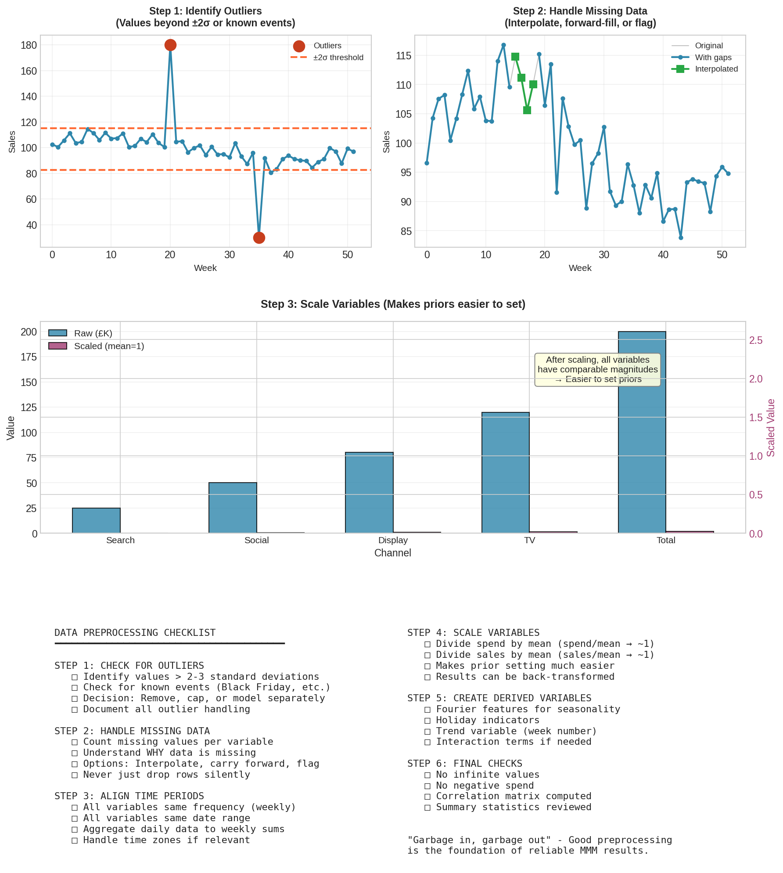

Figure 2: Data preprocessing steps from raw data to model-ready data

## Step 1: Identify and Handle Outliers

Outliers are unusual values that can distort your model.

### How to Find Them

* Look for values more than 2-3 standard deviations from the mean
* Check for known events (Black Friday, product launch, supply disruption)
* Plot your data and look for spikes or dips

### What to Do

* Keep and explain: If the outlier is a real, repeatable event (Black Friday), consider adding a control variable for it
* Cap (Winsorise): Replace extreme values with the 95th or 99th percentile value
* Remove: Drop the week entirely (last resort, loses information)

## Step 2: Handle Missing Data

Missing values break models. You must handle them explicitly.

### Options

* Interpolation: Estimate missing values based on surrounding values. Good for occasional gaps.
* Forward fill: Use the last known value. Good for slow-changing variables like distribution.
* Zero: Assume zero spend if data is missing. Only appropriate if you are confident no spend occurred.
* Remove: Drop rows with missing data. Only if gaps are at the start/end, not middle.

|  |
| --- |
| **WARNING:** Never ignore missing data. Your modelling software may silently drop rows, giving you unexpected results. |

## Step 3: Scale Your Variables

Scaling makes modelling easier by putting variables on comparable scales.

### Why Scale?

If sales are in millions and spend is in thousands, the coefficients will be on very different scales, making prior specification harder.

### How to Scale

scaled_sales = sales / mean(sales)

scaled_spend = spend / mean(spend)

After scaling, both variables have mean of 1. Coefficients are now comparable.

Important: Keep track of your scaling factors so you can convert results back to original units.

## Step 4: Create Derived Variables

Some variables need to be created from raw data:

* Fourier features for seasonality (explained in Chapter 10)
* Holiday indicators (1 during holiday weeks, 0 otherwise)
* Trend variable (simply the week number: 1, 2, 3, ...)

# Chapter 6: Why Correlation Matters (Multicollinearity)

One of the most important data issues in MMM is correlation between marketing channels. This chapter explains why it matters and what to do about it.

## The Problem

Imagine you always increase Google and Facebook spend together. In peak season, both go up. In slow season, both go down. They are perfectly correlated.

Now your model sees that when spend goes up, sales go up. But it cannot tell whether Google caused the sales increase, or Facebook did, or both. The variables are 'collinear.'

The result: unstable, unreliable estimates. Small changes in the data can flip which channel looks effective.

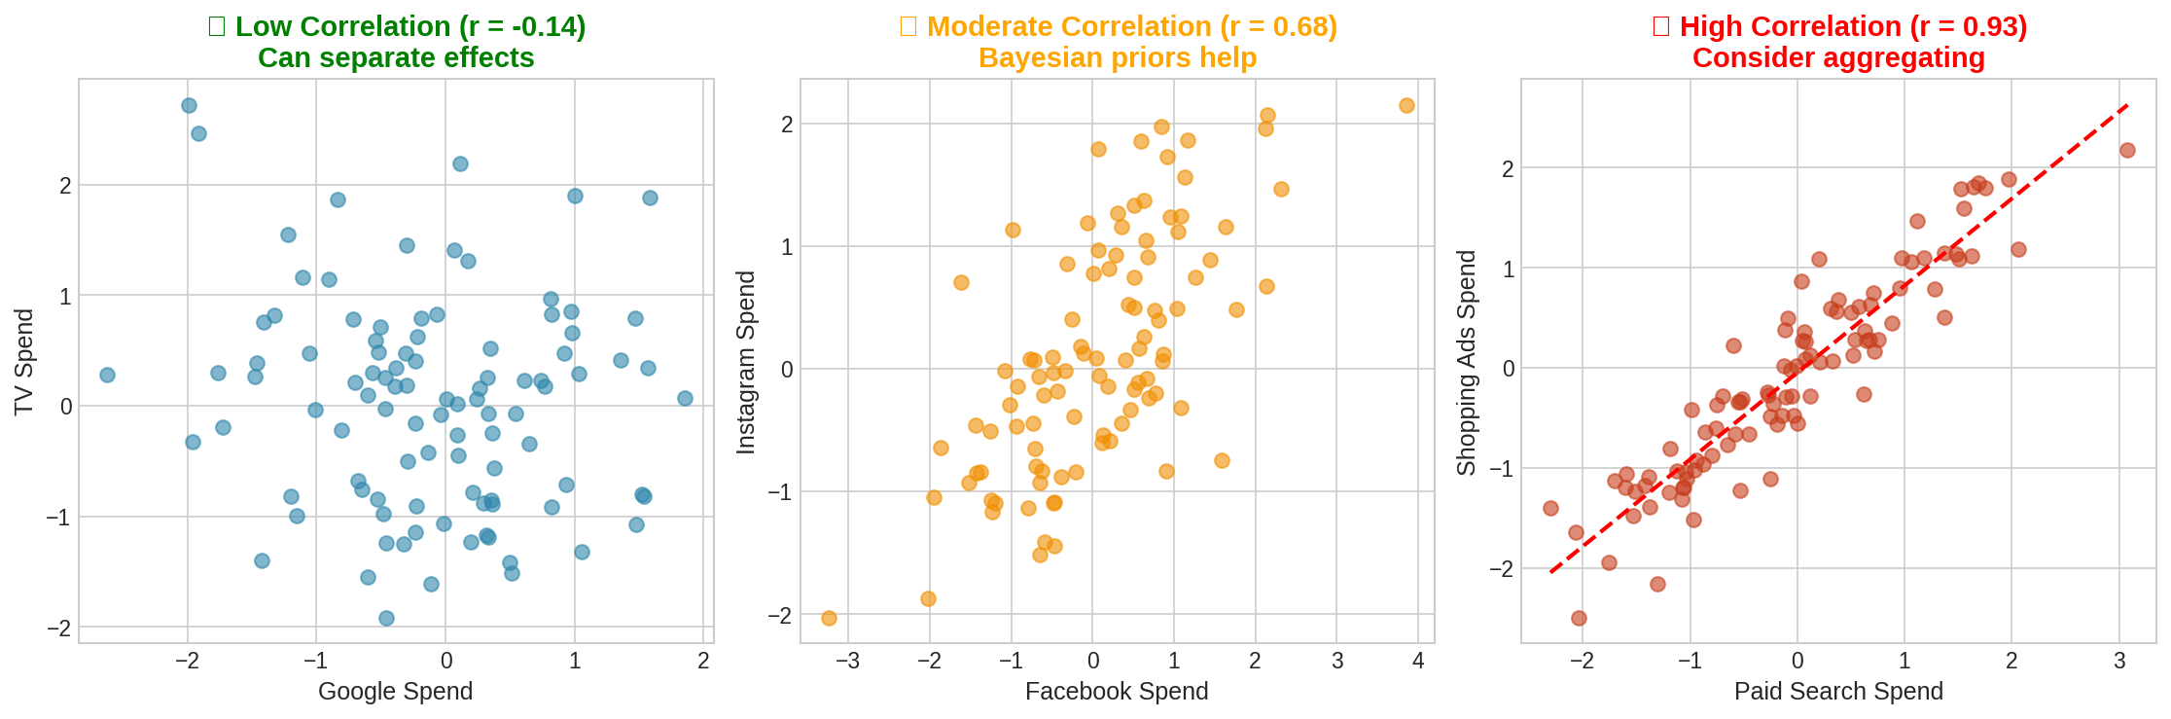

Figure 3: Correlation levels between channels and their effect on estimation

## How to Check for Correlation

Calculate the correlation matrix for all your media variables:

correlations = spend_data.corr()

print(correlations)

### Interpreting Correlations

* r < 0.5: No problem. Channels are separable.
* r = 0.5 to 0.7: Some correlation. Usually fine with Bayesian priors.
* r = 0.7 to 0.85: Moderate concern. Results may be less stable.
* r > 0.85: High correlation. Consider combining channels or using strong priors.

## What To Do About High Correlation

### Option 1: Combine Channels

If Google and Meta are highly correlated and serve similar purposes, combine them into 'Digital Advertising.' You lose granularity but gain stability.

### Option 2: Use Stronger Priors

In Bayesian modelling, priors help stabilise estimates when data is ambiguous. If you have prior knowledge that Google ROI should be around 2.5, you can encode this. The prior helps separate the channels even when data cannot.

### Option 3: Add Data

More data with more variation helps. If you have periods where one channel varied independently of another, include that data.

### Option 4: Use Experimental Data

Run an experiment where you turn off one channel in some regions. This breaks the correlation and gives you a clean estimate for that channel.

|  |
| --- |
| **KEY INSIGHT**  Some correlation is normal and expected. Perfect independence is rare. Bayesian methods handle moderate correlation well. Only worry about r > 0.8. |

**PART III**

MEDIA TRANSFORMATIONS

# Chapter 7: Adstock and Carryover Effects

Advertising does not work instantly. Today's ad affects tomorrow's sales, next week's sales, and potentially next month's sales. This chapter explains how we model this 'carryover' effect.

## Why Carryover Matters

Consider this scenario:

* Week 1: You spend $100,000 on TV advertising
* Week 2: You spend nothing
* Week 3: A customer buys your product

Did Week 1's advertising influence that Week 3 purchase? Almost certainly yes. The customer saw the ad, remembered it, and bought when the need arose.

But a naive model would see no spend in Week 3 and give no credit to advertising. This systematically underestimates advertising effectiveness.

## The Psychology Behind Carryover

Carryover exists because of how human memory and decision-making work:

* Memory: Advertisements create memories that persist over time
* Consideration: Moving from awareness to purchase takes time, especially for big purchases
* Timing: People buy when they need something, not when they see an ad
* Repetition: Multiple exposures build up effect over time

## The Geometric Adstock Formula

The most common way to model carryover is geometric adstock:

**Adstock(t) = Spend(t) + lambda * Adstock(t-1)**

In plain English: This week's adstock equals this week's spend plus a fraction (lambda) of last week's adstock.

The parameter lambda (often written as λ) is the 'decay rate,' constrained between 0 and 1:

* lambda = 0: No carryover at all. Effect is instant and gone.
* lambda = 0.5: Half of last week's effect carries over
* lambda = 0.9: 90% carries over (very slow decay)

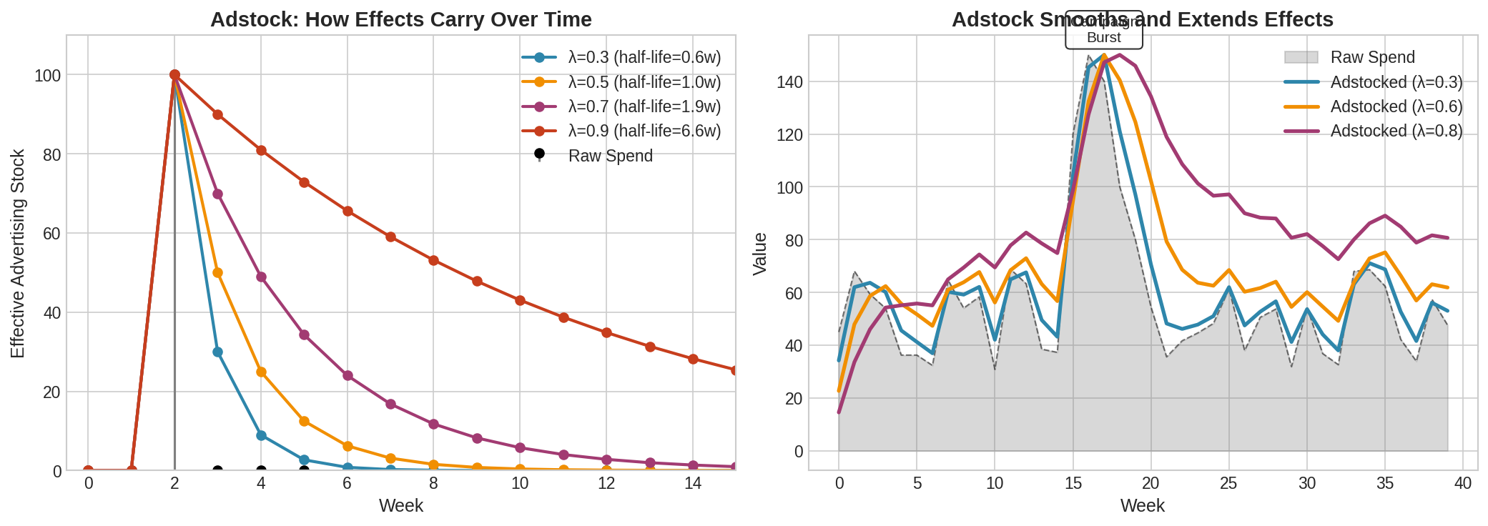

Figure 4: How adstock transforms spend into accumulated effect over time

## Understanding Half-Life

Half-life is often easier to interpret than decay rate. It answers: How long until the effect drops to half?

**Half-life = log(0.5) / log(lambda)**

Examples:

* lambda = 0.3: Half-life = 0.6 weeks (effect mostly gone in a week)
* lambda = 0.5: Half-life = 1.0 week
* lambda = 0.7: Half-life = 2.0 weeks
* lambda = 0.9: Half-life = 6.6 weeks

## Typical Decay Rates by Channel

Different channels have different natural decay rates based on how they work:

### Fast Decay (lambda = 0.1 to 0.4)

* Paid Search: People search with intent and act quickly
* Performance Display: Direct response, immediate action expected

### Medium Decay (lambda = 0.4 to 0.7)

* Social Media: Mix of brand and performance
* Online Video: Memorable but not as lasting as TV

### Slow Decay (lambda = 0.7 to 0.9)

* Television: Mass reach, emotional, memorable
* Brand campaigns: Building awareness over time

These are starting points. In Bayesian MMM, we learn the actual decay rate from the data while using these as informed priors.

## Lag Effects: When There is a Delay Before Effects Start

Separately from decay, some channels have a 'lag' before their effect begins at all. This is different from carryover:

* Carryover (decay): How long effects LAST after they start
* Lag: How long BEFORE effects start

### Why Lags Exist

* Awareness to action: You see a car ad, but only buy months later when your lease ends
* Consideration period: Big purchases require research time
* Media scheduling: TV ads reach peak audience gradually through reruns and DVR

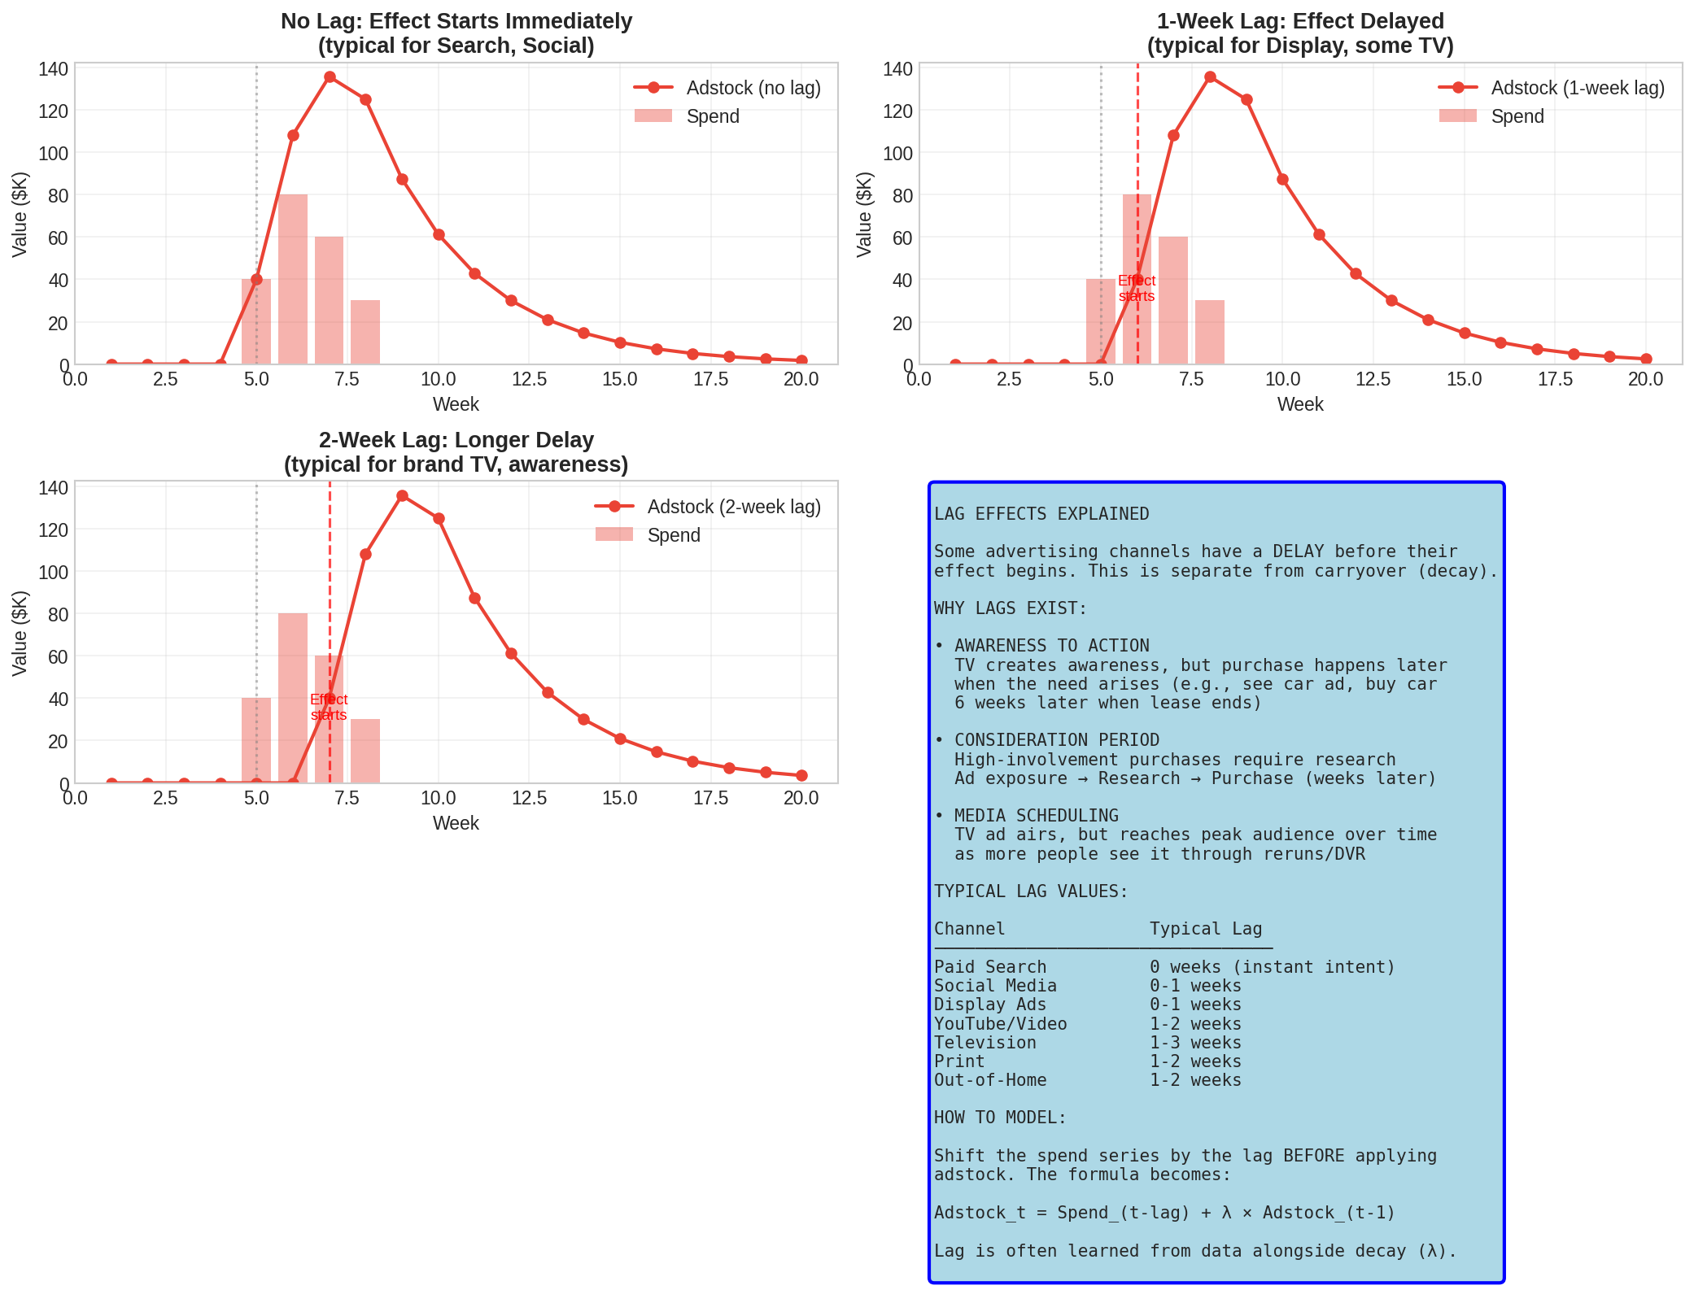

Figure 5: Lag effects showing delayed onset of advertising response

### Typical Lags by Channel

* Paid Search: 0 weeks (instant intent)
* Social Media: 0-1 weeks
* Display: 0-1 weeks
* Television: 1-3 weeks

### How to Model Lag

Shift the spend series by the lag amount before applying adstock:

**Adstock(t) = Spend(t - lag) + lambda * Adstock(t-1)**

The lag can be learned from data alongside the decay rate.

# Chapter 8: Alternative Adstock Functions

Geometric adstock is the most common choice, but other options exist. This chapter covers alternatives.

## Geometric Adstock (Review)

Assumes immediate peak effect that decays exponentially.

* Shape: Peaks at time of spend, then decays
* Best for: Channels with immediate impact (search, social)
* Parameter: lambda (decay rate)

## Weibull Adstock (Delayed Peak)

Some advertising effects build up over time before peaking. TV campaigns often 'wear in' before reaching maximum impact.

* Shape: Builds up, peaks AFTER spend, then decays
* Best for: TV, brand campaigns, awareness advertising
* Parameters: shape and scale

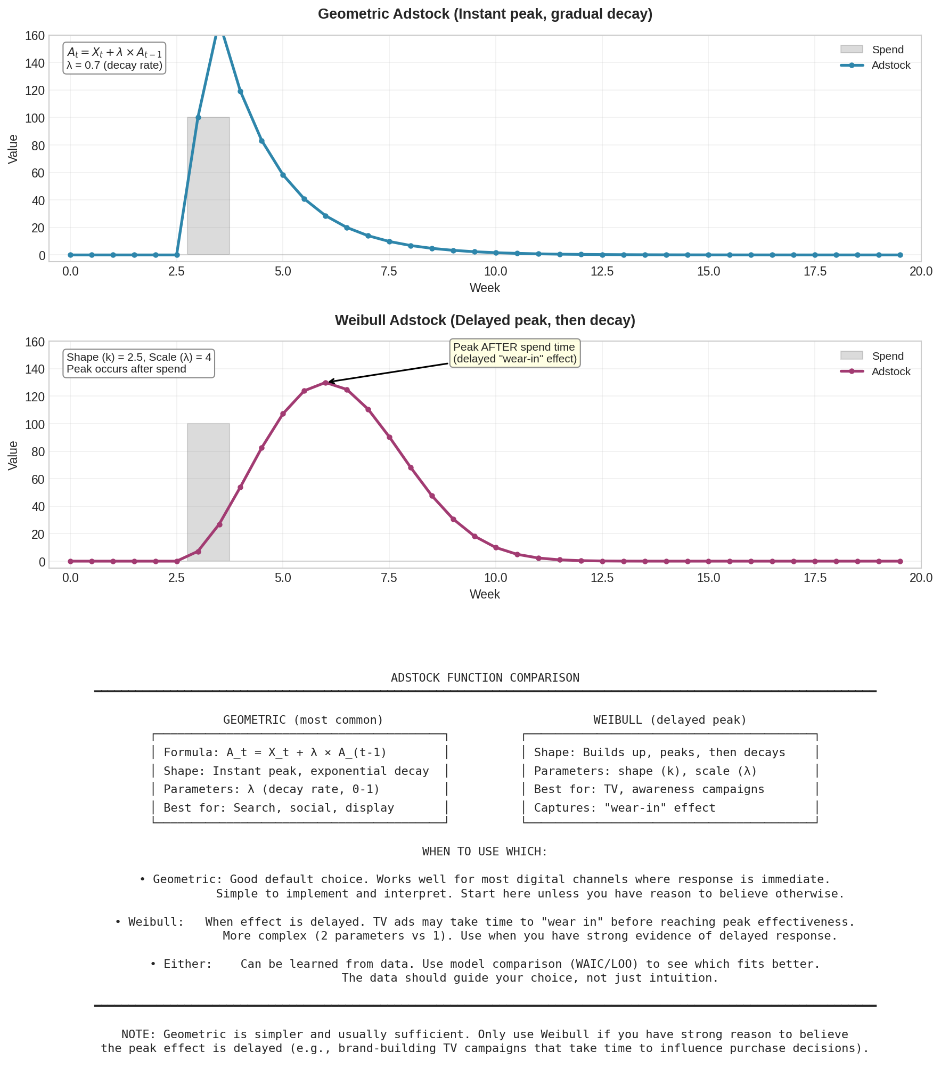

Figure 6: Comparing geometric and Weibull adstock functions

## Which Should You Use?

* Start with geometric: Simpler, works well for most channels
* Consider Weibull for TV: If you have reason to believe effects are delayed
* Let data decide: Use model comparison (WAIC/LOO) to see which fits better

|  |
| --- |
| **TIP:** For beginners, stick with geometric adstock. It is simpler, well-understood, and usually sufficient. Add complexity only when needed. |

# Chapter 9: Saturation and Diminishing Returns

One of the most important concepts in marketing: doubling your spend does NOT double your results. This chapter explains why and how we model it.

## Why Diminishing Returns Exist

Imagine you are advertising running shoes:

* First $1 million: Reaches the most interested runners. High conversion.
* Second $1 million: Reaches somewhat interested people. Medium conversion.
* Third $1 million: Reaches barely interested people. Low conversion.
* Fourth $1 million: Almost no one left to reach. Minimal conversion.

This is audience saturation. Each additional dollar reaches less interested audiences.

Other causes of diminishing returns:

* Frequency fatigue: Seeing the same ad 20 times adds little over seeing it 5 times
* Market size: There are only so many people who might buy your product
* Creative wear-out: The same message loses impact over time

## The Hill Function: An Intuitive Explanation

The most common saturation function in modern MMM is the Hill function. Before we look at the formula, let us understand what it does:

Think of the Hill function as a 'translator' that converts spend into effect. At low spend, every dollar has a big impact. As spend increases, each additional dollar has less and less impact, until eventually more spending barely moves the needle.

**Picture filling a bathtub:**

* When the tub is empty, each bucket of water makes a big difference in the water level
* As the tub fills up, each bucket raises the level less
* When the tub is nearly full, another bucket barely changes anything

The Hill function captures exactly this behaviour mathematically.

### The Formula

**Response = x^S / (K^S + x^S)**

Where x is your spend. This transforms spend into a response between 0 and 1, which we then multiply by a coefficient to get actual sales impact.

### 

### Parameter K: The Half-Saturation Point

K is the most intuitive parameter. It answers: At what spend level do you reach 50% of your maximum possible effect?

* Low K (e.g., £20K): Channel saturates quickly. You hit half your potential at just £20K spend.
* High K (e.g., £100K): Channel has more room. You need £100K to hit half your potential.

**A practical example:**

Suppose K = £50K for your Google Search channel, and you currently spend £50K per week. Assuming S = 1:

* At £50K spend, you are at exactly 50% of maximum response (by definition of K)
* At £100K spend, you reach 67% of maximum response
* At £150K spend (3× the half-saturation point), you reach 75% of maximum response
* At £250K spend (5× the half-saturation point), you reach 83% of maximum response

Notice: Tripling your spend from £50K to £150K only increases response from 50% to 75%. This is why K is called the 'half-saturation point' - it marks where diminishing returns really kick in.

### Parameter S: The Shape

S controls HOW sharply the curve bends:

* S < 1 (e.g., 0.7): Very steep initial rise, then gradual flattening. Most of the gains come early.
* S = 1: Balanced curve. Standard diminishing returns.
* S > 1 (e.g., 1.5): S-shaped curve with a slow start, then steep rise, then saturation. This suggests a 'threshold effect' where you need minimum spend before seeing results.

For most marketing channels, S is typically between 0.5 and 1.0. Values above 1 are less common but can occur for channels that require reaching critical mass.

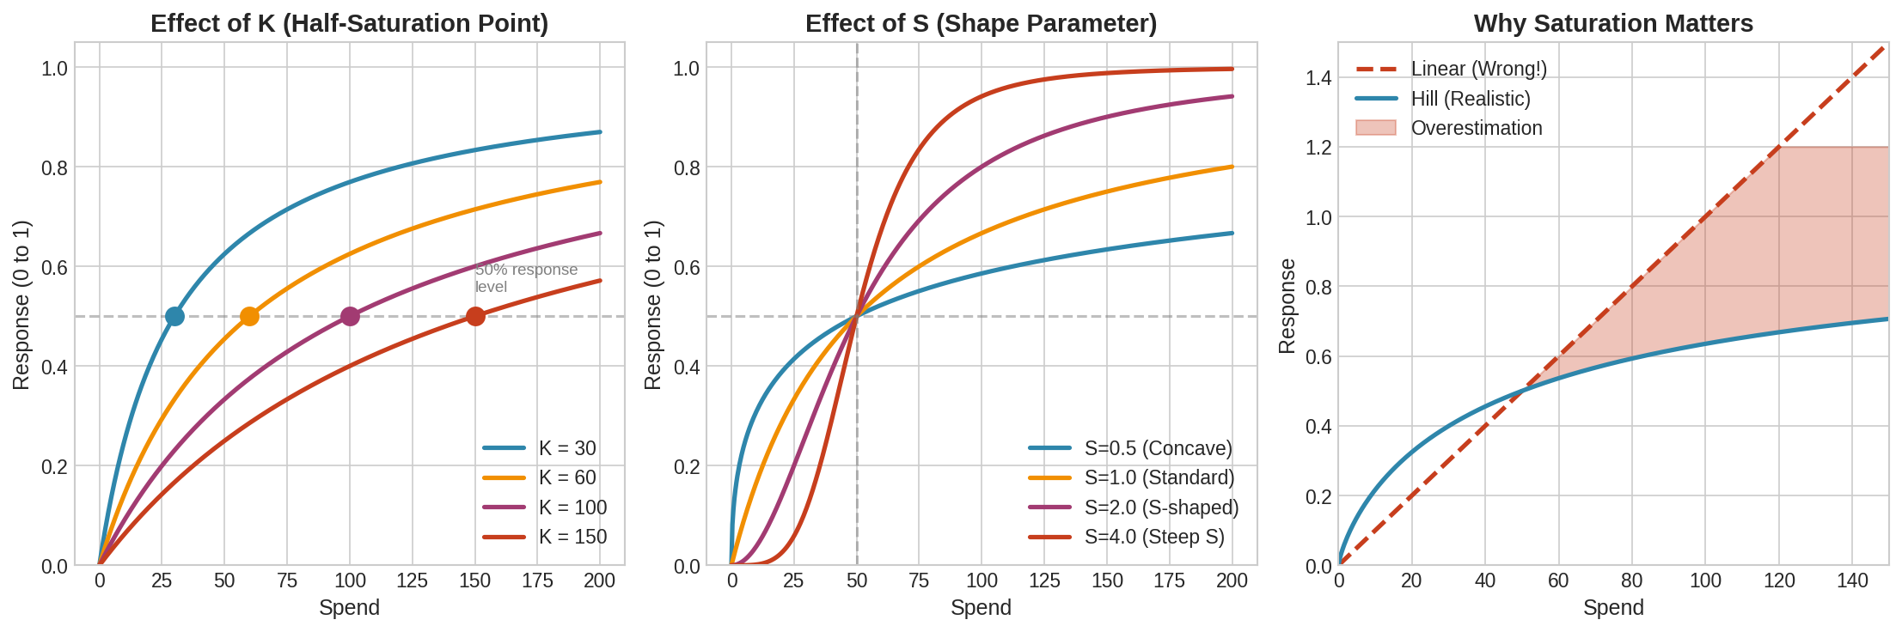

Figure 7: Hill function response curves with different K and S parameters

## Reading a Response Curve

When you see a response curve, here is how to interpret it:

1. Find your current spend level on the x-axis
2. Look at where you are on the curve
3. Is the curve still steep? You have room to grow.
4. Is the curve flattening? You are approaching saturation.
5. Is the curve nearly flat? More spend will barely help.

## The Transformation Pipeline

Spend goes through two transformations before affecting sales:

**Raw Spend -> ADSTOCK -> SATURATION -> Contribution**

Order matters! Adstock first accumulates spend over time, then saturation is applied to this accumulated stock.

Why this order? Saturation happens on accumulated exposure, not instantaneous spend. You do not saturate your audience with one week of heavy spending; you saturate them with sustained spending over time.

## What Saturation Means for Budget Decisions

Understanding saturation is crucial for budgeting:

* If you are on the steep part of the curve: Increasing spend is efficient
* If you are on the flat part: Diminishing returns have set in; consider reallocating
* Different channels saturate at different points: This is why optimal budgets vary by channel

**Chapter 9b: Additive vs Multiplicative Models**

The first major structural decision in MMM is whether to use an additive or multiplicative model formulation. This choice affects how contributions are calculated, how channels interact, and how results are interpreted.

**The Additive Specification**

An additive model expresses the outcome as a sum of components:

Revenue = Baseline + β₁·f(TV) + β₂·f(Digital) + β₃·f(Search) + Controls + ε

In this formulation, each marketing channel contributes an absolute dollar amount. The coefficient β represents dollars of revenue per unit of transformed media.

**Key characteristics of additive models:**

• Decomposition is straightforward—just sum the parts

• Coefficients have direct dollar interpretations

• Zero spend contributes zero dollars

• Channels work independently (no interactions unless explicitly modeled)

**The Multiplicative Specification**

A multiplicative model expresses the outcome as a product:

Revenue = Baseline × (1 + TV_lift) × (1 + Digital_lift) × ε

Or in log-log form:

log(Revenue) = α + β₁·log(TV) + β₂·log(Digital) + ε

Coefficients represent elasticities: 1% increase in TV → β₁% increase in revenue.

**Key characteristics of multiplicative models:**

• Coefficients are elasticities (percentage effects)

• Channels naturally interact

• Cannot handle zero values (log of zero undefined)

• Predictions always positive

• Decomposition requires Shapley values

**When to Use Each Approach**

**Use Additive when:**

• Need clear decomposition for stakeholders

• Business thinks in absolute dollars

• Some channels have zero spend periods

• Want standard tools (PyMC-Marketing, Robyn, LightweightMMM)

**Use Multiplicative when:**

• Channels genuinely interact

• Business thinks in percentage lifts

• Comfortable with Shapley decomposition

**The Practical Consensus**

Most modern MMM uses additive models with non-linear transformations:

Outcome = Baseline + f(TV) + g(Digital) + h(Search) + ...

Where f, g, h are Hill functions with adstock. Used by PyMC-Marketing, Robyn, LightweightMMM.

To add interactions in additive models, include explicit terms:

Revenue = Baseline + β₁·TV + β₂·Digital + β₃·(TV × Digital)

**Quick Reference**

**ADDITIVE: Y = β₀ + β₁X₁ + β₂X₂**

• '$1K more spend → $β more revenue'

• Pros: Simple decomposition, handles zeros

• Tools: PyMC-Marketing, Robyn, LightweightMMM

**MULTIPLICATIVE: log(Y) = α + β₁log(X₁) + β₂log(X₂)**

• '1% more spend → β% more revenue'

• Pros: Natural interactions, always positive

• Tools: Custom PyMC, Meridian

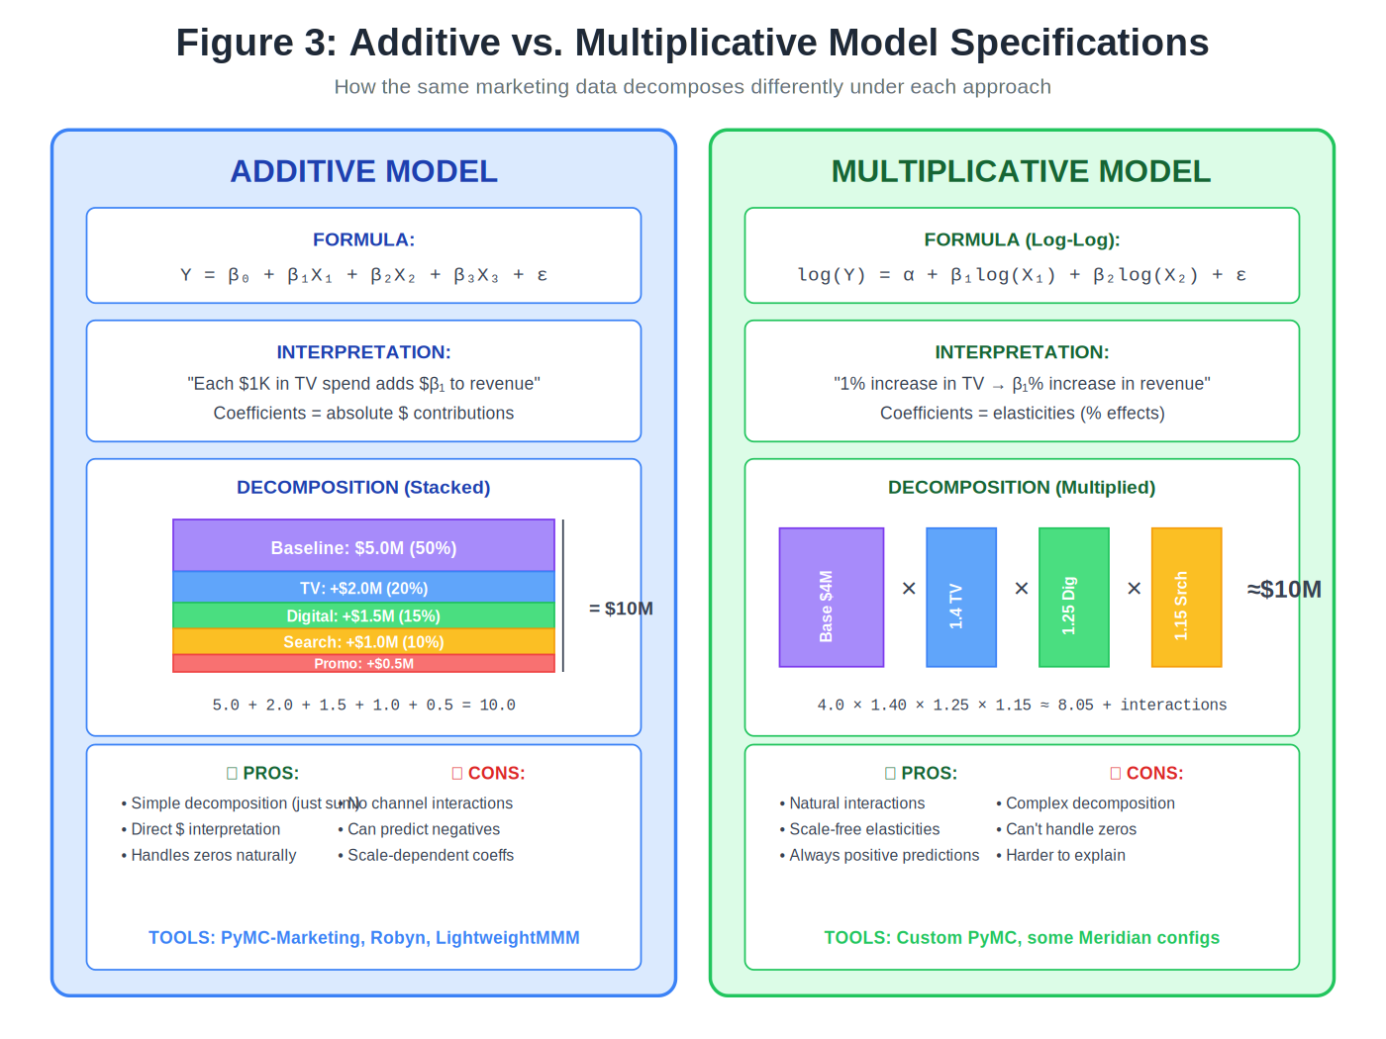

**PART IV**

SEASONALITY AND BASELINE

# Chapter 10: Modelling Seasonality

Seasonality can make or break your model. Get it wrong and you will attribute seasonal sales spikes to advertising. Get it right and you can accurately measure marketing effects.

## Types of Seasonality

* Annual: Holidays, weather, school calendar
* Quarterly: End-of-quarter business cycles
* Monthly: Paycheck timing effects
* Weekly: Weekday vs. weekend patterns

Most MMMs focus on annual seasonality since we typically use weekly data.

## The Danger of Unmodeled Seasonality

Imagine this scenario:

* Your sales spike in December (holiday shopping)
* Your advertising also spikes in December (holiday campaigns)
* A naive model sees: more ads = more sales!

But the sales spike was largely due to holiday shopping, not your ads. Without modelling seasonality, you will overestimate advertising effectiveness.

## Fourier Features: A Clever Solution

We use sine and cosine waves to capture seasonal patterns. This is based on Fourier's theorem: any repeating pattern can be represented as a sum of waves.

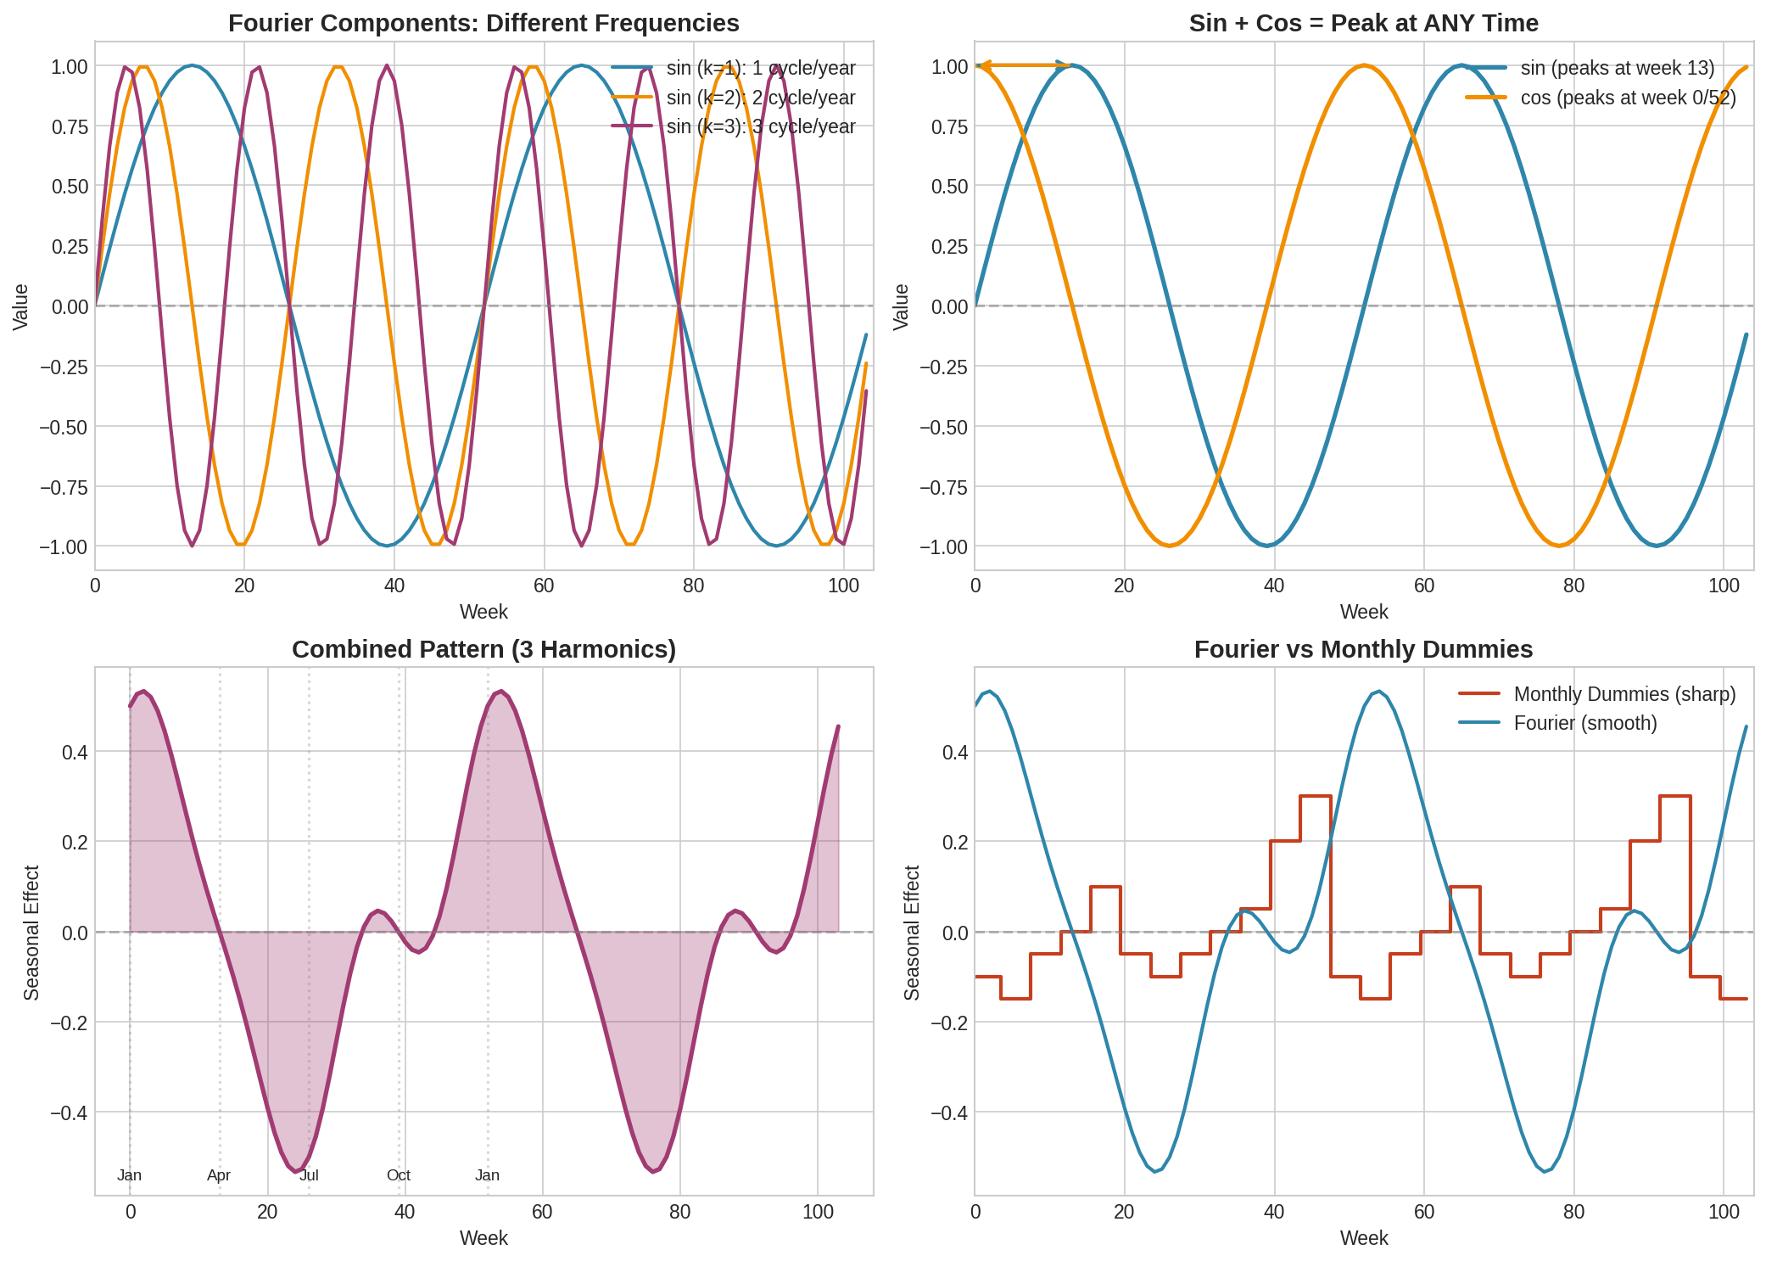

Figure 8: Fourier features showing individual harmonics and their combination

### How It Works

For each 'harmonic' (wave frequency), we create two features:

sin_k = sin(2 * pi * k * week / 52)

cos_k = cos(2 * pi * k * week / 52)

Where k is the harmonic number and week is the week number (1 to 52).

### Example: What Your Data Looks Like

Here is what 3 harmonics (6 features) look like for the first few weeks:

Week | sin_1 cos_1 | sin_2 cos_2 | sin_3 cos_3

-----+----------------+----------------+---------------

1 | 0.12 0.99 | 0.24 0.97 | 0.35 0.94

2 | 0.24 0.97 | 0.46 0.89 | 0.64 0.77

3 | 0.35 0.94 | 0.64 0.77 | 0.84 0.54

4 | 0.46 0.89 | 0.77 0.64 | 0.94 0.35

... | ... ... | ... ... | ... ...

26 | 0.00 -1.00 | 0.00 1.00 | 0.00 -1.00

52 | 0.00 1.00 | 0.00 1.00 | 0.00 1.00

The sin and cos pairs at each harmonic work together. The model learns coefficients for each, and the combination captures your seasonal pattern.

### How Many Harmonics?

* Harmonic 1 (k=1): Captures broad annual pattern (one cycle per year)
* Harmonic 2 (k=2): Captures semi-annual pattern
* Harmonic 3 (k=3): Captures quarterly pattern

Usually 3-4 harmonics are enough. More harmonics capture finer detail but risk overfitting.

## Why Not Just Use Monthly Dummies?

You could create 12 dummy variables for each month. Why use Fourier instead?

* Fewer parameters: 6-8 Fourier features vs 11 monthly dummies
* Smooth curves: Fourier creates smooth transitions, not jumps
* Works with Bayesian priors: Easier to specify reasonable priors

### Example: What Monthly Dummies Look Like

With monthly dummies, your data has 11 binary columns (one month is the reference):

Week | Feb Mar Apr May Jun Jul Aug Sep Oct Nov Dec

-----+------------------------------------------------------

1 | 0 0 0 0 0 0 0 0 0 0 0 (Jan)

2 | 0 0 0 0 0 0 0 0 0 0 0 (Jan)

5 | 1 0 0 0 0 0 0 0 0 0 0 (Feb)

9 | 0 1 0 0 0 0 0 0 0 0 0 (Mar)

... | ...

48 | 0 0 0 0 0 0 0 0 0 0 1 (Dec)

52 | 0 0 0 0 0 0 0 0 0 0 1 (Dec)

Each month gets its own coefficient. This works but assumes sharp jumps between months (e.g., Jan 31 and Feb 1 have completely different seasonality).

|  |
| --- |
| **KEY INSIGHT: RECOMMENDATION**  Start with Fourier features (3 harmonics = 6 parameters). If your business has sharp monthly effects (e.g., monthly subscription billing), consider adding a few specific month dummies on top. |

# Chapter 11: Baseline and Trend

The baseline is what you would sell with no marketing at all. Understanding and modelling baseline correctly is crucial.

## What Makes Up Baseline?

* Brand equity: The value of your brand built over years
* Habitual purchase: Customers who buy regularly regardless of ads
* Word of mouth: People buy because others recommended
* Organic search: People who search for your product directly
* Distribution: Being on store shelves drives sales

## Why Baseline Matters

If your baseline is $80 million and media contribution is $20 million, then marketing is responsible for 20% of sales. But if you model baseline incorrectly as $60 million, you will overestimate media at $40 million, or 40% of sales.

This directly affects ROI calculations and budget decisions.

## Modelling Trend

Businesses often have underlying growth or decline unrelated to marketing:

* Market growth: The category is expanding
* Brand momentum: Your brand is gaining or losing share
* Distribution expansion: You are in more stores each year

We model this with a simple trend variable:

trend = week_number # 1, 2, 3, ...

The model learns a trend coefficient that captures gradual change over time.

## A Caution About Baseline

|  |
| --- |
| **WARNING:** Baseline is not directly observable. It is what the model estimates after accounting for everything else. Be sceptical of very low baseline estimates (< 50% of sales) as they may indicate model problems. |

**PART V**

BAYESIAN INFERENCE

# Chapter 12: Why Bayesian Methods?

MMM can be done with traditional (frequentist) statistics, but modern best practice uses Bayesian methods. This chapter explains why, in terms anyone can understand.

## The Fundamental Difference

Imagine you want to know how effective your Facebook ads are. Traditional and Bayesian statistics approach this differently:

**Traditional (Frequentist) Approach:**

'The true ROI is some fixed number. Our best estimate is 2.5, with a 95% confidence interval of 1.8 to 3.2.'

This sounds precise, but the interpretation is awkward: it means 'if we repeated this study many times, 95% of intervals would contain the true value.' It does NOT mean there is a 95% chance the true value is in this range.

**Bayesian Approach:**

'Based on our data and prior knowledge, there is a 95% probability that ROI is between 1.9 and 3.1, with 2.5 being most likely.'

This is what we actually want to know! Direct probability statements about the parameter.

## Why This Matters for MMM

### Reason 1: Honest Uncertainty

Marketing data is noisy. You have limited weeks of data, channels that move together, and external factors you cannot control. Pretending we know the exact ROI is misleading.

Bayesian methods give us credible intervals that honestly reflect our uncertainty. When data is strong, intervals are narrow. When data is weak, intervals are wide. This honesty is crucial for decision-making.

Example:

Your model says Facebook ROI is 2.0 with 95% credible interval [0.5, 3.5]. This wide interval tells you the estimate is uncertain. You should probably not make a major budget decision based on it. In contrast, if the interval were [1.8, 2.2], you could be more confident.

### Reason 2: Incorporating Prior Knowledge

You are not starting from zero. Before looking at your data, you already know things about marketing:

* Advertising generally helps sales (effects should be positive)
* ROI is typically between 0.5 and 5 (not 100 or -50)
* TV effects decay slowly, search effects decay quickly
* Saturation exists (you cannot get infinite returns)

Bayesian methods let you encode this knowledge through 'priors.' This is like telling the model: 'Here is what we know before looking at the data. Now update this belief based on what the data shows.'

Why does this help?

Suppose your data suggests Facebook ROI is 15. Without priors, you might believe this. With priors that say 'ROI is usually 1-5,' the model will be sceptical and pull the estimate down. This protects against crazy results from noisy data.

### Reason 3: Handling Complexity

MMM has many parameters that need to be estimated simultaneously:

* A coefficient for each channel (3-10 parameters)
* A decay rate for each channel (3-10 parameters)
* Saturation parameters K and S for each channel (6-20 parameters)
* Seasonality terms (6-8 parameters)
* Trend, intercept, noise (3 parameters)

That is potentially 30-50 parameters from maybe 100-200 data points. Traditional methods struggle with this. Bayesian methods handle it naturally by letting parameters inform each other and using priors to regularise estimates.

## What You Get from Bayesian MMM

After fitting a Bayesian model, you get rich outputs:

* Point estimates: The most likely value for each parameter (e.g., ROI = 2.5)
* Credible intervals: The range where the true value probably lies (e.g., 95% CI: 1.9 to 3.1)
* Full distributions: The complete shape of uncertainty for each parameter
* Probability statements: 'There is 90% probability that Facebook ROI is above 1.5'

This last point is incredibly useful. You can answer business questions like:

* What is the probability that increasing Facebook spend will be profitable?
* How confident are we that TV outperforms display?
* What is the risk that our optimal budget recommendation is wrong?

|  |
| --- |
| **KEY INSIGHT: THE BOTTOM LINE**  Bayesian methods give you honest uncertainty, let you use what you already know, and handle the complexity of real marketing data. For MMM, they are now the standard approach. |

# Chapter 13: Understanding Priors

A prior is your belief about a parameter BEFORE looking at the data. This chapter explains how priors work and how to choose them.

## A Simple Analogy

Suppose a friend tells you they flipped a coin 10 times and got 10 heads. What do you believe about this coin?

If you believe coins are almost always fair (strong prior), you will think: 'Probably just a lucky streak. The coin is probably still close to fair.'

If you are open to the possibility of rigged coins (weak prior), you will think: 'This coin is probably biased toward heads.'

Your PRIOR belief about coins affects your POSTERIOR belief after seeing the data.

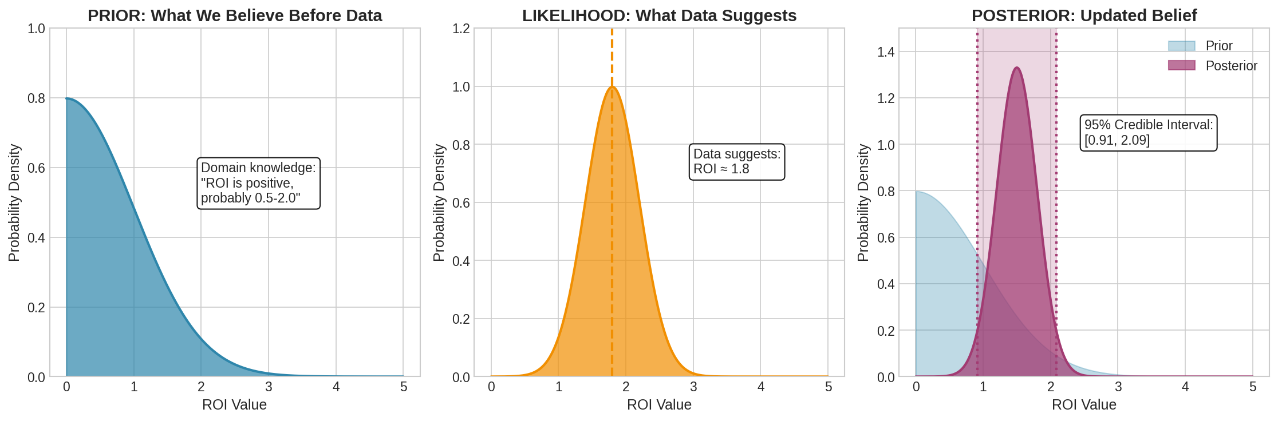

Figure 9: How prior beliefs combine with data to form posterior beliefs

## Types of Priors

### Informative Prior

Strong confidence in a narrow range.

Example: 'Based on past studies, TV ROI is between 1.5 and 2.5.'

Use when: You have solid prior knowledge.

Risk: If your prior is wrong, it will bias results.

### Weakly Informative Prior (Recommended)

General range without strong conviction.

Example: 'ROI is positive and probably less than 10.'

Use when: You have general knowledge but want data to dominate.

Benefit: Guards against extreme estimates without strong bias.

### Non-Informative (Flat) Prior

No prior knowledge at all.

Use when: You truly know nothing (rare in marketing).

Risk: Can lead to extreme estimates with limited data.

## Common Prior Distributions

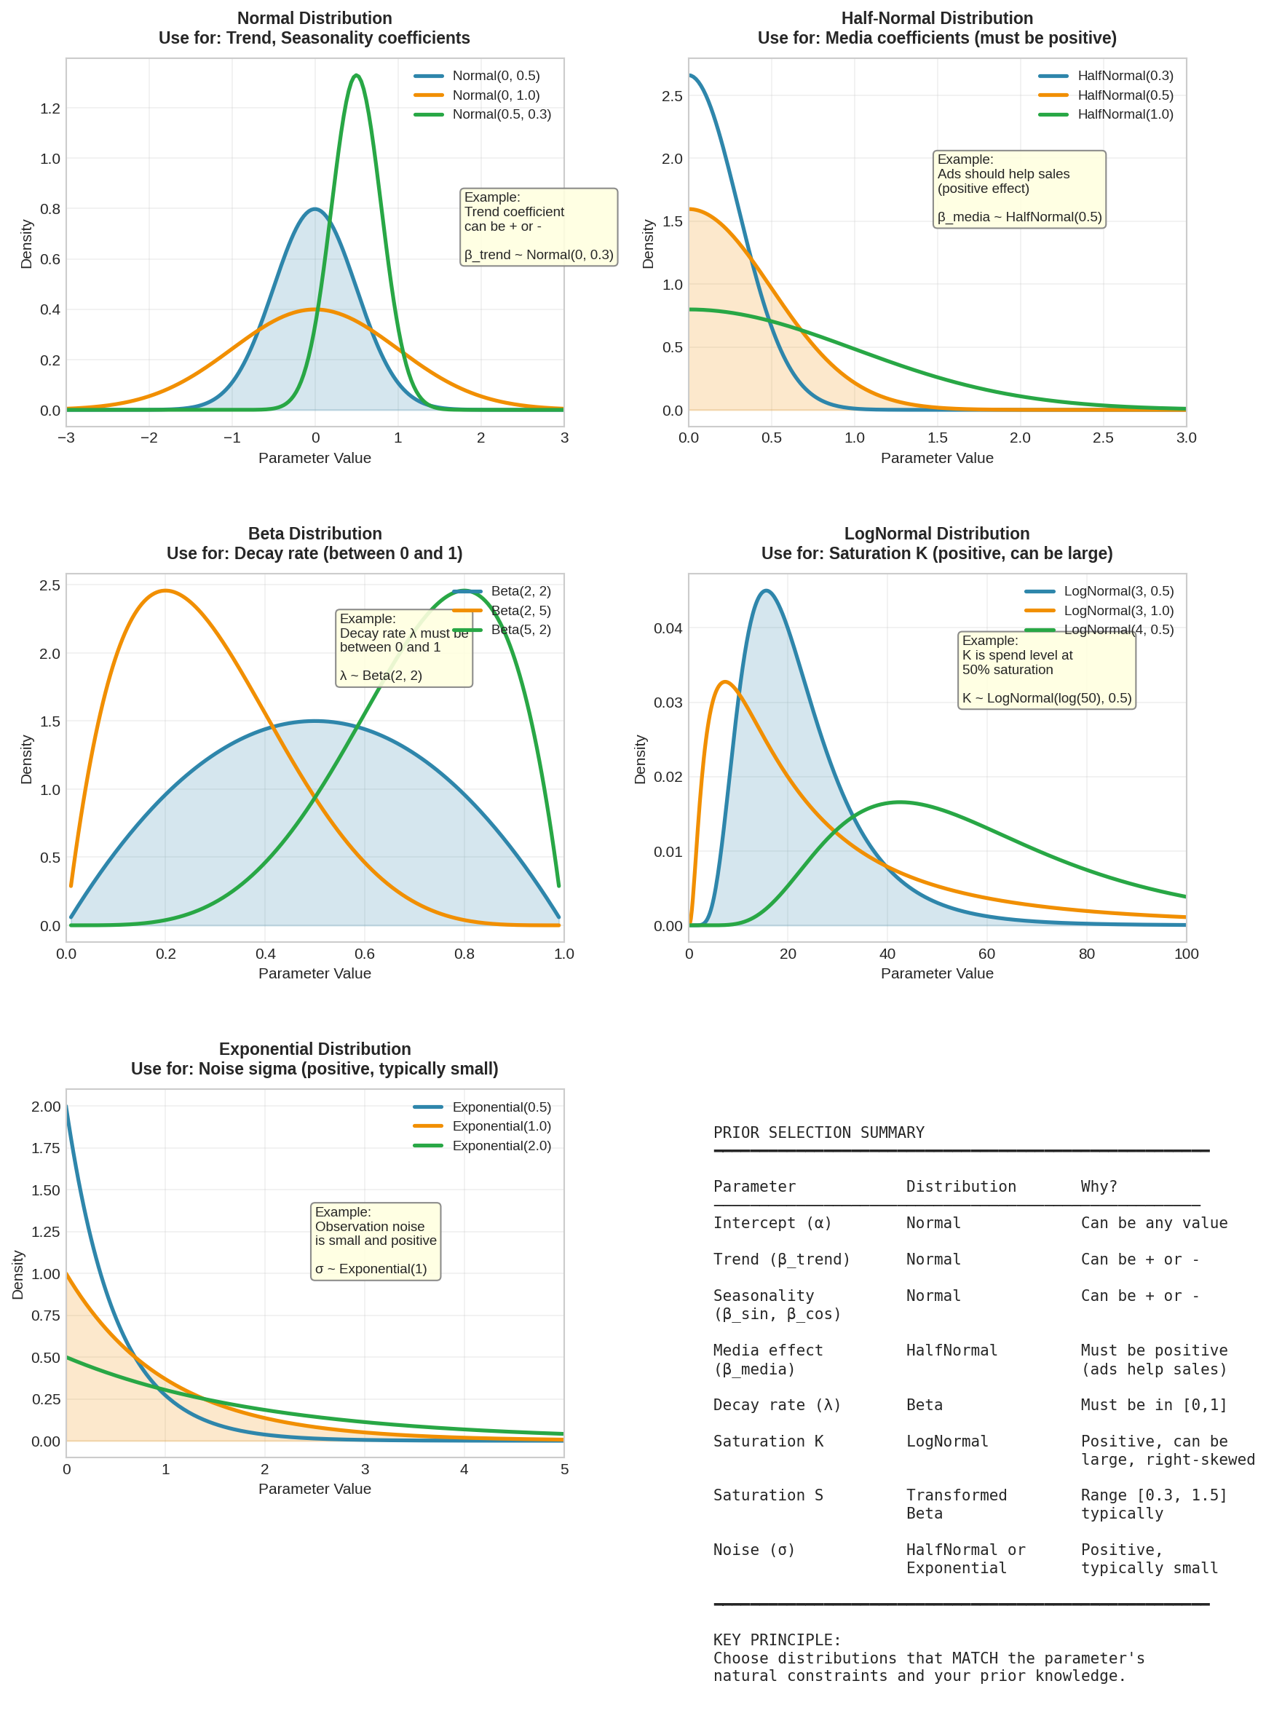

Figure 10: Common prior distributions with examples

### Normal Distribution: Normal(mean, std)

For parameters that can be positive or negative (trend, seasonality coefficients).

* mean: The centre of the distribution - your best guess for the parameter value
* std: The spread - how uncertain you are (larger = more uncertain)

beta_trend ~ Normal(0, 0.1)

This says: 'I think trend is probably around 0 (no trend), and I am fairly confident it is between -0.2 and +0.2 (within 2 standard deviations).'

Practical example: If your sales are scaled to mean=1, a trend coefficient of 0.01 means sales grow by 1% per week. Normal(0, 0.1) allows for trends between roughly -20% and +20% per week, which covers most realistic scenarios while ruling out absurd values like 500% weekly growth.

### Half-Normal Distribution: HalfNormal(std)

For parameters that must be positive (media effects). It is like a Normal distribution folded at zero.

* std: Controls the spread - larger values allow larger effects

beta_media ~ HalfNormal(0.5)

This says: 'The media effect is positive, probably small (most mass near 0), but could be as high as 1.0-1.5.'

Practical example: If sales are scaled to mean=1, a media coefficient of 0.3 means a 1-unit increase in (scaled) media spend increases sales by 30%. HalfNormal(0.5) puts 95% of probability below ~1.0, meaning you expect at most a 100% sales lift from one unit of media - sensible for most channels.

### Beta Distribution: Beta(a, b)

For parameters that must be between 0 and 1 (decay rates, retention rates).

* a and b: Shape parameters that control where the mass concentrates
* a = b: Symmetric around 0.5
* a > b: Skewed toward 1 (higher values more likely)
* a < b: Skewed toward 0 (lower values more likely)

lambda ~ Beta(3, 3)

This says: 'The decay rate is somewhere in [0,1], probably around 0.5, unlikely to be extreme (very close to 0 or 1).'

Practical example: For TV adstock decay, Beta(3, 3) centres on 0.5, meaning about 50% of the effect carries over each week. If you believe TV has longer carry-over, use Beta(5, 2) which centres around 0.7. For digital channels with faster decay, use Beta(2, 4) which centres around 0.33.

### LogNormal Distribution: LogNormal(mu, sigma)

For positive parameters that can vary over a wide range (saturation K, scale parameters).

* mu: The log of the median - exp(mu) gives you the central value
* sigma: Controls the spread on log scale - larger values mean more right-skew

K ~ LogNormal(log(50000), 0.5)

This says: 'The half-saturation point K is probably around £50,000, but could reasonably be anywhere from £20,000 to £125,000.'

Practical example: If your average weekly spend on a channel is £50K, setting K ~ LogNormal(log(50000), 0.5) centres the prior on your actual spend level. The 0.5 sigma means you are open to K being 2-3x higher or lower. If you have no idea, use sigma=1.0 for a wider range.

### Exponential Distribution: Exponential(rate)

For positive parameters that are typically small (noise, error terms).

* rate: Controls the decay - higher rate means smaller values are more likely
* The mean of the distribution is 1/rate

sigma ~ Exponential(1)

This says: 'The noise term is positive, probably around 1, and unlikely to be very large.'

Practical example: If your sales are scaled to mean=1, Exponential(1) expects residual noise to average about 1.0 (100% of mean sales). For tighter fits, use Exponential(2) which expects noise around 0.5. For very noisy data, use Exponential(0.5) which expects noise around 2.0.

|  |
| --- |
| **KEY INSIGHT: PRACTICAL TIP**  When setting priors, think in terms of your data's units. If sales average £1M/week and you expect TV to drive £50K-£200K incremental, work backwards to determine what coefficient values that implies, then set your prior accordingly. |

# Chapter 14: Bayes' Theorem Made Simple

Bayes' theorem is the mathematical foundation. Let us understand it intuitively.

## The Formula

**Posterior = (Likelihood x Prior) / Evidence**

Or more simply:

**What we believe now = How well data fits x What we believed before**

## Each Component

### Prior: What we believed before

'Based on past experience, ROI is probably around 2, maybe between 1 and 3.'

### Likelihood: How well data fits

'Given these ROI values, how probable is the sales data we observed?'

### Posterior: What we believe now

'Combining our prior belief and the data, ROI is most likely 2.3, probably between 1.8 and 2.8.'

## How Prior and Data Combine

* Strong prior + weak data: Posterior is close to prior
* Weak prior + strong data: Posterior is close to what data suggests
* Both strong but different: Posterior is a compromise

|  |
| --- |
| **KEY INSIGHT**  With enough data, the posterior is dominated by the data. Priors matter most when data is limited. This is desirable: we use prior knowledge when data is scarce, but let strong data speak for itself. |

# Chapter 15: How MCMC Works (Without the Math)

MCMC (Markov Chain Monte Carlo) is the algorithm that actually computes Bayesian results. You do not need to understand the math, but understanding the concept helps you interpret results and troubleshoot problems.

## The Problem MCMC Solves

Bayes' theorem tells us what the posterior should be:

**Posterior = (Likelihood × Prior) / Evidence**

For simple problems, we can solve this directly. But MMM has dozens of parameters (decay rates, saturation curves, coefficients for each channel). The math becomes impossibly complex.

Imagine trying to find the shape of a 30-dimensional surface. You cannot visualise it, and the equations have no closed-form solution.

## The Solution: Random Sampling

Instead of solving for the exact posterior, MCMC takes a clever shortcut: it draws SAMPLES from the posterior.

If we have thousands of samples from a distribution, we can approximate the distribution itself:

* The average of samples approximates the mean
* The spread of samples approximates the uncertainty
* The histogram of samples approximates the shape

This is like estimating the average height of people in a city by randomly sampling 10,000 people. You do not need to measure everyone; the sample tells you what you need to know.

## The Mountain Hiking Analogy

To understand how MCMC explores the posterior, imagine this scenario:

You are dropped into a mountain range covered in thick fog. You can only see your feet. Your job is to map where the peaks are.

**The MCMC strategy:**

* Start at a random location
* Take a step in a random direction
* Check your elevation at the new spot
* If the new spot is higher, move there
* If the new spot is lower, maybe move there anyway (with probability depending on how much lower)
* Record your GPS coordinates
* Repeat thousands of times

The key insight: You spend more time near peaks (high probability regions) because you always accept uphill moves and sometimes reject downhill moves. Over thousands of steps, your GPS history traces out the mountain's shape.

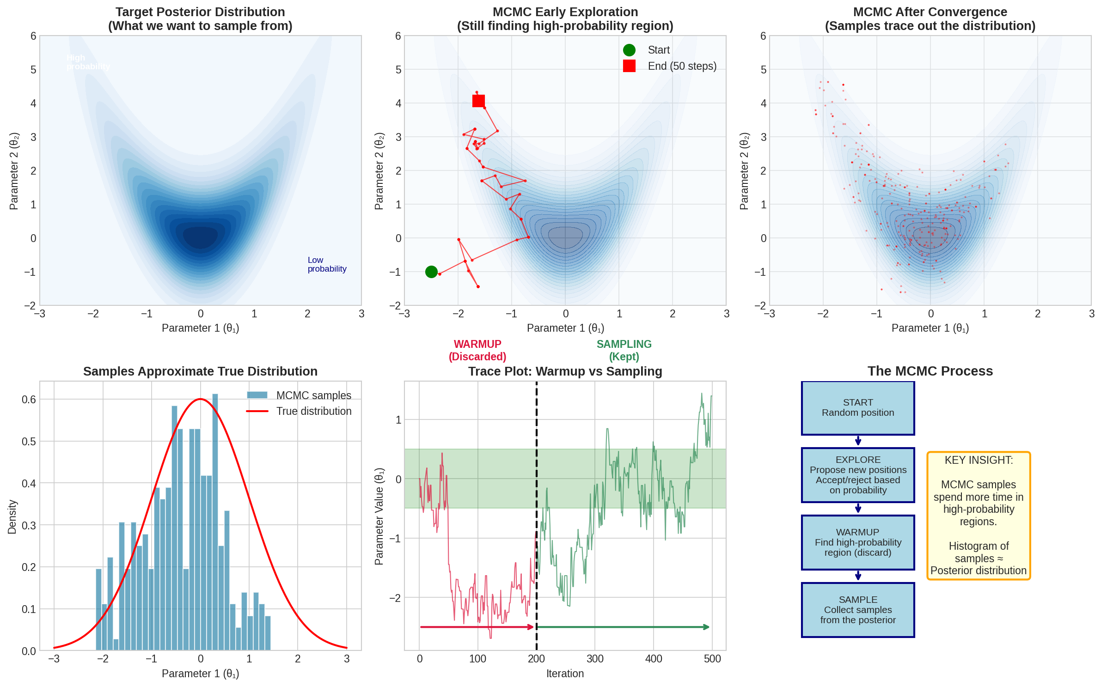

Figure 11: MCMC process showing exploration and convergence

## Warmup (Burn-in): Finding the Mountain

MCMC starts at a random spot that might be in a valley far from any peaks. The first several hundred iterations are spent wandering toward the high-probability region.

These early samples do not represent the posterior; they represent the algorithm finding its way. We discard them.

Typical workflow:

* Run 2000 total iterations
* Discard first 1000 as warmup
* Keep remaining 1000 for inference

## Multiple Chains: Checking We Found the Right Answer

A single MCMC chain might get stuck in a local peak and miss the true highest peak. To protect against this, we run 4 independent chains starting from different random locations.

If all 4 chains find the same peaks and produce similar samples, we are confident we found the right answer. If they end up in different places, the algorithm failed to converge, and we cannot trust the results.

## What You Get at the End

After MCMC runs successfully, you have thousands of samples for each parameter. For example, for Facebook ROI:

* Sample 1: ROI = 2.3
* Sample 2: ROI = 2.1
* Sample 3: ROI = 2.5
* ...and so on for thousands of samples

From these samples, you can compute:

* Point estimate: mean(samples) = 2.35
* Uncertainty: standard deviation(samples) = 0.25
* Credible interval: 5th to 95th percentile = [1.95, 2.75]
* Any probability: 'P(ROI > 2) = fraction of samples above 2 = 85%'

# Chapter 16: Checking Convergence

Before trusting any Bayesian results, you MUST verify that MCMC converged. This chapter shows you how.

|  |
| --- |
| **WARNING:** Never use results from a non-converged model. You could be making decisions based on completely wrong estimates. Always check convergence diagnostics before interpreting results. |

## What Convergence Means

Convergence means the MCMC chains have settled into the true posterior distribution. They are no longer wandering randomly; they are sampling from the right place.

Think of it like this: if you drop several hikers at different points in a mountain range (different starting values), and ask them to find the highest peak, they should all eventually end up in the same place if they search long enough. Convergence means all your 'hikers' (chains) have found and are exploring the same region.

## Why Check Convergence?

If your chains have not converged, your results are meaningless. You might be:

* Estimating from random noise, not the true posterior
* Stuck in a local optimum, missing the true answer
* Getting different answers depending on which chain you look at

Convergence diagnostics are your quality control. They tell you whether you can trust your results.

## Diagnostic 1: R-hat (Gelman-Rubin Statistic)

### What R-hat Measures

R-hat answers the question: 'Are all my chains sampling from the same distribution?'

It does this by comparing two types of variance:

* Within-chain variance (W): How much does each chain wiggle around its own mean?
* Between-chain variance (B): How different are the means of different chains?

**The intuition:**

If all chains have converged to the same distribution, then W and B should be similar. Any chain's variability should look like every other chain's variability. But if chains are stuck in different places, B will be much larger than W.

### When to Use R-hat

* ALWAYS check R-hat for every parameter before using results
* Check after initial model fitting to decide if you need more warmup
* Check when comparing models to ensure both converged
* Report R-hat values when sharing results with others

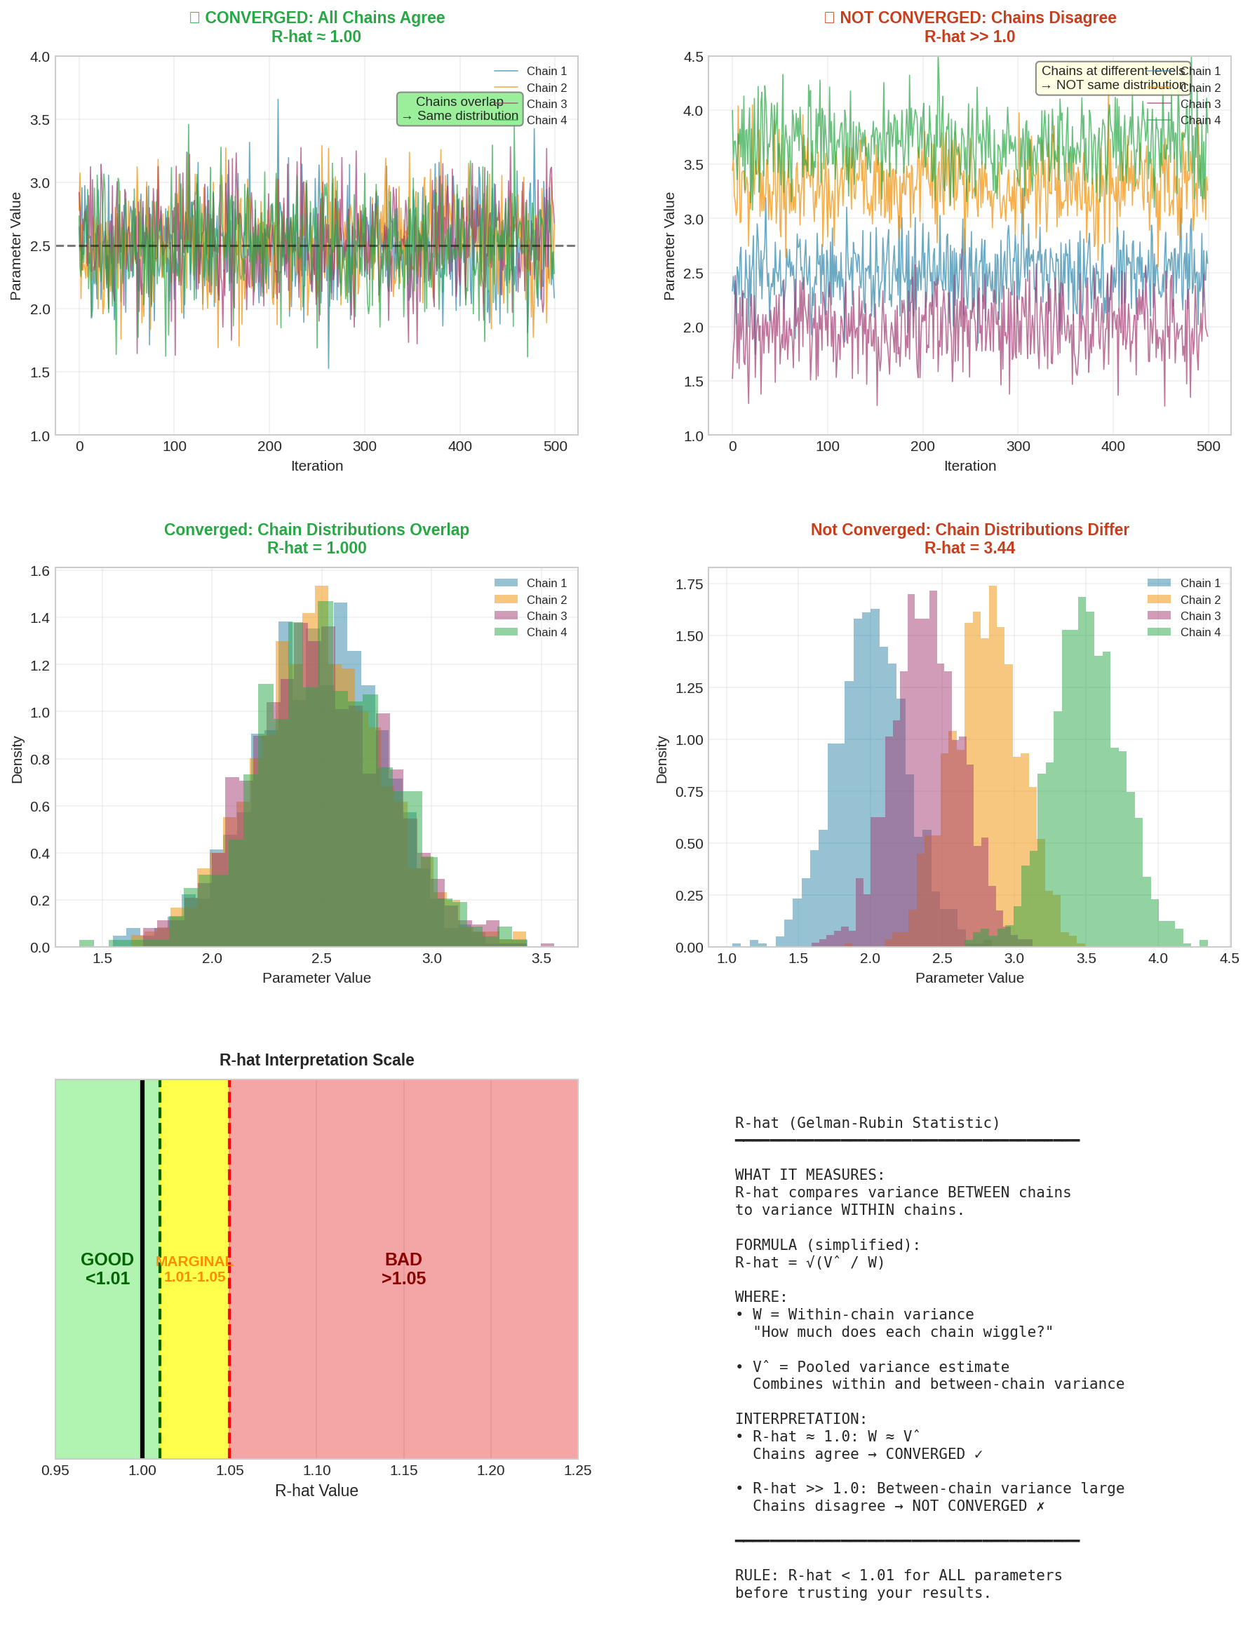

Figure 12: R-hat diagnostic explained

### Interpreting R-hat

* R-hat < 1.01: CONVERGED. All chains agree. Results are trustworthy.
* R-hat 1.01-1.05: MARGINAL. Probably okay, but investigate. Consider more warmup.
* R-hat > 1.05: NOT CONVERGED. Do NOT use these results. Chains disagree.

|  |
| --- |
| **KEY INSIGHT: PRACTICAL TIP**  Modern tools like PyMC report R-hat automatically. Look for the 'r_hat' column in the summary output. If ANY parameter has R-hat > 1.01, investigate before proceeding. |

## Diagnostic 2: ESS (Effective Sample Size)

### What ESS Measures

ESS answers the question: 'How much independent information do I actually have?'

Here is the problem: MCMC samples are NOT independent. Each sample is correlated with its neighbours because the algorithm moves gradually through parameter space. If you have 1,000 MCMC samples, you do NOT have 1,000 independent pieces of information.

**The intuition:**

Imagine you survey 1,000 people about their political views, but you only surveyed people at the same office. Their answers are correlated because of shared environment. You might effectively have information equivalent to only 100 truly independent people. ESS quantifies this: '1,000 correlated samples equals X independent samples.'

### Why ESS Matters

* Low ESS means your estimates are less precise than they appear
* Confidence intervals based on low ESS are unreliable
* You might need thousands of MCMC samples to get just hundreds of effective samples

### When to Use ESS

* Check ESS for every parameter, especially those you care about most
* Use ESS to decide if you need to run chains longer
* When ESS is low despite many samples, it signals mixing problems (see below)

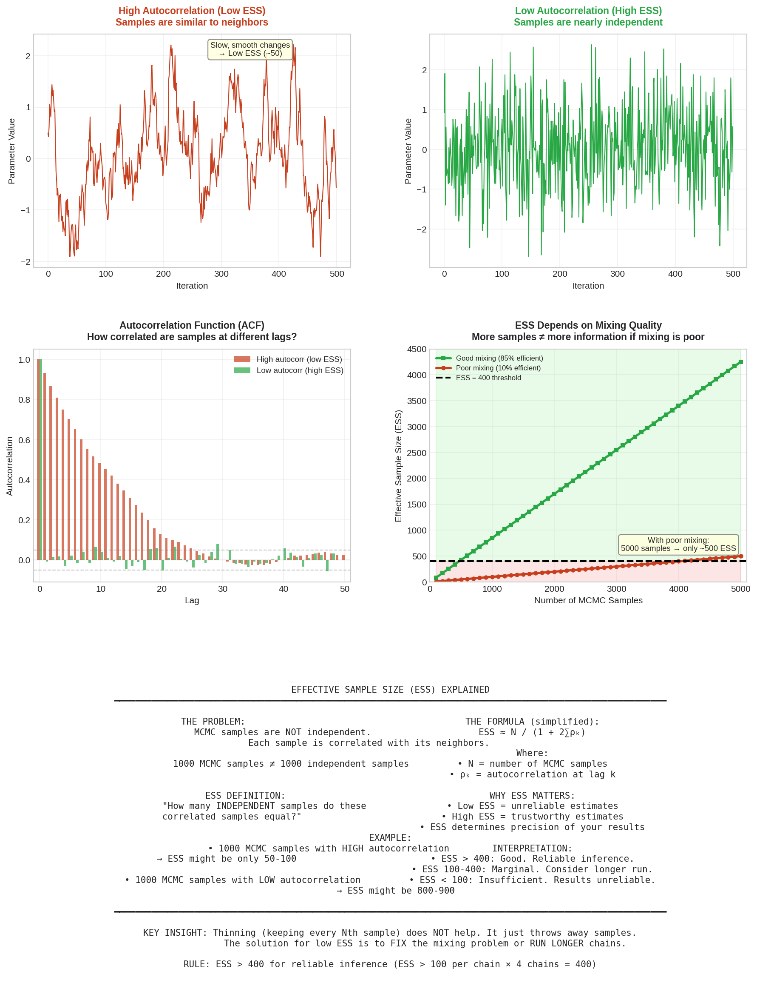

Figure 13: ESS diagnostic explained

### Interpreting ESS

* ESS > 400: GOOD. Enough for reliable inference and stable estimates.
* ESS 100-400: MARGINAL. Consider running longer chains.
* ESS < 100: INSUFFICIENT. Do not trust these results. Need more samples or better mixing.

|  |
| --- |
| **WARNING:** Common mistake: Running more samples when ESS is low. If your model mixes poorly, adding more samples is inefficient. Fix the mixing problem first (reparameterise, stronger priors, higher target_accept), then re-run. |

## Diagnostic 3: Trace Plots

Trace plots show the sampled values over iterations. They give you a visual sense of how the sampler is behaving.

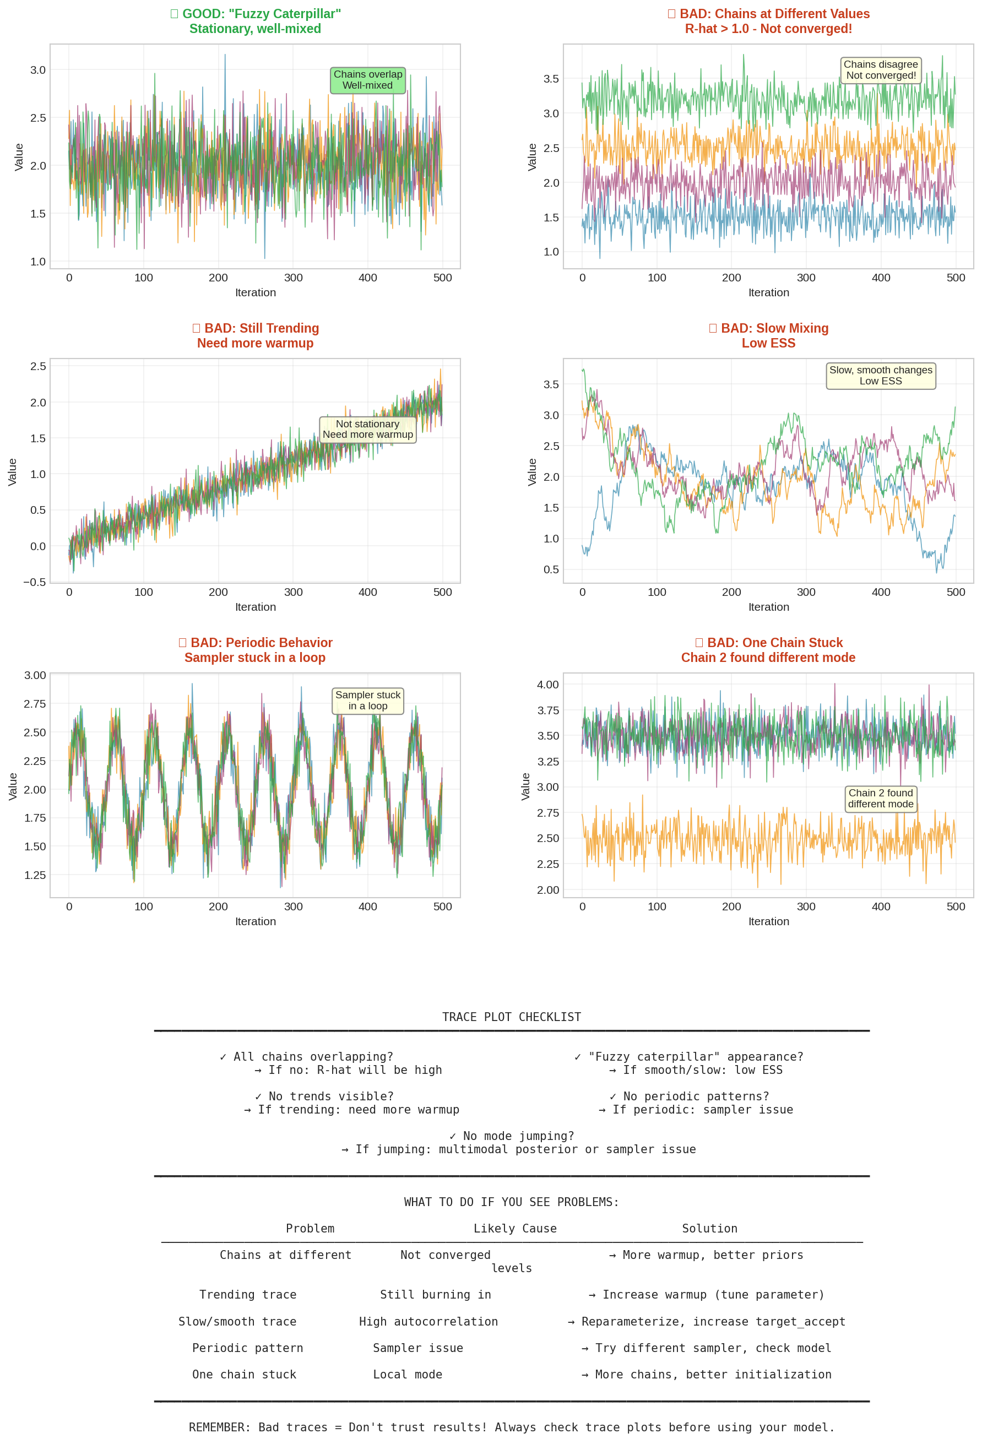

Figure 14: What good and bad trace plots look like

### Good Trace Plots ('Fuzzy Caterpillar')

A healthy trace plot looks like a 'fuzzy caterpillar': random fluctuation around a stable value, with all chains overlapping and no obvious patterns.

* Random fluctuation around a stable value
* All chains overlapping (different colors mixed together)
* No trends, cycles, or other patterns

### Bad Trace Plots and What They Mean

* Chains at different levels: Not converged. R-hat will be high.
* Trending up or down: Still burning in. Need more warmup.
* Slow wiggles: Poor mixing. ESS will be low.
* Periodic patterns: Sampler stuck in a loop. Check model specification.
* One chain stuck: Found local mode. Need more chains or better initialisation.

## What To Do If Convergence Fails

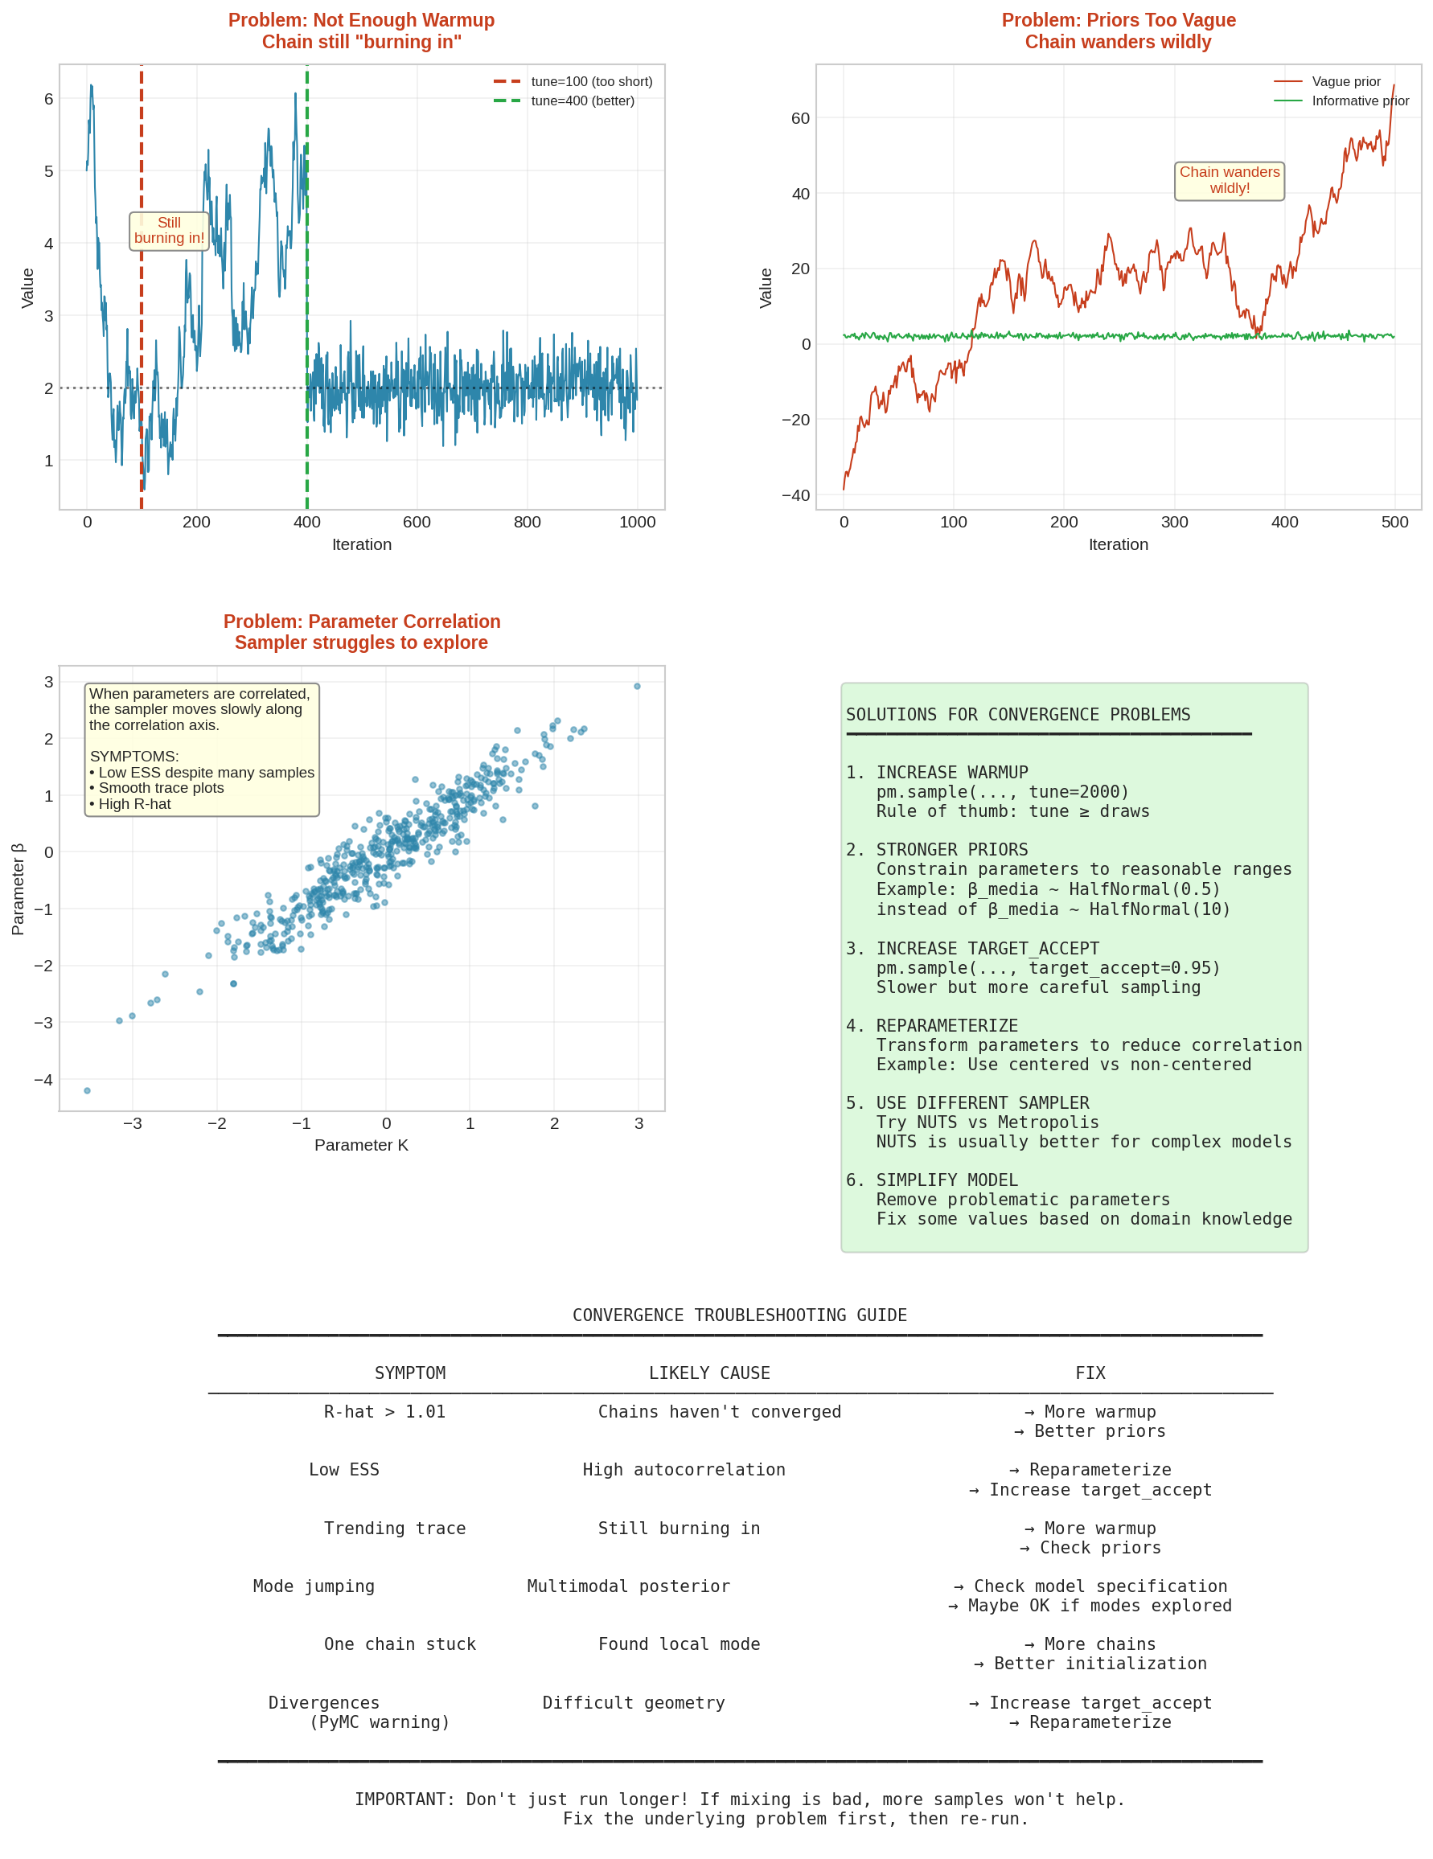

Figure 15: Fixing convergence problems

### Common Fixes

* Increase warmup: Model needs more time to find the posterior. Try tune=2000 or higher.
* Increase target_accept: Makes sampler more careful but slower. Try 0.9 or 0.95.
* Strengthen priors: Vague priors let chains wander. Use informative priors based on domain knowledge.
* Reparameterise: Change how the model is specified to reduce parameter correlation.
* Simplify model: Remove complexity that is causing problems. Fix some parameters at reasonable values.

|  |
| --- |
| **KEY INSIGHT: DEBUGGING WORKFLOW**  1. Check R-hat for all parameters. 2. Check ESS for key parameters. 3. Look at trace plots for any problem parameters. 4. Apply fixes based on what you see. 5. Re-run and check again. |

**PART VI**

BUILDING THE MODEL

# Chapter 17: The Complete Model Structure

This chapter brings everything together. We will see how all the concepts from previous chapters combine into a complete, working MMM. By the end, you will understand exactly what an MMM computes and why.

## The Big Picture

An MMM is fundamentally a decomposition. We are breaking down total sales into parts:

* Part 1: Baseline (what we would sell anyway)
* Part 2: Trend (gradual growth or decline over time)
* Part 3: Seasonality (predictable patterns within the year)
* Part 4: Media contributions (sales driven by each advertising channel)
* Part 5: Other factors (promotions, distribution, etc.)
* Part 6: Unexplained noise (random variation)

The model estimates how much each part contributes. The media contributions are what we care about most, because they tell us the ROI of our advertising.

## The Full Equation

Mathematically, we write:

**y = alpha + trend + seasonality + sum(media_effects) + controls + noise**

Let us unpack each term:

### y: Sales (the outcome)

This is what we are trying to explain. We typically scale sales by dividing by the mean, so the average value is 1.0. This makes coefficients easier to interpret and priors easier to set.

### alpha: Intercept

The baseline level. If everything else were zero (no trend, no seasonality, no media, no controls), what would sales be? For scaled data, this should be around 1.

### trend: Long-term direction

Captures gradual growth or decline: trend = beta_trend × week_number

A positive beta_trend means sales are growing over time (beyond what media explains).

### seasonality: Repeating patterns

Captures annual patterns using Fourier features:

seasonality = sum of (beta_sin_k × sin(2πk×week/52) + beta_cos_k × cos(2πk×week/52))

### media_effects: The key part

For each channel, we compute: beta × Hill(Adstock(spend))

* Adstock transforms raw spend into accumulated exposure
* Hill function applies saturation
* Beta scales the result to sales units

We sum these across all channels.

### controls: Other factors

Coefficients × control variables. For example: beta_promo × promo_indicator

### noise: Random variation

What is left over: noise ~ Normal(0, sigma)

We assume noise is normally distributed with mean zero. Sigma captures how much unexplained variation there is.

## Why We Scale Data

Before fitting the model, we typically scale both sales and media spend. This is not just a technical convenience - it makes the model work better and results easier to interpret.

### Scaling Sales to Mean 1

We divide all sales values by the mean sales:

scaled_sales = raw_sales / mean(raw_sales)

If your average weekly sales are £2 million, after scaling:

* A week with £2M sales becomes 1.0
* A week with £3M sales becomes 1.5 (50% above average)
* A week with £1.5M sales becomes 0.75 (25% below average)

**Why do this?**

* Interpretability: All coefficients are now in 'percentage of average sales' units
* Prior setting: We can use the same priors regardless of whether sales are £1M or £100M
* Numerical stability: MCMC algorithms work better when values are near 1 rather than millions
* Comparability: Results can be compared across different brands or time periods

### Scaling Media Spend

We typically scale media spend the same way:

scaled_spend = raw_spend / mean(raw_spend)

Or sometimes by dividing by the maximum:

scaled_spend = raw_spend / max(raw_spend)

This ensures the saturation function (Hill) operates on values between 0 and ~2, which is numerically stable.

## Specifying Each Parameter

In Bayesian MMM, every parameter needs a prior distribution. The prior encodes our beliefs before seeing the data. Here is the detailed reasoning for each parameter:

### Intercept (alpha)

alpha ~ Normal(1, 0.5)

**What alpha represents:**

The intercept is the baseline level of sales when all other factors (trend, seasonality, media) are at their reference values. For scaled data where mean sales = 1, the intercept should be approximately 1.

**Why Normal(1, 0.5)?**

* Centre at 1: Because scaled sales average 1.0, the baseline should be around 1.0
* Standard deviation 0.5: This creates a 95% prior interval of roughly [0, 2]
* This says: 'Baseline is probably between 0% and 200% of average sales'

What if baseline is NOT near 1?

If your model estimates alpha = 0.3, that means 30% of average sales come from baseline, with the remaining 70% explained by trend, seasonality, and media. This might indicate overfitting to media or missing control variables.

**Adjusting the prior:**

* If you believe baseline is higher (strong brand), try Normal(1.2, 0.3)
* If you believe baseline is lower (media-dependent brand), try Normal(0.7, 0.3)
* Narrower std (0.3) = more confident; wider std (0.7) = less certain

### Trend (beta_trend)

beta_trend ~ Normal(0, 0.1)

**What beta_trend represents:**

The trend coefficient captures gradual growth or decline over time that is NOT explained by media or seasonality. It multiplies the week number (1, 2, 3, ...).

**Understanding the scale:**

With scaled sales (mean = 1), a beta_trend of 0.01 means:

* Week 1: trend contribution = 0.01 × 1 = 0.01 (1% of average sales)
* Week 52: trend contribution = 0.01 × 52 = 0.52 (52% of average sales)
* This is equivalent to ~67% annual growth (compounding weekly)

**Why Normal(0, 0.1)?**

* Centre at 0: We do not know in advance if the trend is up or down
* Standard deviation 0.1: Creates 95% interval of roughly [-0.2, 0.2]
* At 0.2 per week, annual impact would be 0.2 × 52 = 10.4 (1040% of baseline) - extreme but possible
* Most realistic trends fall well within this range

**Adjusting the prior:**

* Growing market: If you know the category is growing, try Normal(0.005, 0.05)
* Stable market: Try Normal(0, 0.05) with tighter std
* Declining market: Try Normal(-0.005, 0.05)

### Seasonality (beta_sin, beta_cos)

beta_sin_k ~ Normal(0, 0.3)

beta_cos_k ~ Normal(0, 0.3)

**What seasonality coefficients represent:**

Each Fourier harmonic has a sin and cos component. Together they capture a seasonal pattern at that frequency. The coefficients scale the waves.

**Understanding the scale:**

With scaled sales, a coefficient of 0.3 means that harmonic can shift sales by ±30% of average:

* If beta_sin_1 = 0.3, the annual sine wave can push sales up to 1.3 at its peak
* Combined effects across harmonics can be larger

**Why Normal(0, 0.3)?**

* Centre at 0: We do not know if a particular harmonic will be positive or negative
* Standard deviation 0.3: Allows seasonal swings of ±30% at 1 std, ±60% at 2 std
* This accommodates most real-world seasonality (even holiday spikes)

**Adjusting the prior:**

* Highly seasonal business (retail, travel): Try Normal(0, 0.5) for more flexibility
* Stable business (utilities, subscriptions): Try Normal(0, 0.15) to constrain seasonality
* Keep priors the same across all harmonics unless you have specific knowledge

### Media Effect (beta_media)

beta_media ~ HalfNormal(0.5)

**What beta_media represents:**

This coefficient translates transformed media (after adstock and saturation) into sales. It captures the 'strength' of that channel.

**Why HalfNormal (not Normal)?**

Advertising should HELP sales, not hurt them. A negative media coefficient makes no business sense. HalfNormal is a normal distribution folded at zero - it only allows positive values.

**Understanding the scale:**

With scaled data, if beta_TV = 0.4 and the transformed TV variable ranges from 0 to 1:

* At maximum TV effect (transformed = 1): contribution = 0.4 (40% of average sales)
* At zero TV: contribution = 0
* This means TV can drive up to 40% of your average weekly sales

**Why HalfNormal(0.5)?**

* Scale 0.5: Most probability mass is below 1.0
* 95% of prior probability is below ~1.0 (100% of average sales from one channel)
* Allows for large effects but expresses skepticism about very large effects

**Adjusting the prior:**

* Channel you expect to be strong (TV for brand advertiser): Try HalfNormal(0.7)
* Channel you expect to be weak (niche channel): Try HalfNormal(0.3)
* If you have prior ROI estimates, work backwards to implied coefficient

### Decay Rate (lambda)

lambda ~ Beta(2, 2)

**What lambda represents:**

Lambda is the carry-over rate in the adstock transformation. It determines how much of last week's effect carries into this week.

* Lambda = 0: No carry-over (effect is immediate and disappears)
* Lambda = 0.5: 50% carries over each week (half-life of ~1 week)
* Lambda = 0.9: 90% carries over (effect persists for many weeks)

**Why Beta(2, 2)?**

* Beta distribution is bounded between 0 and 1 (exactly what we need for a rate)
* Beta(2, 2) is symmetric around 0.5, expressing uncertainty
* It gently penalises extreme values (0 or 1) while allowing the data to determine the actual rate
* 95% of probability is between roughly 0.1 and 0.9

**Adjusting the prior:**

* TV/brand media (expect slow decay): Try Beta(3, 2) or Beta(5, 2), centred higher
* Search/performance media (expect fast decay): Try Beta(2, 3) or Beta(2, 5), centred lower
* If you have prior knowledge that decay is around 0.7: Try Beta(7, 3)

|  |
| --- |
| **KEY INSIGHT: CHANNEL-SPECIFIC GUIDANCE**  Typical decay rates: TV/Radio: 0.6-0.8 (slow decay), Print: 0.5-0.7, Digital Display: 0.3-0.5, Paid Search: 0.1-0.3 (fast decay). Use these as starting points for informative priors. |

### Saturation K (Half-Saturation Point)

K ~ LogNormal(log(median_spend), 0.5)

**What K represents:**

K is the spend level at which you reach 50% of maximum possible effect. It is the 'inflection point' of the saturation curve.

**Why LogNormal?**

* K must be positive (you cannot have negative saturation point)
* K is typically in the same ballpark as your actual spend
* LogNormal is right-skewed, allowing for K to be larger than expected
* LogNormal on the log scale is equivalent to Normal, making it easy to specify

**Understanding LogNormal(log(median_spend), 0.5):**

If your median weekly TV spend is £100K:

* log(100000) ≈ 11.5
* LogNormal(11.5, 0.5) centres K around £100K
* The 0.5 sigma means 95% of prior probability is roughly between £37K and £270K
* This expresses: 'K is probably somewhere between a third and three times our typical spend'

**Adjusting the prior:**

* If you believe you are far from saturation: Increase the centre (e.g., log(2 × median_spend))
* If you believe you are already saturated: Decrease the centre
* More uncertainty: Increase sigma to 0.7 or 1.0
* Less uncertainty: Decrease sigma to 0.3

### Saturation S (Shape Parameter)

S ~ 0.3 + 1.2 * Beta(2, 2)

**What S represents:**

S controls the SHAPE of the saturation curve:

* S < 1: Steep initial rise, then gradual flattening (most common for marketing)
* S = 1: Balanced diminishing returns
* S > 1: S-shaped curve with slow start, then steep rise, then saturation (threshold effect)

**Why this transformation?**

We want S to be in the range [0.3, 1.5] for most marketing applications:

* Beta(2, 2) gives values between 0 and 1, centred at 0.5
* Multiplying by 1.2 gives range [0, 1.2]
* Adding 0.3 shifts to range [0.3, 1.5]
* The centre is at 0.3 + 1.2 × 0.5 = 0.9

**Adjusting the prior:**

* If you expect strong diminishing returns: Try 0.2 + 0.8 × Beta(2, 2) for range [0.2, 1.0]
* If you expect threshold effects: Try 0.5 + 1.5 × Beta(2, 2) for range [0.5, 2.0]
* For most cases, the default works well

### Noise (sigma)

sigma ~ HalfNormal(0.3)

**What sigma represents:**

Sigma is the standard deviation of the residuals - the unexplained variation after accounting for all model components. It measures how 'noisy' your data is.

**Why HalfNormal?**

* Sigma must be positive (standard deviation cannot be negative)
* HalfNormal naturally handles this constraint
* It puts most probability near zero, expressing belief that noise should be small

**Understanding HalfNormal(0.3):**

With scaled sales (mean = 1):

* Most probability is below 0.6 (sigma rarely exceeds 0.6)
* If sigma = 0.3, unexplained variation is about ±30% of average sales at 1 std
* If sigma = 0.1, your model explains most variation (±10% residual noise)
* If sigma = 0.5, there is substantial unexplained variation

**Adjusting the prior:**

* Clean data (stable category, good coverage): Try HalfNormal(0.2)
* Noisy data (volatile category, missing controls): Try HalfNormal(0.5)
* If your model consistently estimates sigma > 0.4, you may be missing important variables

## Summary: Prior Selection Checklist

When setting priors, ask yourself:

1. What is the natural range for this parameter? (Use appropriate distribution)
2. What is my best guess for the centre? (Set the location parameter)
3. How uncertain am I? (Set the scale parameter - wider = more uncertain)
4. Do I have domain knowledge to inform tighter priors?
5. Am I being too restrictive? (Priors should guide, not dominate)

|  |
| --- |
| **KEY INSIGHT: PRACTICAL TIP**  Start with the default priors shown here. Run the model and check if posteriors are 'piling up' against prior bounds. If so, your priors may be too restrictive. If posteriors look reasonable and R-hat/ESS are good, your priors are working. |

## How It All Fits Together

When you fit the model, the MCMC algorithm finds the combination of parameter values that best explains your data while respecting the priors. The output is posterior distributions for every parameter.

From these posteriors, you can:

* Extract point estimates (posterior means)
* Calculate credible intervals
* Compute derived quantities like ROI
* Generate predictions
* Run optimisation

# Chapter 18: Time-Varying Effects

Standard MMM assumes advertising effectiveness is constant over time. But this is not always true.

## What Can Change Over Time?

### Creative Fatigue

The same ad loses impact as people see it repeatedly. A fresh campaign is more effective than a tired one.

### Market Changes

Competitors enter or exit. Economic conditions shift. Consumer preferences evolve.

### Channel Maturation

A new channel (like TikTok) may be very effective early when it is novel, then become less effective as it matures.

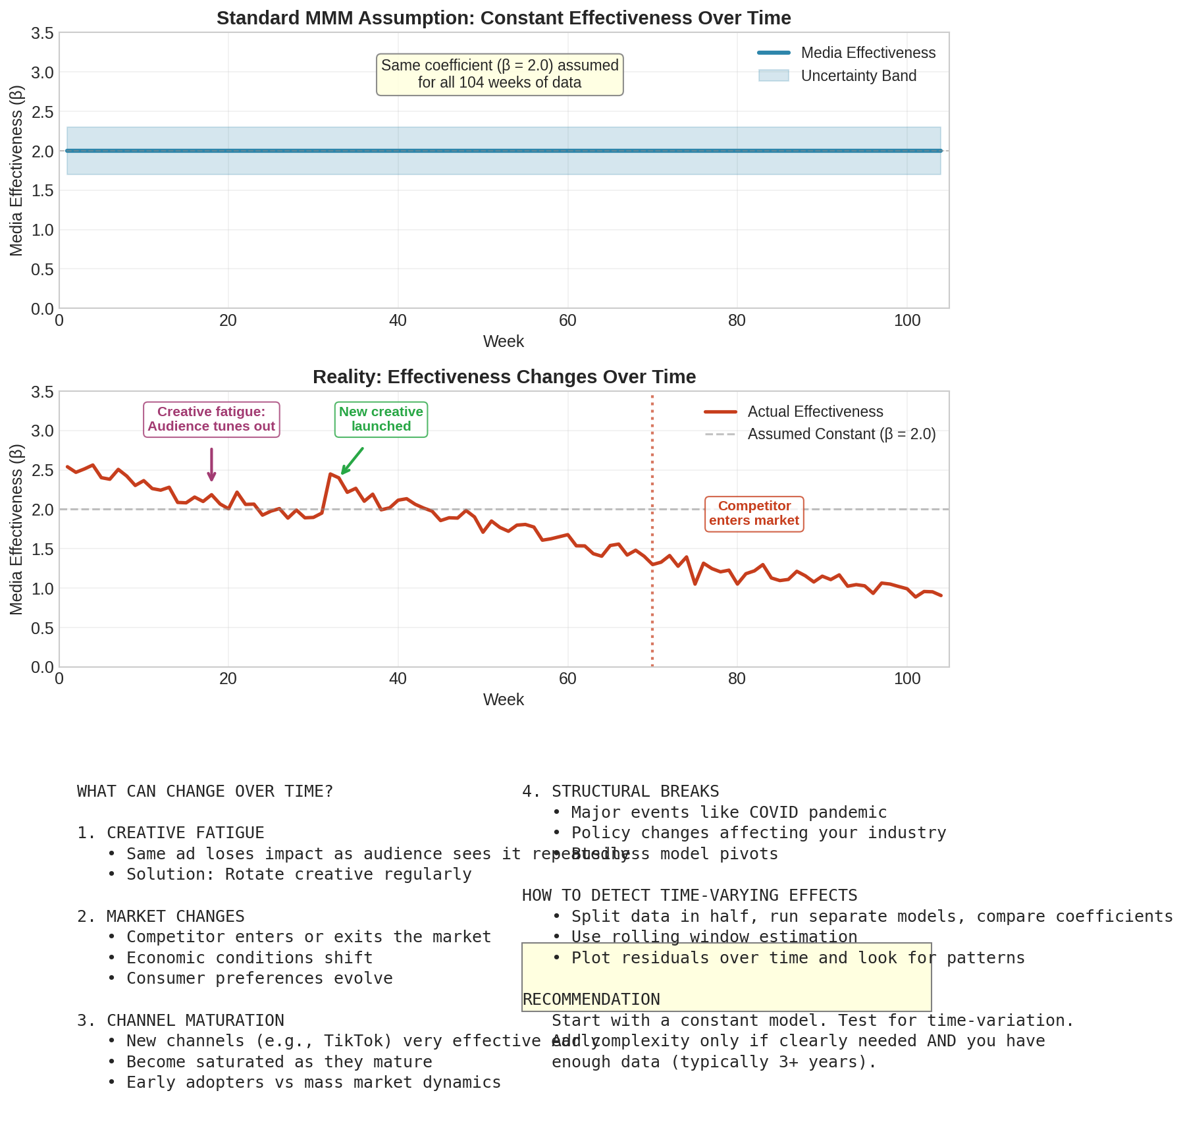

Figure 16: Constant vs time-varying effectiveness

## How to Detect Time-Varying Effects

* Split data in half and run separate models. Do coefficients differ substantially?
* Plot residuals over time. Do they show patterns?
* Check if results are stable when adding or removing recent data.

## How to Model Time-Varying Effects

For beginners, start with the constant model. Only add time-variation if:

* You have strong evidence effects are changing
* You have enough data (3+ years)
* You have a specific hypothesis about what is changing

|  |
| --- |
| **TIP:** Time-varying models are more complex and require more data. Most practitioners start with constant effects and only add time-variation when clearly needed. |

# Chapter 19: Hierarchical Models (Advanced)

If you have data across multiple regions, products, or brands, hierarchical models let you 'borrow strength' across groups.

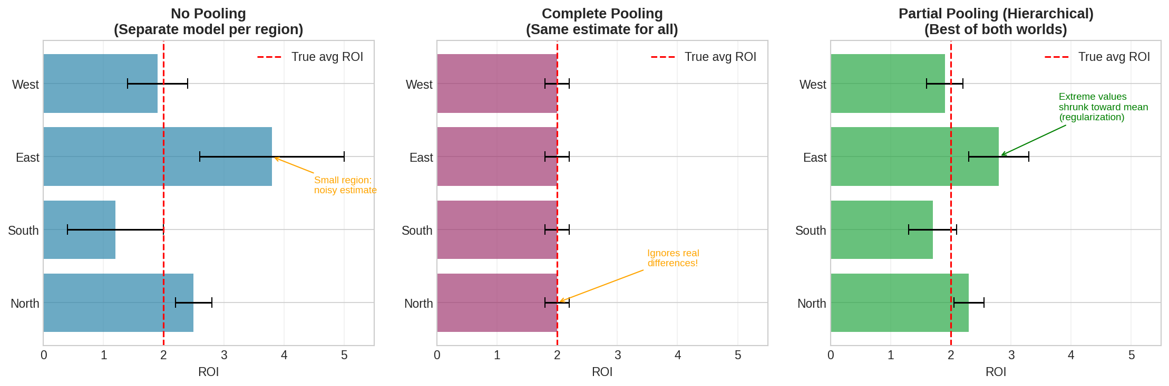

Figure 17: Comparing no pooling, complete pooling, and partial pooling

## The Problem

Suppose you have data for 10 regions:

* Some regions have lots of data (reliable estimates)
* Some regions have little data (noisy estimates)

## Three Approaches

### No Pooling: Separate model per region

Each region gets its own estimates. Small regions have very uncertain estimates.

### Complete Pooling: One model for all regions

All regions share the same estimates. Ignores real differences between regions.

### Partial Pooling (Hierarchical): Best of both

Regions share information but can differ. Small regions are 'shrunk' toward the overall average. Large regions with strong data can differ more.

## When to Use Hierarchical Models

* You have multiple groups (regions, products, brands)
* Some groups have limited data
* You believe groups are related but not identical

For beginners: Start with a single aggregate model. Add hierarchy only when you have a specific need and sufficient data.

## Pooled Regression: A Practical Alternative

Pooled regression (also called panel regression) is a simpler approach to multi-region modelling. Instead of estimating separate models, you stack all regional data together and estimate one model.

### What Is a Cross-Section?

A cross-section (or region) could be:

* A Designated Market Area (DMA) - e.g., London, Manchester, Birmingham
* A retailer - e.g., Tesco, Sainsbury's, ASDA
* A product variant - e.g., pack size, flavour
* A customer segment - e.g., new vs returning customers

### Benefits of Pooling

* More data points = more robust estimates
* Ability to measure regional-level activities (local promotions, store events)
* Can capture more media granularity

Example: If you have 3 years of weekly data (156 weeks) across 5 regions, pooling gives you 780 data points instead of 156.

### Important: Normalisation

When pooling data across regions with different sales levels, you must normalise. Otherwise, you may get spurious relationships.

Common normalisation approaches:

* Divide by the regional mean
* Subtract the regional mean (demeaning)
* Use log transformation (which inherently normalises)

|  |
| --- |
| **KEY INSIGHT: RULE OF THUMB**  Assume the same percentage contribution across regions. If you suspect some regions are more price-sensitive than others, split the variable by region to estimate different elasticities. |

# Chapter 20: Cross-Channel Interactions

Does TV make your search ads more effective? Do your channels work better together than separately?

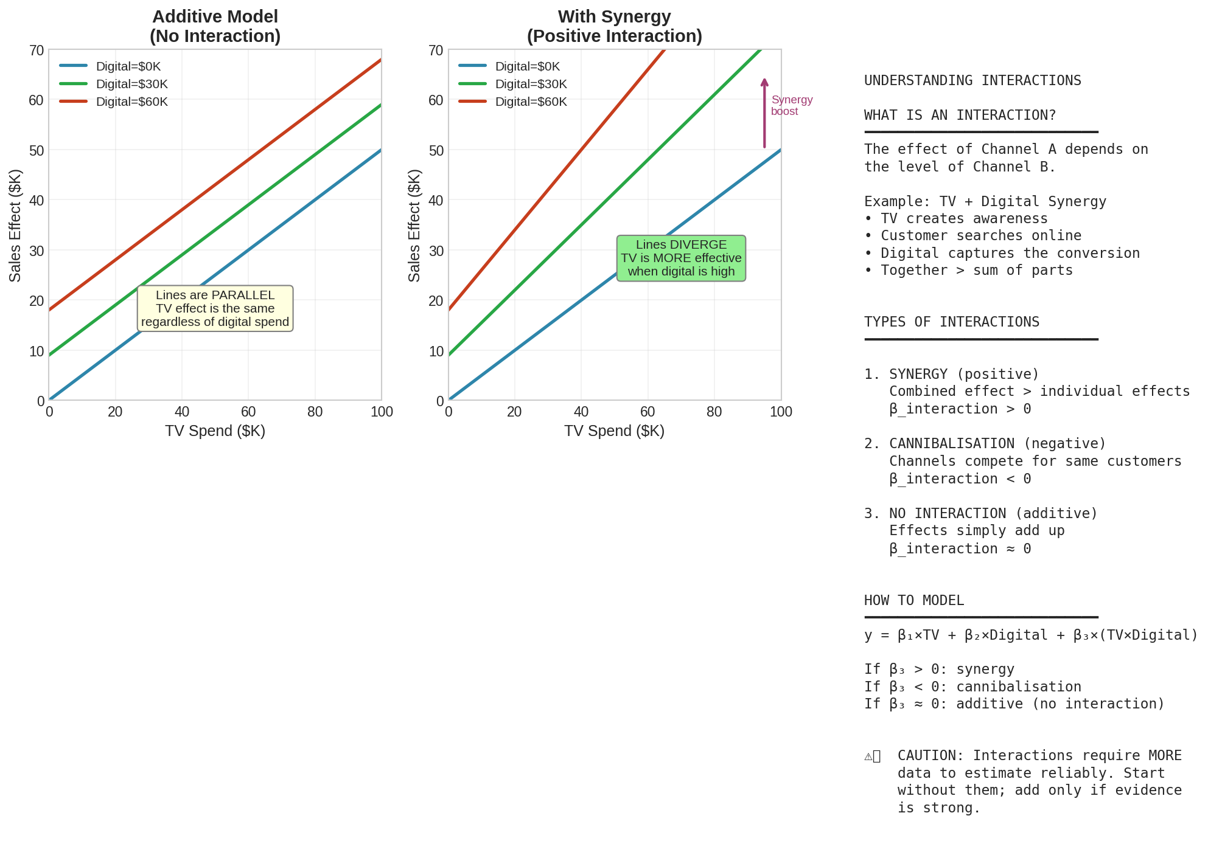

Figure 18: Additive effects vs synergy between channels

## What Are Interactions?

An interaction means the effect of one channel DEPENDS on the level of another.

### Example: TV + Search Synergy

TV creates awareness. When people become interested, they search. Your search ads capture this interest. TV makes search more effective.

## Types of Interactions

### Synergy (Positive Interaction)

Channels amplify each other. TV + Search together beats TV alone + Search alone.

### Cannibalisation (Negative Interaction)

Channels compete for the same customers. Email + Display together is less than their sum.

## How to Model Interactions

Add an interaction term:

y = beta_TV * TV + beta_Search * Search + beta_interaction * (TV * Search)

If beta_interaction > 0: synergy

If beta_interaction < 0: cannibalisation

## The Endogeneity Problem

Consider a telco running a multichannel campaign. Some customers:

* Buy directly after seeing TV → attributed to TV
* Search after seeing TV, then buy → attributed to Search (last touch)

But the TV clearly influenced the search behaviour! The indirect impact of TV should be counted.

This is called the endogeneity problem: channels influence each other, making it hard to isolate true effects with standard regression.

## Nested Models: A Solution

Nested models (using Two-Stage Least Squares, 2SLS) can separate direct and indirect effects:

### Step 1: Model the intermediate channel

Search = f(TV, other factors)

This captures how TV drives search activity.

### Step 2: Use predicted values in the main model

Sales = f(TV, predicted_Search, other factors)

This separates the direct effect of TV from its indirect effect through search.

### Step 3: Decompose attribution

* Direct impact: Effect of TV on sales (holding search constant)
* Indirect impact: Effect of TV on search × effect of search on sales
* Total impact: Direct + Indirect

This allows you to properly credit TV for the search conversions it influenced.

## A Word of Caution

|  |
| --- |
| **WARNING:** Interactions and nested models are hard to estimate reliably. They require more data than main effects. Start without interactions; add only if you have strong evidence and sufficient data. |

**PART VII**

MODEL VALIDATION

# Chapter 21: In-Sample Validation

Before using any model for decisions, you must validate it. Validation answers: Is this model any good? Can we trust its results? This chapter covers in-sample validation, which checks how well the model fits the data it was trained on.

## What Is In-Sample Validation?

In-sample validation measures how well your model explains the data used to build it. Think of it as asking: 'Does the model at least fit the historical data?'

This is a necessary but not sufficient condition. A model that cannot fit historical data is definitely bad. But a model that fits historical data perfectly might still be bad (it could be overfitting). We address overfitting in the next chapter.

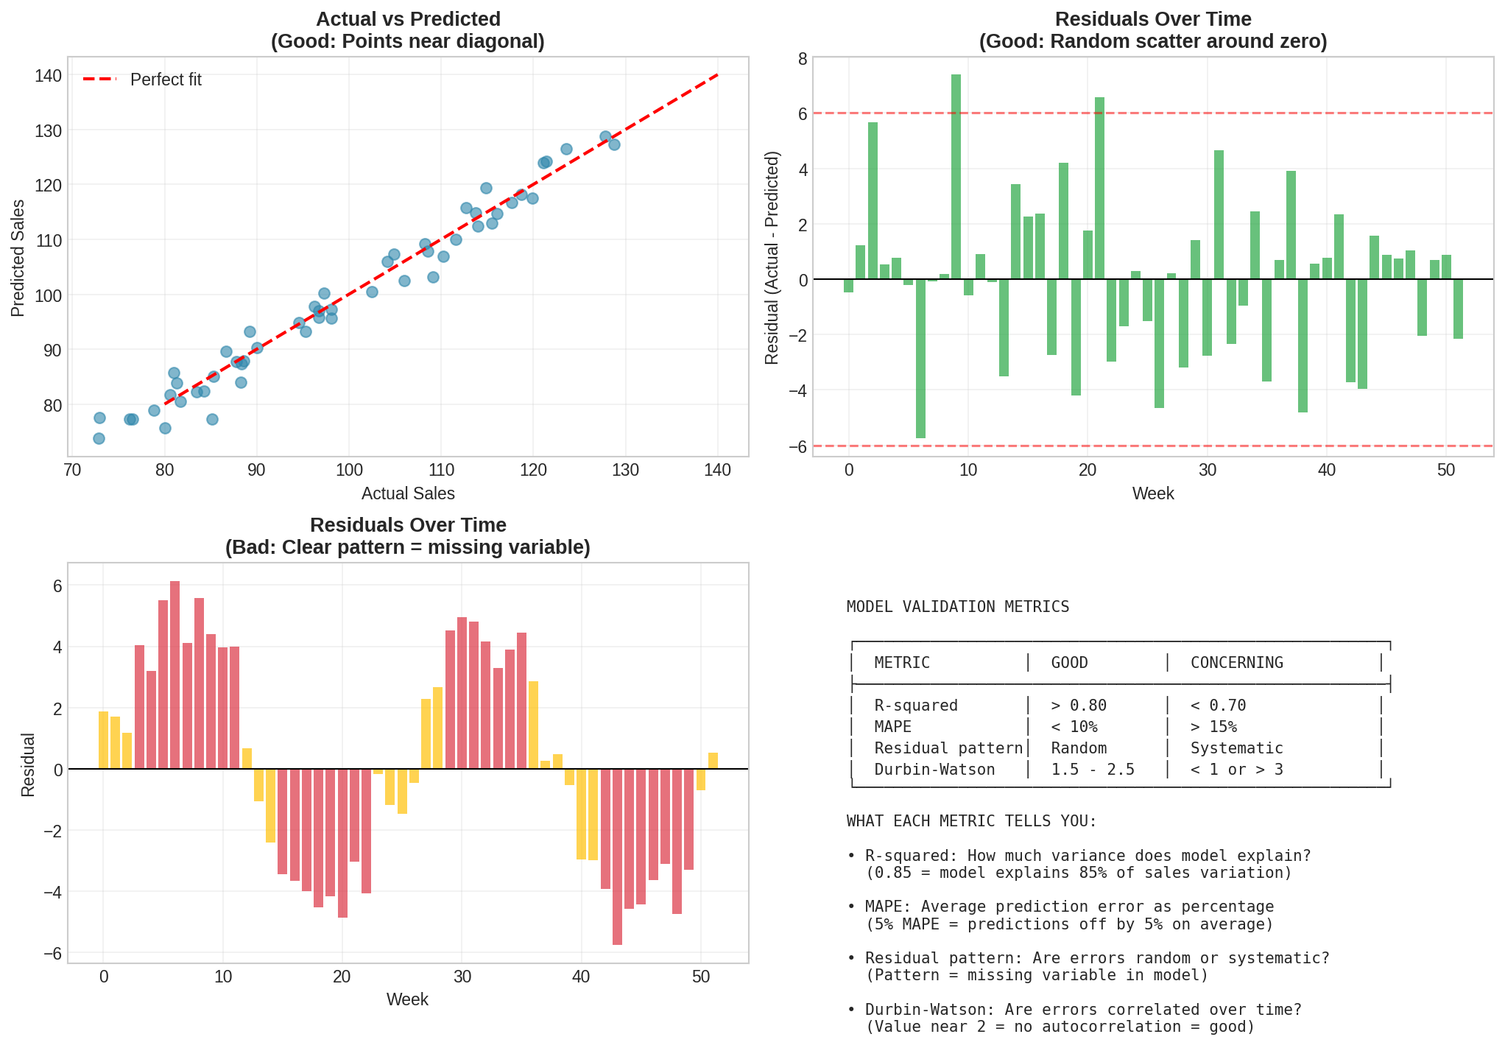

Figure 19: Model validation overview showing fit metrics and residual analysis

## Metric 1: R-squared (Coefficient of Determination)

R-squared answers: What fraction of sales variation does the model explain?

**How to interpret R-squared:**

* R-squared = 0.90: Model explains 90% of variation. Excellent. Only 10% is unexplained noise.
* R-squared = 0.80: Model explains 80% of variation. Good. This is typical for well-built MMMs.
* R-squared = 0.70: Model explains 70% of variation. Acceptable, but there may be missing factors.
* R-squared = 0.50: Model explains only 50%. Concerning. Major factors are probably missing.

|  |
| --- |
| **KEY INSIGHT: TYPICAL VALUES**  R-squared above 0.80 is typical for well-specified MMMs. If yours is below 0.70, consider what might be missing: promotions? distribution changes? competitor activity? external factors? |

A caution about R-squared:

R-squared can be misleadingly high if you have strong seasonality or trend. The model might just be capturing seasonality, not media effects. Always look at R-squared alongside other metrics.

## Metric 2: MAPE (Mean Absolute Percentage Error)

MAPE answers: On average, how far off are our predictions in percentage terms?

MAPE = mean(|actual - predicted| / actual) * 100%

Example: If actual sales are $100K and predicted sales are $95K, the error is 5%.

**How to interpret MAPE:**

* MAPE < 5%: Excellent. Predictions are very accurate.
* MAPE 5-10%: Good. Typical for a solid MMM.
* MAPE 10-15%: Acceptable, but room for improvement.
* MAPE > 15%: Concerning. Model may be missing important drivers.

MAPE is often more intuitive than R-squared because it is in percentage terms. Saying 'our predictions are off by 7% on average' is easier to understand than 'R-squared is 0.85.'

## Metric 3: Residual Analysis

Residuals are the differences between actual and predicted values:

**Residual = Actual - Predicted**

Analysing residuals tells you whether the model is systematically wrong in certain ways.

### What Good Residuals Look Like

* Random scatter around zero: No pattern, just noise
* Roughly constant spread: Similar variance throughout
* No extreme values: Residuals should be small relative to sales

### What Bad Residuals Look Like

* Waves or cycles: You are probably missing seasonality or a cyclical factor
* Trend (drifting up or down): Model does not capture underlying trend correctly
* Increasing spread over time: Variance is not constant (heteroscedasticity)
* Clusters of positive or negative: Model systematically over/under-predicts in certain periods

### The Durbin-Watson Test

This statistical test checks if residuals are correlated over time (autocorrelation).

* DW near 2.0: No autocorrelation. Residuals are independent. Good.
* DW < 1.5: Positive autocorrelation. Residuals tend to follow each other.
* DW > 2.5: Negative autocorrelation. Residuals tend to alternate.

If DW is far from 2, it usually means you are missing a variable that creates patterns over time.

## Putting It All Together

A well-validated model should have:

* R-squared > 0.80
* MAPE < 10%
* Residuals that look random (no patterns)
* Durbin-Watson between 1.5 and 2.5

If any of these fail, investigate before trusting the model.

# Chapter 22: Out-of-Sample Validation

In-sample fit can be misleading. A model might 'memorise' noise instead of learning real patterns. Out-of-sample validation is the true test of predictive ability.

## Why In-Sample Fit Is Not Enough

Imagine a student who memorises the answers to practice exam questions. They score perfectly on practice tests. But give them a new exam and they fail, because they never learned the underlying concepts.

Models can do the same thing. Given enough parameters, a model can fit any dataset perfectly, including the noise. This is called 'overfitting.'

Out-of-sample validation tests whether the model learned real patterns or just memorised noise. We do this by predicting data the model has never seen.

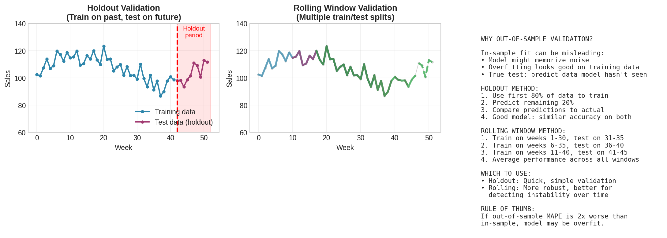

Figure 20: Holdout and rolling window validation methods

## Method 1: Holdout Validation

The simplest approach: hold back some data, train on the rest, then test on the holdout.

**Step by step:**

1. Split your data: Use the first 80% (e.g., 83 weeks of 104) for training
2. Fit the model on training data only
3. Use the fitted model to predict the holdout period (remaining 20%)
4. Compare predictions to actual values
5. Calculate MAPE on the holdout data

**How to interpret:**

* Holdout MAPE similar to in-sample MAPE: Good. Model generalises well.
* Holdout MAPE somewhat worse (up to 50% higher): Normal. Some degradation is expected.
* Holdout MAPE much worse (2x or more): Concerning. Model may be overfit.

Example:

If in-sample MAPE is 6% and holdout MAPE is 8%, this is fine. If in-sample MAPE is 6% and holdout MAPE is 15%, investigate overfitting.

## Method 2: Rolling Window (Time Series Cross-Validation)

More robust than simple holdout, but requires more computation. Tests whether performance is stable over time.

**How it works:**

1. Define a training window size (e.g., 30 weeks) and test window (e.g., 5 weeks)
2. First fold: Train on weeks 1-30, test on weeks 31-35
3. Second fold: Train on weeks 6-35, test on weeks 36-40
4. Third fold: Train on weeks 11-40, test on weeks 41-45
5. Continue rolling forward until you run out of data
6. Average the performance metrics across all folds

**Why rolling window is better:**

* Tests multiple time periods, not just one
* Reveals if model performance varies over time
* Reduces chance of getting lucky (or unlucky) with a single holdout

## What Good Out-of-Sample Performance Looks Like

A well-generalising model should show:

* Holdout MAPE within 1.5x of in-sample MAPE
* Consistent performance across rolling window folds
* No systematic bias (not always over-predicting or under-predicting)

## What To Do If Out-of-Sample Validation Fails

If holdout performance is much worse than in-sample:

1. Simplify the model: Reduce the number of parameters
2. Strengthen priors: Use more regularising priors
3. Check for data leakage: Make sure no holdout information leaked into training
4. Look for structural breaks: Maybe the relationship changed over time
5. Add more data if possible: More training data helps generalisation

## A Critical Reminder

|  |
| --- |
| **WARNING:** Never use out-of-sample data for model selection and then report performance on that same data. If you tried multiple models and picked the one that performed best on holdout, you need a fresh holdout to report unbiased performance. |

# Chapter 23: Posterior Predictive Checks

This is a powerful validation technique unique to Bayesian modelling.

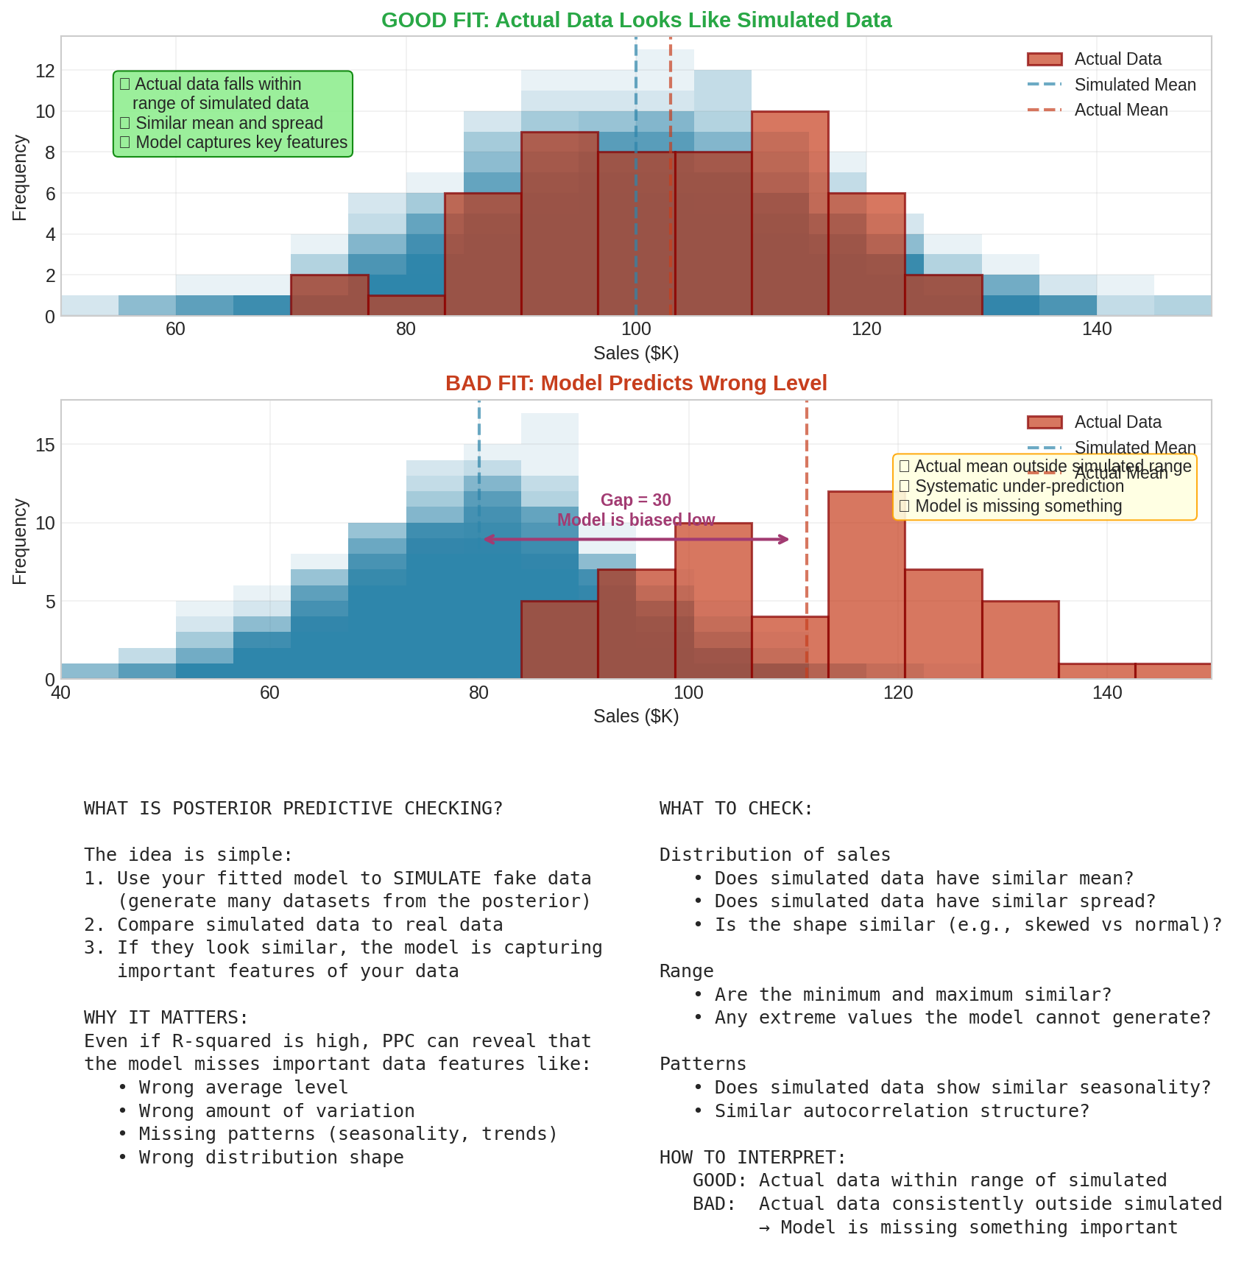

Figure 21: Posterior predictive checks showing good and bad fits

## The Idea

1. Use your fitted model to SIMULATE fake data (many times)
2. Compare simulated data to actual data
3. If they look similar, the model captures important features of your data

## What to Compare

* Distribution of sales: Does simulated data have similar mean, spread, shape?
* Range: Are the minimum and maximum similar?
* Patterns: Does simulated data show similar seasonality?

## Interpreting Results

* Actual data within range of simulated: Model is reasonable
* Actual data consistently outside simulated: Model is missing something

## Python Implementation

# Generate posterior predictive samples

with model:

ppc = pm.sample_posterior_predictive(trace)

# Compare distributions

simulated = ppc.posterior_predictive['y']

actual = observed_sales

# Plot histograms to compare

# Chapter 24: Sensitivity Analysis

How robust are your results? Would small changes in assumptions change your conclusions?

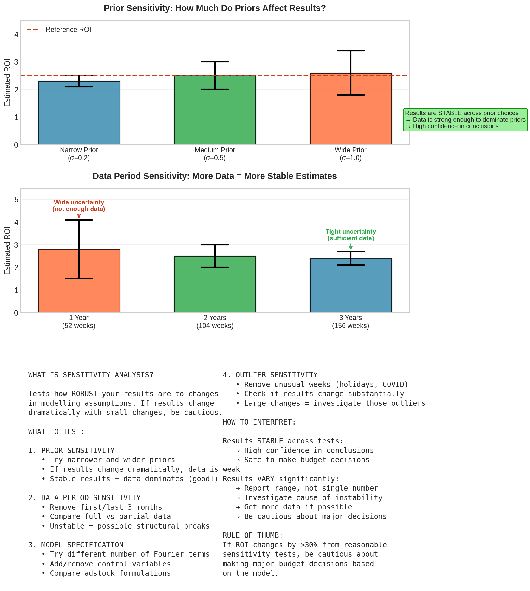

Figure 22: Sensitivity analysis showing prior and data period effects

## What to Test

### Prior Sensitivity

Try different priors:

* Narrower priors (more informative)
* Wider priors (less informative)
* Different centres

If results change dramatically, your data may be too weak to overcome prior assumptions.

### Data Period Sensitivity

Try different time periods:

* Remove the first 6 months
* Remove the last 6 months
* Use only the last 2 years

If results change dramatically, there may be structural breaks in your data.

### Model Specification Sensitivity

Try different model choices:

* More or fewer Fourier terms
* Different adstock function
* Add or remove control variables

## Interpreting Sensitivity

* Results stable across tests: High confidence in conclusions
* Results vary significantly: Report a range, not a single number. Investigate the cause.

|  |
| --- |
| **KEY INSIGHT: RULE OF THUMB**  If ROI changes by more than 30% from reasonable sensitivity tests, be cautious about major budget decisions. |

# Chapter 25: Comparing Models (WAIC and LOO)

When you have multiple candidate models, how do you choose the best one? This chapter explains the two main tools for Bayesian model comparison: WAIC and LOO-CV.

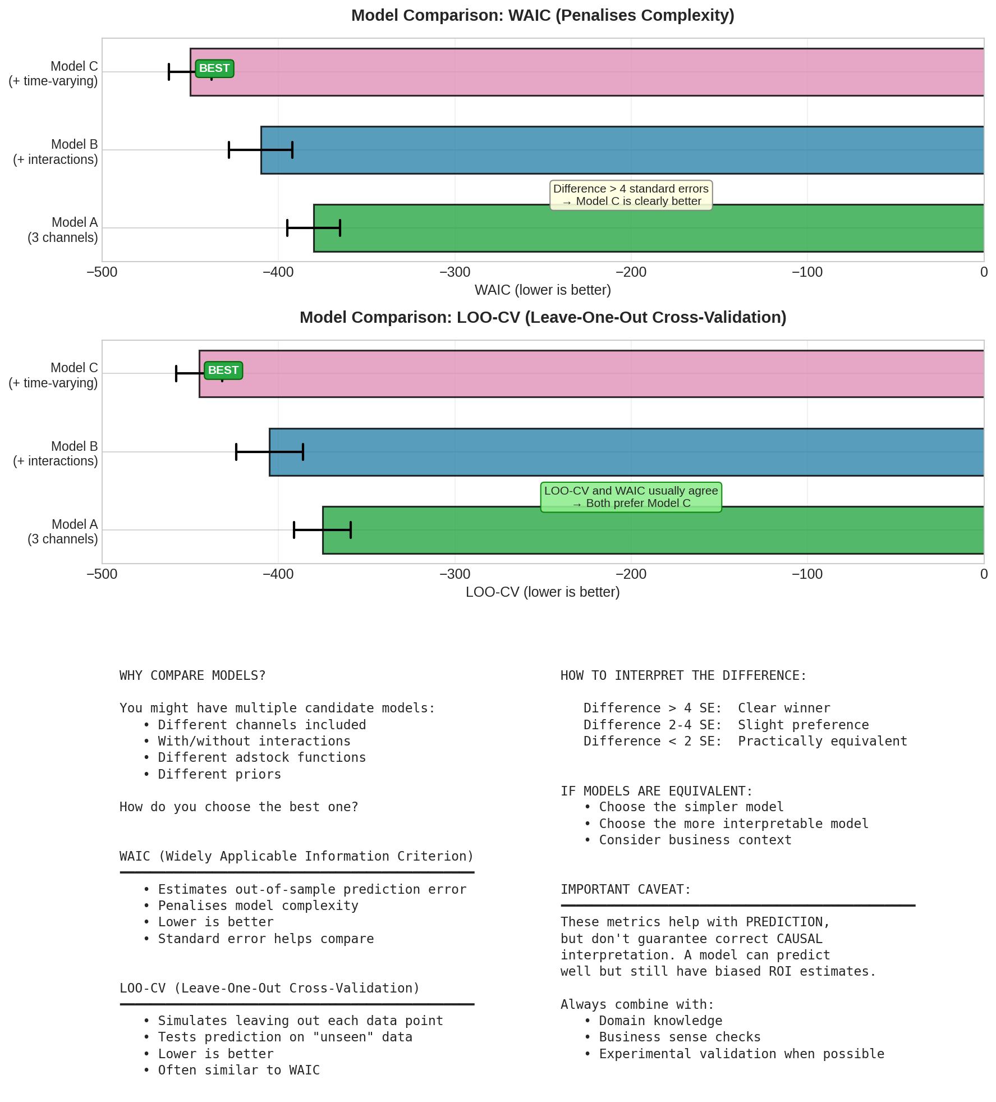

Figure 23: Model comparison using WAIC and LOO-CV

## The Problem: Why Not Just Use R-squared?

R-squared measures how well your model fits the data you have. But there is a critical flaw: R-squared ALWAYS improves as you add more parameters, even if those parameters just capture noise.

**Example:**

* Model A (simple): 5 parameters, R² = 0.85
* Model B (complex): 15 parameters, R² = 0.92

Model B fits better, but is it actually better? It might be overfitting - memorising the training data rather than learning the true patterns. When you use Model B to predict new data, it might perform worse than Model A.

**What we really want:**

A metric that estimates how well the model will predict NEW, UNSEEN data. This is called 'out-of-sample predictive performance'. Both WAIC and LOO estimate this without requiring you to hold out data.

## The Key Concept: Expected Log Predictive Density (ELPD)

Both WAIC and LOO estimate something called ELPD. Understanding ELPD helps you interpret these metrics correctly.

### What ELPD Measures

ELPD answers the question: 'If I use this model to predict new data from the same process, how good will those predictions be on average?'

**More technically:**

For each potential new observation, the model assigns a probability (actually a probability density). ELPD is the average log of these probabilities across all possible new observations.

### Why 'Log' Probability?

* Probabilities are between 0 and 1, which makes them hard to work with
* Log probabilities are negative numbers (log of something < 1 is negative)
* Higher (less negative) log probability = better prediction
* Logs turn multiplication into addition, which is mathematically convenient

**Example:**

Suppose your model predicts next week's sales will be around £2M with some uncertainty. If actual sales turn out to be £2.1M:

* If your prediction was confident and centred near £2.1M → high probability density → high log probability → good
* If your prediction was uncertain (wide distribution) → moderate probability density → moderate log probability
* If your prediction was confident but centred at £1.5M → low probability density → very negative log probability → bad

### Why ELPD Matters for Model Comparison

A model with higher ELPD makes better predictions. When comparing models:

* Model A: ELPD = -250 (less negative = better)
* Model B: ELPD = -275 (more negative = worse)

Model A is expected to predict new data better than Model B.

## Understanding WAIC (Widely Applicable Information Criterion)

### What WAIC Does

WAIC estimates ELPD using only your fitted model and training data. It does this by:

1. Measuring how well the model predicts the training data (goodness of fit)
2. Subtracting a penalty for model complexity (to avoid rewarding overfitting)

### The Complexity Penalty: Why It Works

This is the clever part. WAIC estimates 'effective number of parameters' by looking at how much the model's predictions vary across different posterior samples.

**Intuition:**

If a parameter is well-constrained by the data, it takes similar values across all posterior samples, and predictions do not vary much. This parameter is 'using' the data efficiently.

If a parameter is poorly constrained (maybe it is just fitting noise), it varies a lot across posterior samples, and predictions vary too. This parameter is 'overfitting' to the particular training data.

WAIC penalises this overfitting by measuring how much predictions vary and treating that as the 'effective' complexity.

### The WAIC Formula

WAIC = -2 × (lppd - p_waic)

Where:

* lppd = log pointwise predictive density (goodness of fit)
* p_waic = effective number of parameters (complexity penalty)
* The -2 scaling puts it on the 'deviance' scale (convention from AIC/BIC)

### Why 'Widely Applicable'?

Unlike older criteria (AIC, BIC), WAIC:

* Does NOT assume the posterior is normally distributed
* Does NOT require knowing the 'true' number of parameters
* Works for hierarchical models where parameter counting is ambiguous
* Works for any model where you can compute posterior predictions

This makes WAIC suitable for the complex Bayesian models used in MMM.

### Interpreting WAIC Values

* WAIC is on the deviance scale: LOWER is BETTER (more negative ELPD × -2 = lower WAIC)
* The absolute number is meaningless - only DIFFERENCES between models matter
* WAIC comes with a standard error (SE) to assess uncertainty
* A difference of 10 with SE of 3 is meaningful; a difference of 10 with SE of 15 is not

## Understanding LOO-CV (Leave-One-Out Cross-Validation)

### The Gold Standard: True Cross-Validation

The most honest way to measure out-of-sample performance is actual cross-validation:

1. Remove one data point
2. Fit the model on the remaining N-1 points
3. Predict the held-out point
4. Measure how good that prediction was
5. Repeat for all N points
6. Average the results

This directly measures what we care about: how well does the model predict data it has not seen?

### The Problem: Computational Cost

For Bayesian models, fitting takes time. If you have 150 weeks of data and each model takes 5 minutes to fit:

150 models × 5 minutes = 750 minutes = 12.5 hours

And that is just for ONE model specification. If you want to compare 5 different models, you need 62.5 hours of computation. This is impractical.

### The Solution: PSIS-LOO (Pareto Smoothed Importance Sampling LOO)

PSIS-LOO is a clever approximation that gives you LOO results without refitting the model N times. It works by reweighting your existing posterior samples.

**The key insight:**

When you remove one data point, the posterior changes, but usually not by much. The 'new' posterior (without that point) is similar to the 'old' posterior (with all points). We can approximate the new posterior by reweighting samples from the old posterior.

### How Importance Sampling Works

Imagine you have 4,000 posterior samples from your full model. To approximate 'what if we had not seen data point i':

1. Calculate how much each posterior sample 'relies on' data point i
2. Samples that relied heavily on point i get downweighted
3. Samples that barely used point i keep their weight
4. Use these reweighted samples to predict point i

The 'Pareto Smoothed' part stabilises these weights when they become extreme, making the approximation more reliable.

### Pareto k Diagnostics: When to Trust LOO

LOO provides a diagnostic called 'Pareto k' for each data point. This tells you how reliable the importance sampling approximation is:

* k < 0.5: GOOD. The approximation is reliable. This point is 'typical' and removing it does not change the posterior much.
* k = 0.5-0.7: OKAY. Slight concern but usually acceptable. The point has some influence.
* k > 0.7: WARNING. The approximation is unreliable for this point. It is highly influential - removing it would substantially change the posterior.
* k > 1.0: PROBLEM. The importance sampling has broken down. The variance is infinite.

**What high Pareto k values mean:**

Points with high k are 'influential observations' - they have outsized impact on your model. This could be:

* Outliers (unusually high or low sales weeks)
* Data errors (typos, missing data coded as zero)
* Real events your model cannot explain (competitor launch, PR crisis)
* Model misspecification (wrong functional form)

**Action steps:**

If more than 10% of points have k > 0.7:

1. Investigate those specific data points - are they real or errors?
2. Consider whether your model is missing important variables
3. Try a more robust model specification
4. As a last resort, use WAIC instead (but understand LOO is warning you about something)

### Interpreting LOO Values

* LOO reports ELPD directly: HIGHER (less negative) is BETTER
* Can also be reported as -2 × ELPD (like WAIC): then LOWER is BETTER
* Comes with standard errors for proper comparison
* The Pareto k diagnostics are a major advantage over WAIC

## WAIC vs LOO: Which Should You Use?

Both methods estimate the same thing (ELPD) and usually give very similar answers. However, there are important differences:

### Advantages of LOO

* Pareto k diagnostics identify influential observations
* More robust when the posterior is not well-behaved
* Better theoretical properties (asymptotically exact)
* Widely recommended in modern Bayesian literature

### Advantages of WAIC

* Slightly faster to compute
* No Pareto k warnings to interpret
* More established in some fields (easier to explain to reviewers)

### Recommendation

Use LOO (specifically PSIS-LOO) as your default. The Pareto k diagnostics alone make it worth the slightly extra computation. Only fall back to WAIC if:

* LOO has too many high Pareto k values (and you have investigated them)
* You need to match methodology in a specific field
* Computation time is critical and you have verified LOO and WAIC agree

## Practical Guide: Interpreting Model Comparison Results

### Step 1: Check Diagnostics First

Before comparing ELPD values, check that LOO is reliable:

# In Python with ArviZ

loo_result = az.loo(trace, pointwise=True)

print(loo_result) # Shows count of high-k observations

If many points have k > 0.7, investigate before trusting the comparison.

### Step 2: Compare ELPD Differences

The difference in ELPD between models is what matters, not the absolute values.

Model A: ELPD = -245.3 (SE = 12.1)

Model B: ELPD = -238.7 (SE = 11.8)

Difference: 6.6 in favour of Model B

### Step 3: Assess Statistical Significance

ArviZ computes the SE of the difference directly. Divide difference by SE:

SE of difference ≈ 5.2

Z-score = 6.6 / 5.2 = 1.27

A z-score < 2 means the difference is not statistically significant at conventional levels.

### Rules of Thumb for ELPD Differences

* Difference > 10 AND z-score > 2: Strong evidence for better model
* Difference 5-10 AND z-score > 2: Moderate evidence
* Difference 2-5 OR z-score 1-2: Weak evidence, slight preference
* Difference < 2 OR z-score < 1: Models are practically equivalent

### Step 4: When Models Are Equivalent

If WAIC/LOO cannot distinguish models statistically:

* Prefer the simpler model (Occam's Razor)
* Prefer the model with better interpretability
* Prefer the model that aligns better with domain knowledge
* Consider which model stakeholders will trust more

## Worked Example: Choosing Adstock Specification

You are building an MMM and want to decide between adstock specifications:

Model A: Geometric adstock for all channels

Model B: Weibull adstock for TV, geometric for others

Model C: Weibull adstock for all channels

You fit all three and compute LOO:

Model A: ELPD = -245.3 (SE = 12.1), 2 high-k points

Model B: ELPD = -241.8 (SE = 11.9), 1 high-k point

Model C: ELPD = -240.9 (SE = 12.3), 4 high-k points

**Analysis:**

* Model C has best ELPD but more high-k points - the LOO estimate is less reliable
* Model B vs A: Difference = 3.5, SE of difference ≈ 4.2, z = 0.83 (not significant)
* Model C vs B: Difference = 0.9 (practically identical)
* Model B has fewest high-k points (most reliable estimate)

**Decision:**

Choose Model B (Weibull for TV only). Reasoning:

* Similar predictive performance to C but simpler
* Better than A (even if not statistically significant, the direction is right)
* TV is the channel most likely to have delayed peak effects (Weibull makes sense)
* Fewest influential observations (most robust estimates)

## Common Mistakes to Avoid

### Mistake 1: Ignoring Standard Errors

A difference of 5 ELPD points means nothing if the SE is 10. Always check statistical significance.

### Mistake 2: Over-Interpreting Small Differences

If two models have ELPD within 2-3 points, they are effectively equivalent. Do not chase tiny improvements.

### Mistake 3: Ignoring Pareto k Warnings

High Pareto k values are a gift - they tell you which data points are problematic. Investigate them.

### Mistake 4: Using WAIC/LOO as the Only Criterion

These metrics measure prediction, not causal validity. A model can predict well while being causally wrong. Combine with domain expertise and experimental validation.

## What WAIC and LOO Do NOT Tell You

|  |
| --- |
| **WARNING:** WAIC and LOO measure PREDICTIVE performance, not CAUSAL validity. A model can predict well while getting the causal relationships completely wrong. For example, if TV and search always move together, a model might attribute all effect to search (easier to fit) and predict just as well. Always combine statistical model comparison with: (1) prior predictive checks, (2) posterior predictive checks, (3) domain expertise validation, and (4) comparison with experimental results where available. |

## Python Implementation

import arviz as az

# Fit your models (trace_a, trace_b, trace_c)

# ...

# Calculate LOO for each model

loo_a = az.loo(trace_a, pointwise=True) # pointwise gives Pareto k

loo_b = az.loo(trace_b, pointwise=True)

# Check Pareto k diagnostics

print(loo_a) # Shows number of high-k observations

# Compare models

comparison = az.compare({

'geometric': trace_a,

'weibull_tv': trace_b,

'weibull_all': trace_c

})

print(comparison)

# Visualise comparison

az.plot_compare(comparison)

|  |
| --- |
| **KEY INSIGHT: PRACTICAL TIP**  Run az.loo() with pointwise=True and check the Pareto k values. If more than 10% of observations have k > 0.7, investigate those data points. They might be outliers, data errors, or events your model cannot explain (like a major competitor launch). |

# Chapter 25b: Commercial Evaluation

Statistical validation is necessary but not sufficient. Your model must also make business sense.

## Why Commercial Evaluation Matters

A model can pass all statistical tests but still be wrong. It might predict well in-sample while having incorrect causal interpretations. Commercial evaluation is your final sanity check.

## Key Questions to Ask

### Do the Results Match Business Intuition?

* Are the relative ROIs between channels plausible?
* Does the baseline level make sense for your business?
* Are the seasonal patterns what you would expect?

### Are Response Curves Sensible?

* Do they show diminishing returns (they should)?
* Are saturation points realistic?
* Are any channels showing unexpected shapes (linear when should be curved)?

### Do Results Align with Known Facts?

* Do results match any experiments you have run?
* Are channels you know to be effective showing up as effective?
* Are channels you have doubts about showing appropriate uncertainty?

### What Do Stakeholders Think?

* Present preliminary results to marketing and finance teams
* Ask: 'Does anything surprise you here?'
* Surprise is not bad, but it should trigger investigation

## Common Red Flags

* ROI > 10x for any channel: Very rare in practice, check for data leakage
* TV showing no effect: TV usually has some effect, check adstock settings
* Search ROI lower than other channels: Search often has highest ROI, investigate
* Baseline < 30% of sales: Usually baseline is 50-80%, check model specification

|  |
| --- |
| **KEY INSIGHT: THE FINAL TEST**  Show results to someone who knows the business but was not involved in the modelling. If they say 'that cannot be right' about multiple findings, go back and investigate. |

**PART VIII**

POST-MODELLING ANALYSIS

# Chapter 26: Extracting Response Curves

Response curves are your primary tool for understanding channel effectiveness. They answer the fundamental question: 'If I spend X dollars on this channel, how much incremental sales will I get?'

## What Is a Response Curve?

A response curve is a graph showing the relationship between spend and sales contribution for a single channel. The x-axis shows spend levels (from zero to high spend), and the y-axis shows the incremental sales generated.

Key features of a response curve:

* It starts at zero: Zero spend means zero contribution from that channel
* It curves upward: More spend generates more sales, but at a decreasing rate
* It flattens: At high spend levels, additional spend yields diminishing returns
* It has a maximum: There is only so much a channel can contribute

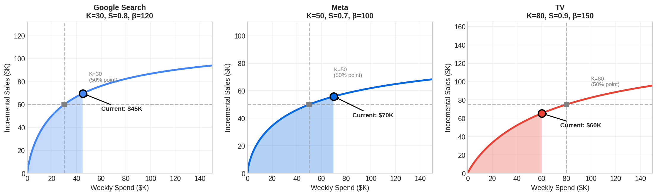

Figure 24: Response curves by channel showing current spend and saturation

## How to Read a Response Curve

Let us walk through how to interpret a response curve step by step:

**Step 1: Find your current spend**

Look for the vertical line or marker showing your current weekly spend. This tells you where you are operating today.

**Step 2: Check your position on the curve**

Is your current spend on the steep part of the curve (left side) or the flat part (right side)?

* Steep part: You have room to grow. Additional spend will be efficient.
* Flat part: You are saturated. Additional spend will yield little return.

**Step 3: Estimate potential gains**

To see what happens if you increase spend, move right along the curve. The additional height is your incremental gain. If the curve is flat, the gain is small.

**Step 4: Compare across channels**

Look at response curves for all channels side by side. Which channels still have steep curves? Those are candidates for increased investment.

## Why Response Curves Have Uncertainty

Remember, we are using Bayesian methods. We do not get a single response curve; we get a DISTRIBUTION of possible curves.

This happens because:

* The media coefficient (beta) has uncertainty
* The saturation parameter K has uncertainty
* The shape parameter S has uncertainty

Each combination of these parameters gives a different curve. When we show all possible curves, we see a band of uncertainty.

## How to Extract Response Curves from Your Model

Since we have parameter DISTRIBUTIONS (not point estimates), we get a DISTRIBUTION of curves:

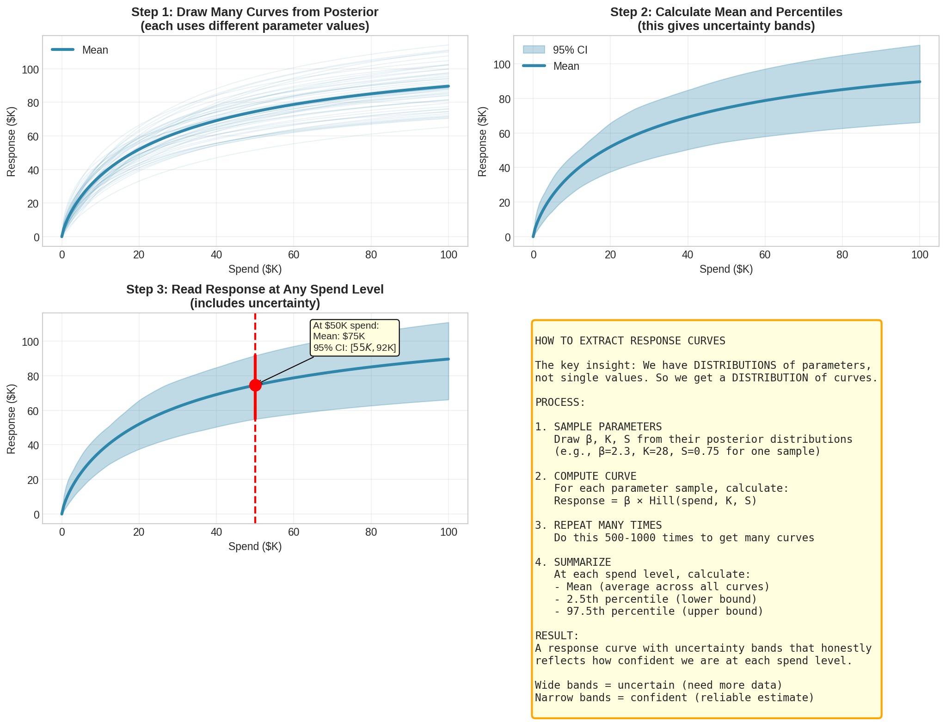

Figure 25: Step-by-step process for extracting response curves with uncertainty

**The process:**

1. Take one sample from the posterior (specific values for beta, K, S)
2. Compute the response curve using those parameters
3. Repeat for many samples (500-1000 times)
4. At each spend level, calculate the mean and percentiles

The result is a curve with uncertainty bands. The middle line is your best estimate. The bands show the range of plausible values.

## Interpreting Uncertainty Bands

Wide bands mean: The model is unsure about this channel's effectiveness. Be cautious about major decisions.

Narrow bands mean: The model is confident. You can trust these estimates more.

Bands that overlap between channels: You cannot be sure which channel is better.

## Common Patterns and What They Mean

**Pattern 1: Steep curve that flattens quickly**

Interpretation: Channel is efficient at low spend but saturates fast. Good for targeted campaigns.

Example: Branded search often shows this pattern.

**Pattern 2: Gradual curve that stays steep longer**

Interpretation: Channel can absorb more spend before saturating. Good for scaling.

Example: Television often shows this pattern.

**Pattern 3: Very flat curve**

Interpretation: Channel may be oversaturated or ineffective. Consider reducing spend.

**Pattern 4: Curve with very wide uncertainty**

Interpretation: Not enough data or too much noise. Consider running experiments to validate.

# Chapter 27: Marginal ROI

Average ROI tells you what happened in the past. Marginal ROI tells you what WILL happen if you spend more. This distinction is crucial for budget decisions.

## Understanding the Difference

### Average ROI: Looking Backward

Average ROI answers: 'Overall, how much return did we get on our total spend?'

**Average ROI = Total Contribution / Total Spend**

Example: You spent $1 million on Google and generated $2.5 million in incremental sales. Average ROI = 2.5.

This is useful for understanding historical performance, but it can be misleading for future decisions.

### Marginal ROI: Looking Forward

Marginal ROI answers: 'If I spend ONE MORE dollar, how much additional sales will I get?'

**Marginal ROI = Additional Sales / Additional Spend**

This is what actually matters for decisions, because you are deciding about FUTURE spend, not past spend.

## Why They Differ: A Detailed Example

Imagine a channel with diminishing returns. Let us trace through what happens:

**At $100K spend:**

* Cumulative contribution: $300K
* Average ROI: $300K / $100K = 3.0
* Marginal ROI (for next $10K): $25K / $10K = 2.5

**At $200K spend:**

* Cumulative contribution: $500K
* Average ROI: $500K / $200K = 2.5
* Marginal ROI (for next $10K): $15K / $10K = 1.5

**At $300K spend:**

* Cumulative contribution: $620K
* Average ROI: $620K / $300K = 2.1
* Marginal ROI (for next $10K): $8K / $10K = 0.8

Notice how marginal ROI declines faster than average ROI. At $300K spend, average ROI (2.1) looks healthy, but marginal ROI (0.8) tells you the next dollar is barely profitable!

## Why Marginal ROI Matters More for Decisions

Consider this real scenario:

* Channel A: Spent $1M, generated $2M. Average ROI = 2.0
* But Channel A is highly saturated. Marginal ROI = 0.8
* Channel B: Spent $0.5M, generated $0.8M. Average ROI = 1.6
* But Channel B has headroom. Marginal ROI = 2.5

Which channel should get more budget? Channel B!

Despite lower average ROI, Channel B will generate more incremental sales per dollar. This is the key insight that many marketers miss when they focus only on average ROI.

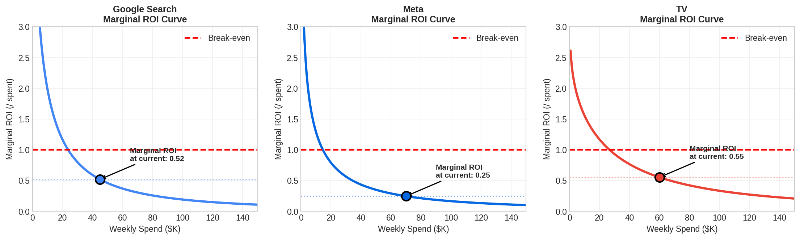

Figure 26: Marginal ROI curves showing diminishing returns

## How to Calculate Marginal ROI

Mathematically, marginal ROI is the derivative (slope) of the response curve at your current spend level.

For the Hill function, the formula is:

**Marginal = beta * S * K^S * x^(S-1) / (K^S + x^S)^2**

You do not need to compute this by hand. Your modelling tool will calculate it.

**What matters is understanding the intuition:**

* Marginal ROI is always highest at low spend (steep part of curve)
* Marginal ROI declines as spend increases (curve flattens)
* Marginal ROI approaches zero at very high spend (fully saturated)

## The Key Insight for Optimisation

|  |
| --- |
| **KEY INSIGHT: THE OPTIMISATION PRINCIPLE**  Optimal budget allocation equalises marginal ROI across all channels. If one channel has higher marginal ROI than another, you should shift budget to it until the marginals equalise. |

Think of it like water finding its level. Budget should 'flow' from saturated channels (low marginal ROI) to unsaturated channels (high marginal ROI) until all channels have the same marginal return.

## Presenting Marginal ROI to Stakeholders

When communicating with non-technical audiences:

* Avoid the term 'marginal' (it sounds like 'small'). Say 'incremental ROI' instead.
* Explain: 'This is the return on the NEXT dollar, not the past spend.'
* Show visually: 'We are here on the curve. Moving right means diminishing returns.'
* Connect to action: 'Channel X has higher incremental ROI, so we recommend shifting budget there.'

# Chapter 28: Budget Optimisation

This is where MMM becomes truly actionable. Budget optimisation uses everything we have learned to answer: 'How should we allocate our marketing budget to maximise sales?'

## The Optimisation Problem

We want to find the best allocation of a fixed total budget across channels. Mathematically:

**Maximise: Total Sales = sum of response(spend_i) for all channels**

**Subject to: sum of spend_i = Total Budget**

In plain English: Find the spend levels for each channel that together produce the most sales, while spending exactly our budget (no more, no less).

## The Solution: Equalise Marginal ROI

The optimal allocation has a beautiful property: at the optimum, marginal ROI is equal across all channels.

**Why? Consider this logic:**

1. Suppose Google has marginal ROI of 3.0 and Facebook has marginal ROI of 1.5
2. This means the next dollar on Google generates $3, while on Facebook it generates $1.50
3. We should shift $1 from Facebook to Google
4. This gains us $3 - $1.50 = $1.50 in incremental sales
5. Keep shifting until marginal ROIs are equal

When marginal ROIs are equal, there is no further improvement possible. You have found the optimum.

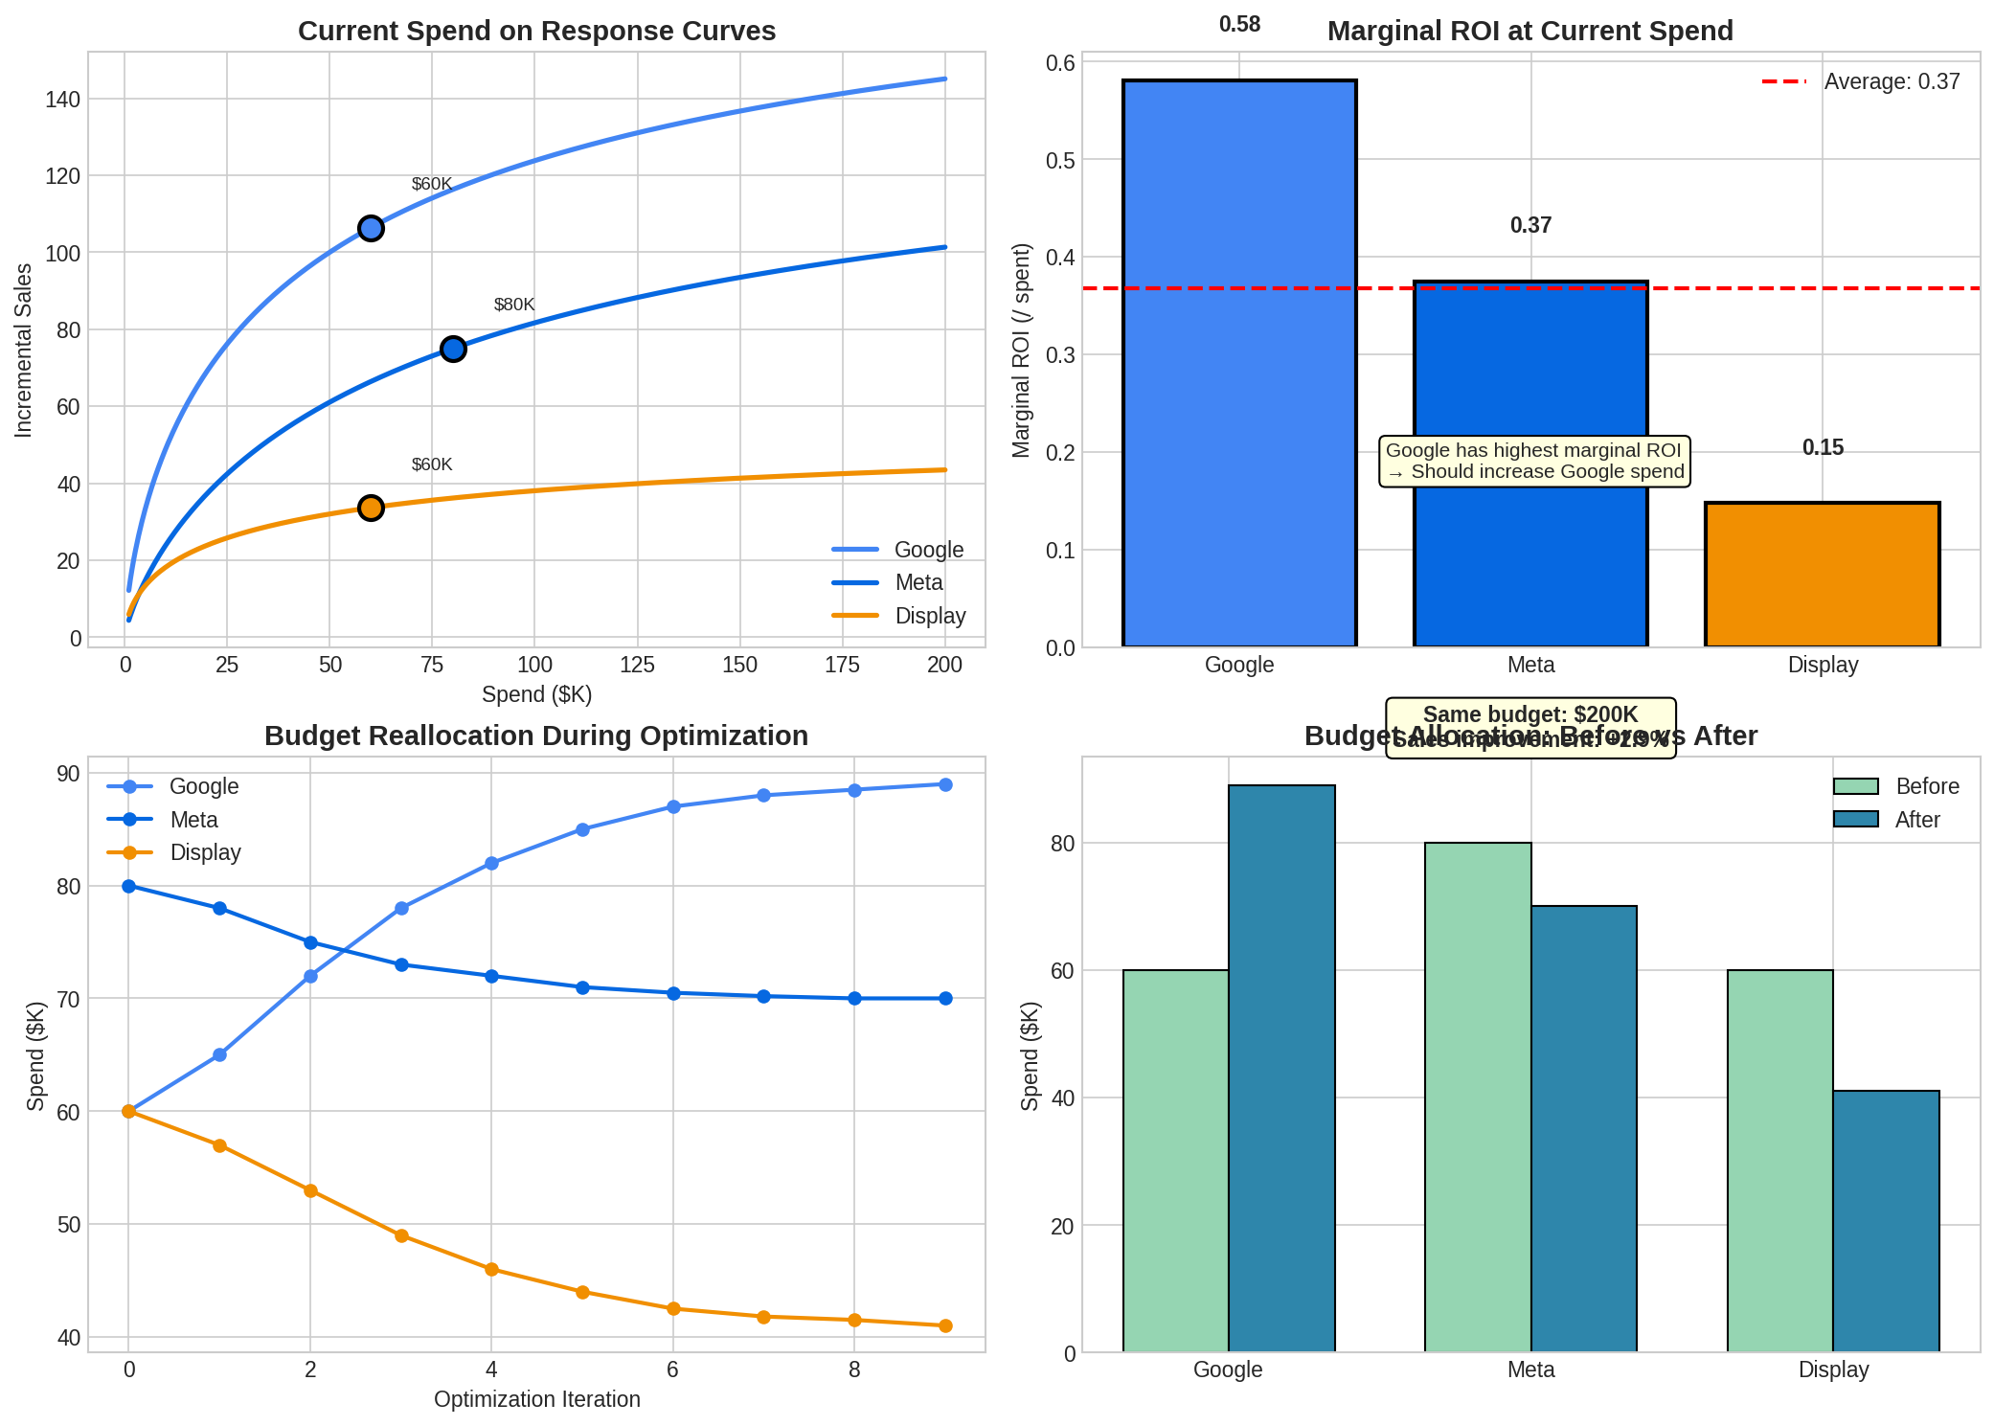

Figure 27: Budget optimisation through marginal ROI equalisation

## Step-by-Step Optimisation Process

**Step 1: Extract current marginal ROIs**

Using your fitted model, calculate the marginal ROI for each channel at current spend levels. This tells you which channels have headroom and which are saturated.

**Step 2: Identify reallocation opportunities**

Channels with HIGH marginal ROI: Candidates for increased spend

Channels with LOW marginal ROI: Candidates for decreased spend

Large gaps in marginal ROI indicate large potential gains from reallocation.

**Step 3: Run the optimiser**

Use numerical optimisation (your tool will do this) to find the allocation that maximises total contribution subject to budget constraints. The algorithm iteratively shifts budget until marginal ROIs equalise.

**Step 4: Review the results**

The optimiser will suggest new spend levels for each channel. Compare to your current allocation. Large shifts may require scrutiny.

**Step 5: Apply constraints and judgement**

Pure optimisation often suggests extreme shifts. Apply business constraints and common sense before implementing.

## Real-World Constraints

Pure mathematical optimisation rarely works in practice. You need to incorporate business reality:

### Minimum Spend Constraints

* Contractual commitments: You may have minimum spend agreements with partners
* Relationship maintenance: Cannot zero out a channel without consequences
* Testing requirements: Need some spend to continue learning

### Maximum Spend Constraints

* Channel capacity: Some channels cannot absorb unlimited budget
* Inventory limits: Only so much premium ad inventory available
* Creative constraints: Cannot scale spend without more creative

### Strategic Constraints

* Brand presence: May need presence in certain channels for strategic reasons
* New channel testing: Reserve budget for experimentation
* Risk limits: Avoid over-concentrating in any single channel

## A Worked Example

**Current allocation (total budget: $100K/week):**

* Google: $30K (marginal ROI = 2.8)
* Facebook: $40K (marginal ROI = 1.4)
* TV: $30K (marginal ROI = 2.2)

Observation: Google has highest marginal ROI, Facebook has lowest. We should shift from Facebook to Google.

**Optimised allocation:**

* Google: $45K (marginal ROI = 1.9)
* Facebook: $25K (marginal ROI = 1.9)
* TV: $30K (marginal ROI = 1.9)

After reallocation, marginal ROIs are equalised at 1.9. Expected improvement: +8% total contribution.

## How to Present Optimisation Results

When presenting to stakeholders, include:

* Current vs recommended allocation: Show the shift clearly
* Expected improvement: Quantify the gain (with uncertainty range)
* Marginal ROI comparison: Explain WHY the shift makes sense
* Constraints applied: Note any minimum/maximum bounds used
* Sensitivity analysis: How much does the answer change with different assumptions?
* Implementation plan: Suggest phased approach, not instant shift

## Important Caveats

|  |
| --- |
| **WARNING:** Never implement large budget shifts without validation. The model has uncertainty. Start with small shifts (10-20%), measure actual results, then scale up if validated. |

Additional cautions:

* Optimisation assumes the model is correct. If the model is wrong, the optimisation will be wrong.
* Historical relationships may not hold at very different spend levels.
* Competitive response is not modelled. If you cut TV, competitors may fill the gap.
* Long-term effects may differ from short-term effects captured by MMM.

## Common Mistakes When Optimising

Avoid these pitfalls that derail many optimisation projects:

### Mistake 1: Ignoring Uncertainty

Optimising to point estimates ignores that your model has uncertainty. The 'optimal' allocation based on mean estimates might be suboptimal considering uncertainty bands.

Solution: Run optimisation across multiple posterior samples and report the range of recommendations.

### Mistake 2: Extrapolating Beyond Data

If you have never spent more than £50K/week on a channel, the model's prediction at £100K is pure extrapolation.

Solution: Constrain optimisation to spend ranges you have actually observed (or close to them).

### Mistake 3: Ignoring Fixed Costs

MMM typically models variable effects. But channels have fixed costs (creative production, agency fees) that affect true ROI.

Solution: Include fixed costs in your total cost calculation when computing actual ROI.

### Mistake 4: Annual Planning with Weekly Models

MMM is estimated on weekly data but budgets are often annual. Seasonal effects mean optimal weekly allocation varies throughout the year.

Solution: Optimise separately for different seasons, or use time-varying optimisation.

### Mistake 5: Recommending 100% Shifts

Never recommend completely zeroing out a channel or doubling spend overnight.

Solution: Apply business constraints and phase shifts gradually (10-20% per period).

# Chapter 29: Long-term vs Short-term Effects

Standard MMM captures short-term effects. But advertising can have long-term effects too.

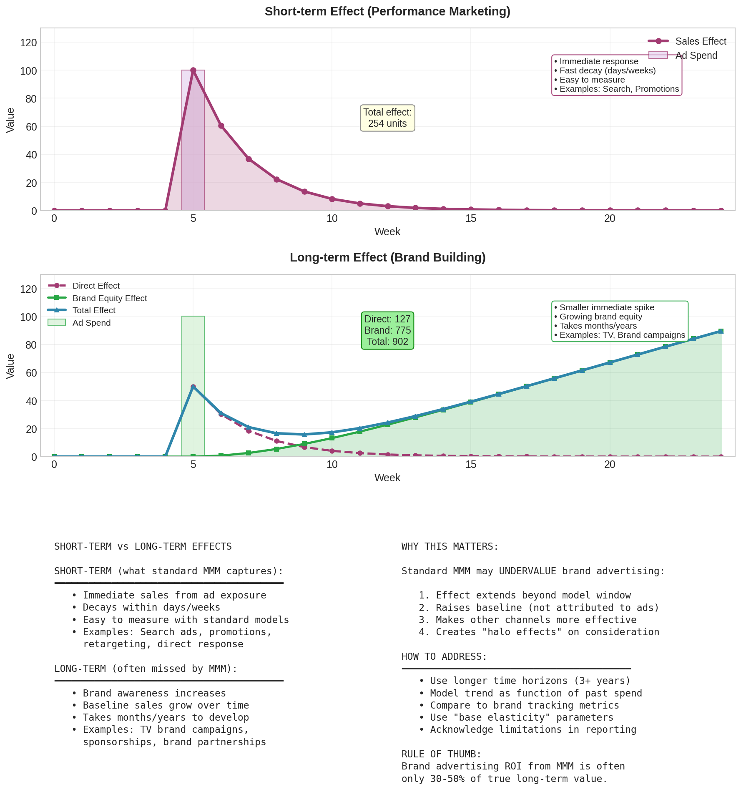

Figure 28: Short-term performance effects vs long-term brand building

## Short-term Effects (What Standard MMM Captures)

* Immediate sales from ad exposure
* Decays within days or weeks
* Examples: Search ads, promotional advertising

## Long-term Effects (Often Missed)

* Brand awareness increases
* Baseline sales grow over time
* Takes months or years to develop
* Examples: TV brand campaigns, sponsorships

## Why This Matters

Standard MMM may undervalue brand advertising because:

* Long-term effects extend beyond the model window
* Effects on baseline are not attributed to advertising
* Synergies with future campaigns are not captured

## How to Address

* Use longer time horizons (3+ years)
* Model trend as a function of past advertising
* Compare to brand tracking metrics
* Acknowledge limitations in reporting

|  |
| --- |
| **KEY INSIGHT: RULE OF THUMB**  Brand advertising ROI from standard MMM is often 30-50% of true long-term value. Adjust expectations accordingly. |

# Chapter 29b: Additional Metrics Beyond ROI

While ROI is the most common metric, there are several other useful ways to express marketing effectiveness.

## CPA: Cost Per Acquisition

CPA answers: 'How much did it cost to acquire one customer/conversion?'

**CPA = Total Spend / Number of Conversions**

CPA is the inverse perspective of ROI. Instead of asking 'how much did I earn?', it asks 'how much did I spend?'

### When to Use CPA

* Customer acquisition businesses (D2C, subscriptions)
* Lead generation campaigns
* When you have target CPA thresholds from finance
* When comparing to industry benchmarks

### CPA from MMM

# Calculate CPA from model results

incremental_conversions = model_contribution / avg_order_value

cpa = channel_spend / incremental_conversions

## Incremental Revenue

The total additional revenue generated by a channel:

**Incremental Revenue = Total Contribution (£)**

This is simply the contribution figure from your model, expressed in currency.

## Effectiveness

Effectiveness measures the impact relative to spend:

**Effectiveness = Incremental Revenue / Total Spend**

This is equivalent to ROI. An effectiveness of 2.5 means you generated £2.50 for every £1 spent.

## Efficiency

Efficiency measures the conversion rate of spend to revenue:

**Efficiency = Incremental Revenue / (Incremental Revenue + Spend)**

An efficiency of 0.7 means 70% of total value created went to revenue, 30% was the cost.

## Marginal CPA

Just as marginal ROI looks forward, marginal CPA asks: 'What would it cost to acquire one MORE customer?'

At low spend, marginal CPA is low. As the channel saturates, marginal CPA increases.

|  |
| --- |
| **KEY INSIGHT: CHOOSING METRICS**  Use ROI for general effectiveness comparisons. Use CPA when you have specific acquisition cost targets. Use incremental revenue when communicating absolute impact to finance teams. |

**PART IX**

INCREMENTALITY AND CALIBRATION

# Chapter 30: Incrementality Testing

MMM uses correlation to ESTIMATE causation. Experiments PROVE causation. This chapter explains how to use experiments alongside MMM.

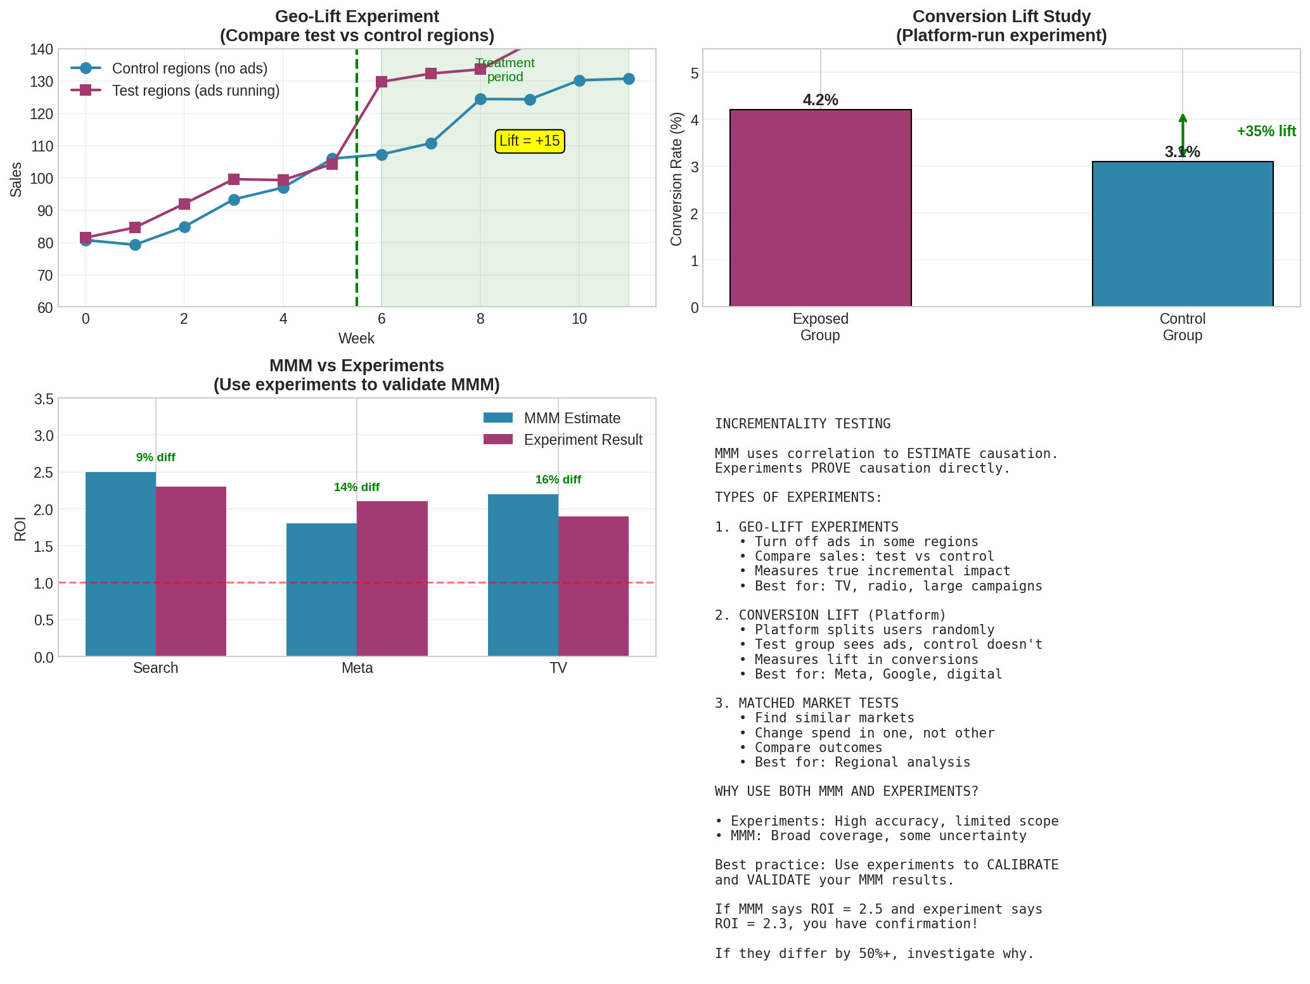

Figure 29: Types of incrementality tests and their relationship to MMM

## Types of Experiments

### Geo-Lift Experiments

Turn off advertising in some geographic regions. Compare sales to control regions.

* Pros: Measures true incremental impact across all conversions
* Cons: Requires turning off ads (lost revenue), takes weeks to run
* Best for: TV, radio, large digital campaigns

### Conversion Lift (Platform-Run)

The platform (Meta, Google) randomly splits users. Test group sees ads; control group does not.

* Pros: Easy to run, randomised
* Cons: Only measures digital, only platform conversions
* Best for: Meta, Google campaigns

### Matched Market Tests

Find similar markets. Change spend in one, keep the other constant.

* Pros: More natural than blackout
* Cons: Markets are never perfectly matched
* Best for: Regional analysis

## Using Experiments to Validate MMM

Run an experiment on a channel. Compare:

* Experiment result: 'True' incremental effect
* MMM estimate: Model-based estimate

If they agree (within reasonable bounds), you have validation.

If they disagree significantly, investigate why.

## Using Lift Tests to Calibrate MMM: The Key Technique

This is one of the most powerful techniques in modern MMM practice. The idea is to use experimental results as PRIORS in your Bayesian model, grounding your MMM in causal truth.

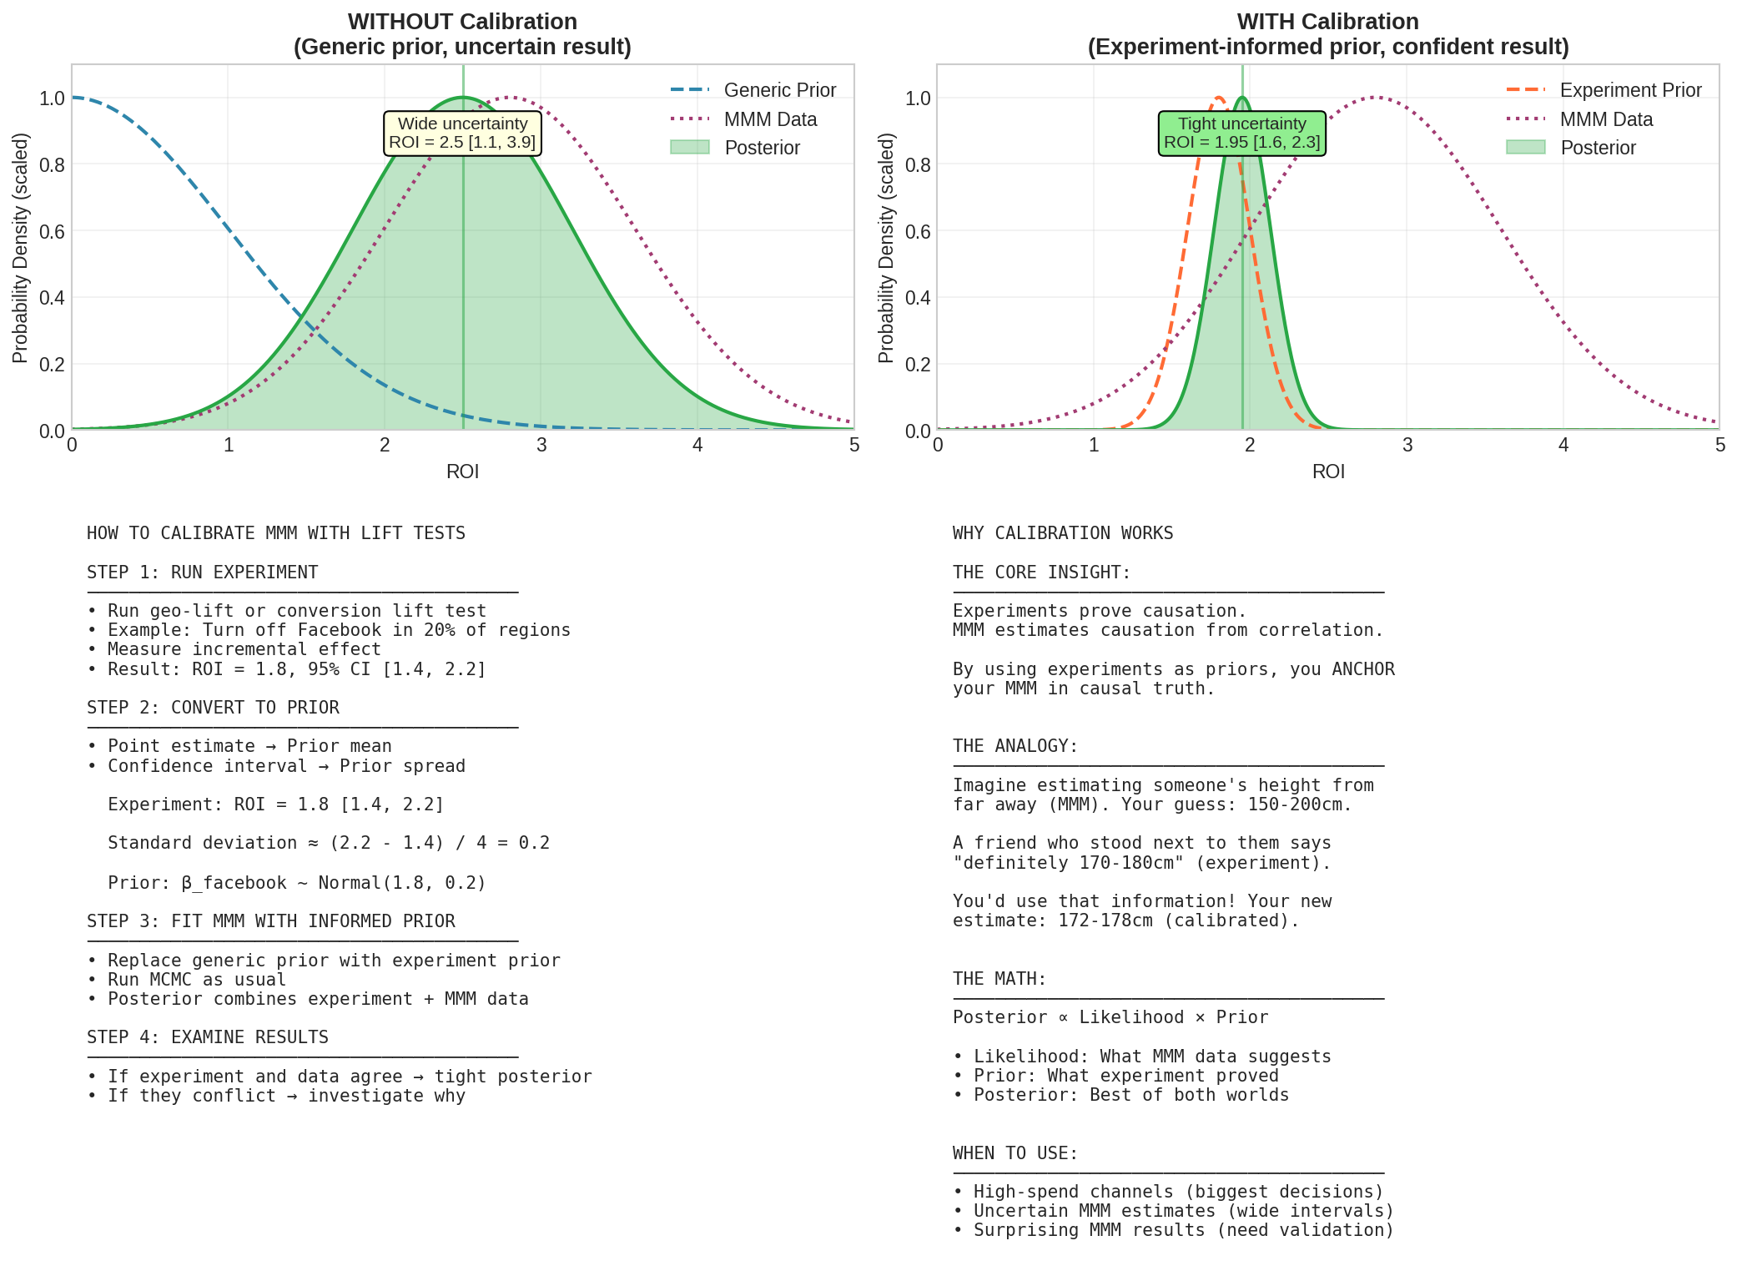

Figure 30: How calibration with lift tests improves MMM precision and reliability

### Why Calibrate with Experiments?

MMM has a fundamental limitation: it relies on correlation patterns in observational data. Even with good modelling practices, there is always some uncertainty about whether we have captured true causal effects or just correlations.

Experiments, by contrast, establish causation directly through randomisation. When you turn off ads in randomly selected regions and see sales drop, you KNOW the ads were causing those sales.

The insight: Why not combine the strengths of both approaches?

* Experiments give us causal truth, but only for specific channels at specific times
* MMM gives us broad coverage across all channels and time periods, but with more uncertainty
* By using experiments to inform MMM priors, we get the best of both worlds

### The Intuition: Anchoring Your Model in Reality

Think of it like this: Imagine you are trying to estimate someone's height, but you can only see them from far away (your MMM data). Your estimate might be reasonable, but it has uncertainty.

Now imagine a friend who stood next to them tells you 'they are definitely between 170 and 180 cm' (your experiment). You would not ignore this information! You would use it to anchor your estimate.

That is exactly what calibration does. The experiment 'anchors' your MMM estimate in a known range, reducing the chance of wildly wrong results.

### How It Works: Step by Step

**Step 1: Run a well-designed experiment**

Run a geo-lift test or conversion lift study on a channel. For example, turn off Facebook ads in 20% of regions for 4 weeks.

Result: You measure that Facebook drives incremental ROI of 1.8, with a confidence interval of 1.4 to 2.2.

**Step 2: Convert experiment results to a prior distribution**

Translate the experimental result into a probability distribution:

* The experiment's point estimate (1.8) becomes the prior mean
* The experiment's confidence interval determines the prior's spread

# Experiment result: ROI = 1.8, 95% CI [1.4, 2.2]

# This means standard deviation is approximately (2.2 - 1.4) / 4 = 0.2

# So our prior is:

beta_facebook ~ Normal(1.8, 0.2)

**Step 3: Use this as your prior in the MMM**

Instead of using a generic weakly informative prior like HalfNormal(1), you use the experiment-informed prior. The model now 'knows' that Facebook ROI should be around 1.8.

**Step 4: Fit the model and examine the posterior**

The posterior will be a combination of your experimental prior and what the MMM data suggests. If the MMM data agrees with the experiment, the posterior will be tight around 1.8. If the data suggests something different, the posterior will be a compromise.

### A Concrete Example

Suppose you have two scenarios:

**Scenario A: No calibration (generic prior)**

beta_facebook ~ HalfNormal(1.0) # Generic prior

# MMM data suggests ROI could be anywhere from 0.5 to 4.0

# Posterior: ROI = 2.5 [0.8, 4.2] # Wide uncertainty

**Scenario B: With calibration (experiment-informed prior)**

beta_facebook ~ Normal(1.8, 0.2) # Informed by lift test

# MMM data still suggests the same patterns

# Posterior: ROI = 1.9 [1.5, 2.3] # Much tighter, anchored by experiment

The calibrated model gives you a much more precise and trustworthy estimate.

### What If the Experiment and MMM Data Disagree?

This is actually valuable information! If your experiment says ROI is 1.8 but your MMM data strongly suggests 3.5, something is wrong. Possible causes:

* The experiment was flawed (contamination, wrong holdout period)
* The MMM is missing important variables
* Market conditions changed between experiment and MMM period
* There are interaction effects the experiment did not capture

In Bayesian terms, when prior and data conflict strongly, the posterior will be a compromise, and the model may show signs of poor fit. This is a signal to investigate, not to ignore.

### How Tight Should the Experimental Prior Be?

This is a judgement call:

* Very tight prior (small sigma): You trust the experiment strongly. MMM data will barely move the estimate.
* Moderate prior: You trust the experiment but allow MMM data to refine it.
* Loose prior: You use the experiment as a general guide but let MMM data dominate.

Rule of thumb: If your experiment was well-designed and recent, use a tighter prior. If it was small, old, or had issues, use a looser prior.

### Which Channels to Calibrate

You cannot run experiments on every channel. Prioritise:

* Largest spend channels (biggest impact on budget decisions)
* Channels with most uncertainty in MMM (widest credible intervals)
* Channels where MMM results seem surprising

|  |
| --- |
| **KEY INSIGHT: THE POWER OF CALIBRATION**  A calibrated MMM combines the causal rigour of experiments with the comprehensive coverage of modelling. Many practitioners consider calibration essential for any MMM that will drive significant budget decisions. |

**PART X**

COMMON PITFALLS

# Chapter 31: Common Mistakes and How to Avoid Them

Years of MMM practice have revealed recurring pitfalls. Learn from others' mistakes.

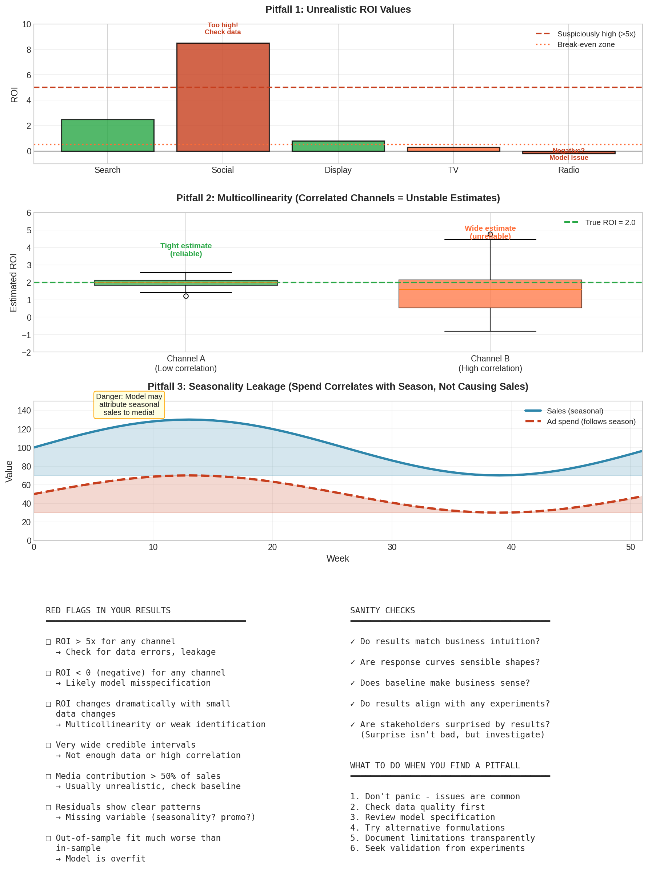

Figure 31: Common pitfalls in MMM and how to identify them

## Pitfall 1: Unrealistic ROI Estimates

### Symptom

ROI of 8x or higher for some channels. Or negative ROI.

### Causes

* Data errors (wrong units, missing data)
* Seasonality leaking into media effects
* Multicollinearity making estimates unstable
* Model misspecification

### Solution

* Sanity check: Is this ROI plausible given industry benchmarks?
* Check data carefully for errors
* Ensure seasonality is properly modeled
* Examine correlation matrix

## Pitfall 2: Seasonality Leakage

### Symptom

Channels that spike during peak season show unrealistically high ROI.

### Cause

If advertising spend follows seasonality and seasonality is not modeled, the model attributes seasonal sales to advertising.

### Solution

Always include proper seasonality modelling. Check if channel coefficients change significantly when you add/remove seasonality terms.

## Pitfall 3: Overfitting

### Symptom

Great in-sample fit but poor out-of-sample predictions.

### Cause

Too many parameters relative to data. Model memorises noise.

### Solution

* Use regularising priors
* Reduce model complexity
* Always check out-of-sample performance

## Pitfall 4: Ignoring Uncertainty

### Symptom

Reporting ROI as '2.47' without any range.

### Cause

Treating point estimates as truth. Ignoring credible intervals.

### Solution

Always report uncertainty: 'ROI is estimated at 2.5, with 95% probability between 1.8 and 3.1.'

## Pitfall 5: Not Validating with Experiments

### Symptom

Making major budget decisions based solely on MMM.

### Cause

Over-confidence in model. Not testing assumptions.

### Solution

Run incrementality tests to validate key findings before major budget shifts.

# Chapter 32: Troubleshooting Guide

When things go wrong, use this reference.

## Problem: Model Will Not Converge

Symptoms: R-hat > 1.05, chains at different values

Try:

1. Increase warmup iterations (tune parameter)
2. Increase target_accept to 0.95 or 0.99
3. Simplify model (fewer channels, simpler priors)
4. Check for data issues (extreme values, missing data)
5. Reparameterise problematic parameters

## Problem: Very Wide Credible Intervals

Symptoms: ROI could be anywhere from 0.5 to 5.0

Try:

1. Check for multicollinearity between channels
2. Add more data if possible
3. Use more informative priors based on domain knowledge or experiments
4. Consider combining correlated channels

## Problem: ROI Estimates Seem Wrong

Symptoms: Values that contradict business intuition or experiments

Try:

1. Check data quality (units, missing values, outliers)
2. Ensure seasonality is properly modeled
3. Check for omitted variables (promotions, distribution)
4. Compare to external benchmarks
5. Run sensitivity analysis

## Problem: Poor Out-of-Sample Performance

Symptoms: Holdout MAPE much worse than in-sample

Try:

1. Simplify model (fewer parameters)
2. Use stronger regularising priors
3. Check for structural breaks in data
4. Ensure no data leakage in preprocessing

## Problem: Residuals Show Patterns

Symptoms: Waves or trends in residual plot

Try:

1. Add more Fourier terms for seasonality
2. Check for missing control variables
3. Add holiday indicators
4. Check for trend changes

**PART XI**

DEPLOYMENT AND COMMUNICATION

# Chapter 33: Communicating Results to Stakeholders

The best model in the world is useless if you cannot communicate its findings effectively.

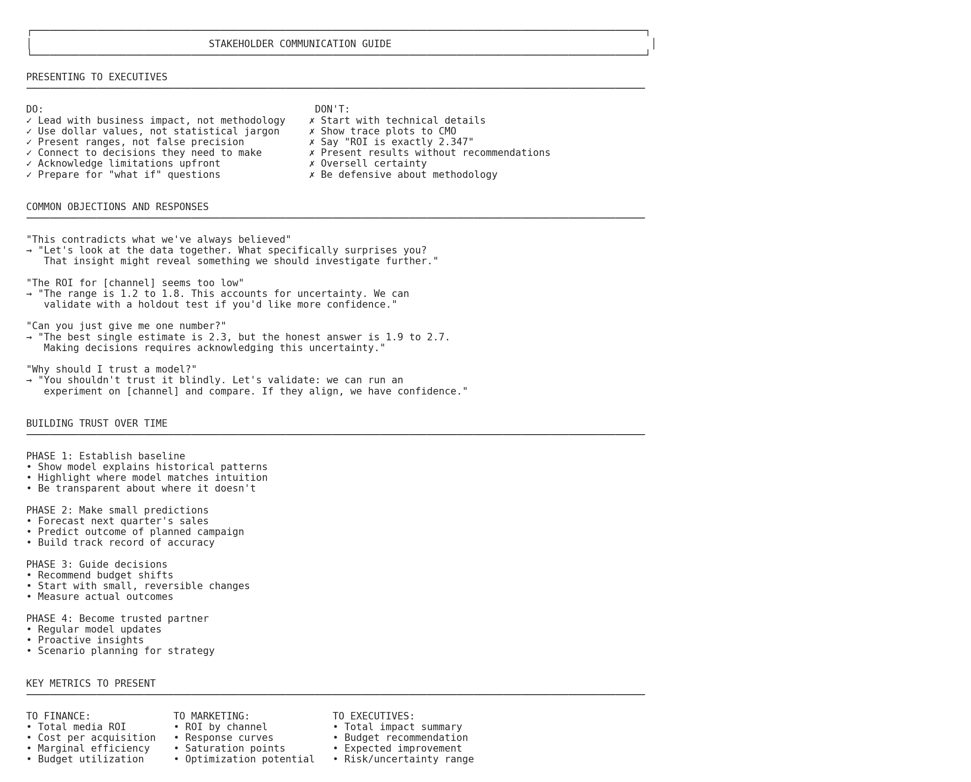

Figure 32: Guide to stakeholder communication

## Know Your Audience

### For Executives

* Lead with business impact, not methodology
* Use dollar values, not statistical jargon
* Present ranges, not false precision
* Connect to decisions they need to make

### For Finance

* Focus on ROI and efficiency metrics
* Show cost-per-acquisition
* Demonstrate budget optimisation
* Compare to historical benchmarks

### For Marketing

* Show response curves by channel
* Explain saturation points
* Provide optimisation recommendations
* Include creative and tactical implications

## Handling Common Objections

### 'This contradicts what we have always believed'

Response: 'Let us look at the data together. What specifically surprises you? That insight might reveal something we should investigate further.'

### 'The ROI for [channel] seems too low'

Response: 'The range is X to Y, accounting for uncertainty. We can validate with a holdout test if you would like more confidence.'

### 'Can you just give me one number?'

Response: 'The best single estimate is X, but the honest answer is a range from Y to Z. Making good decisions requires acknowledging this uncertainty.'

## Building Trust Over Time

1. Start by showing the model explains historical patterns
2. Make small predictions and track accuracy
3. Guide small, reversible decisions
4. Build a track record before major recommendations

## Reporting Best Practices

### Dynamic Dashboards Are Essential

Static PowerPoint presentations are no longer sufficient. Marketing leaders need real-time insights accessible through dynamic dashboards that allow them to:

* Dive deep into the data and inspect specific metrics
* Slice and dice results by region, time period, or segment
* Run their own scenarios and what-if analyses
* Adapt presentations to different internal audiences

The final presentation should focus on insights and recommendations, while dashboards provide the supporting detail.

### Tell a Story

Data alone is not enough. People connect with stories, not spreadsheets. Your presentation should:

* Have a clear narrative arc: situation, complication, resolution
* Lead with the insight, not the methodology
* Be concise enough for anyone to explain the key takeaways
* Connect findings to actions stakeholders can take

### Tailor to Your Audience

Senior executives care about different things than analysts. Two-thirds of CEOs have ignored data-driven insights that contradicted their intuition. To build trust:

* Share preliminary results early with business stakeholders
* Ensure results are plausible before the final presentation
* If results surprise, investigate before presenting
* Use the iterative process: check, refine, validate, present

|  |
| --- |
| **KEY INSIGHT: THE ITERATION RULE**  We recommend three iterations before the final presentation: (1) Share initial findings, get feedback (2) Refine model based on input (3) Present final results to a pre-aligned audience. |

# Chapter 33b: Forecasting and Simulation

MMM is not just about understanding the past - it enables you to predict outcomes for different budgeting scenarios.

## What Is MMM Forecasting?

Forecasting (also called 'What-If' analysis or simulation) uses your fitted model to predict what would happen under different scenarios. Given a proposed media plan, what sales can you expect?

## The Forecasting Process

* Choose the validated model with best predictive accuracy
* Define the scenario: What spend levels for each channel?
* Apply the same transformations used in modelling (adstock, saturation)
* Use the estimated coefficients to predict outcomes
* Calculate confidence intervals around the prediction

## Types of Scenarios

### Budget Reallocation

Keep total budget constant, shift between channels. Compare predicted outcomes to current allocation.

### Budget Increase/Decrease

What happens if total budget increases by 20%? Decreases by 10%? The model shows expected impact.

### Channel Addition/Removal

What if you add a new channel? What if you completely cut one? Forecasting quantifies the expected impact.

### Seasonal Planning

How should budget vary across seasons? Forecast outcomes for different seasonal weightings.

## Forecasting Example

A D2C brand wants to double their paid search spend. The forecasting process:

1. Current search spend: £50K/week → £100K/week
2. Apply adstock transformation to the new spend series
3. Apply saturation function (note: doubling spend does NOT double effect)
4. Multiply transformed spend by the search coefficient
5. Add contributions from other channels (unchanged) and baseline
6. Result: Expected subscription increase of 35% (not 100%)

The gap between 100% spend increase and 35% outcome increase reflects diminishing returns.

## Forecast Uncertainty

|  |
| --- |
| **WARNING:** Every forecast has uncertainty. Report ranges, not point estimates. If the model predicts 10,000 conversions, the honest answer might be '8,500-11,500 with 90% probability'. |

## Common Forecasting Mistakes

* Extrapolating far beyond historical spend ranges
* Ignoring uncertainty in the forecast
* Assuming linear relationships when the model is non-linear
* Forgetting to apply transformations to new data
* Treating forecasts as guarantees rather than estimates

# Chapter 34: Model Maintenance

An MMM is not a one-time project. It needs ongoing care.

## When to Refresh Your Model

* Quarterly: Update with new data, rerun estimation
* After major changes: New channels, new products, market shifts
* When predictions diverge: Model no longer matches reality

## What to Check During Refresh

* Convergence: Does model still converge properly?
* Stability: Are coefficients similar to last run?
* Fit: Is predictive performance maintained?
* Sanity: Do results still make business sense?

## Versioning and Documentation

Keep records of:

* Model specification (what variables, what priors)
* Data sources and preprocessing steps
* Results and key findings
* Decisions made based on the model
* Any anomalies or concerns

## When to Rebuild From Scratch

* Major business model change
* Significant market disruption (COVID-level)
* New data sources that change everything
* Accumulated drift makes patching insufficient

**PART XII**

THE COMPLETE WORKFLOW

# Chapter 35: End-to-End MMM Process

This chapter synthesises everything into a complete workflow. Use this as your roadmap for any MMM project.

A typical MMM project takes 4-8 weeks depending on data availability and complexity. Here is what each phase involves:

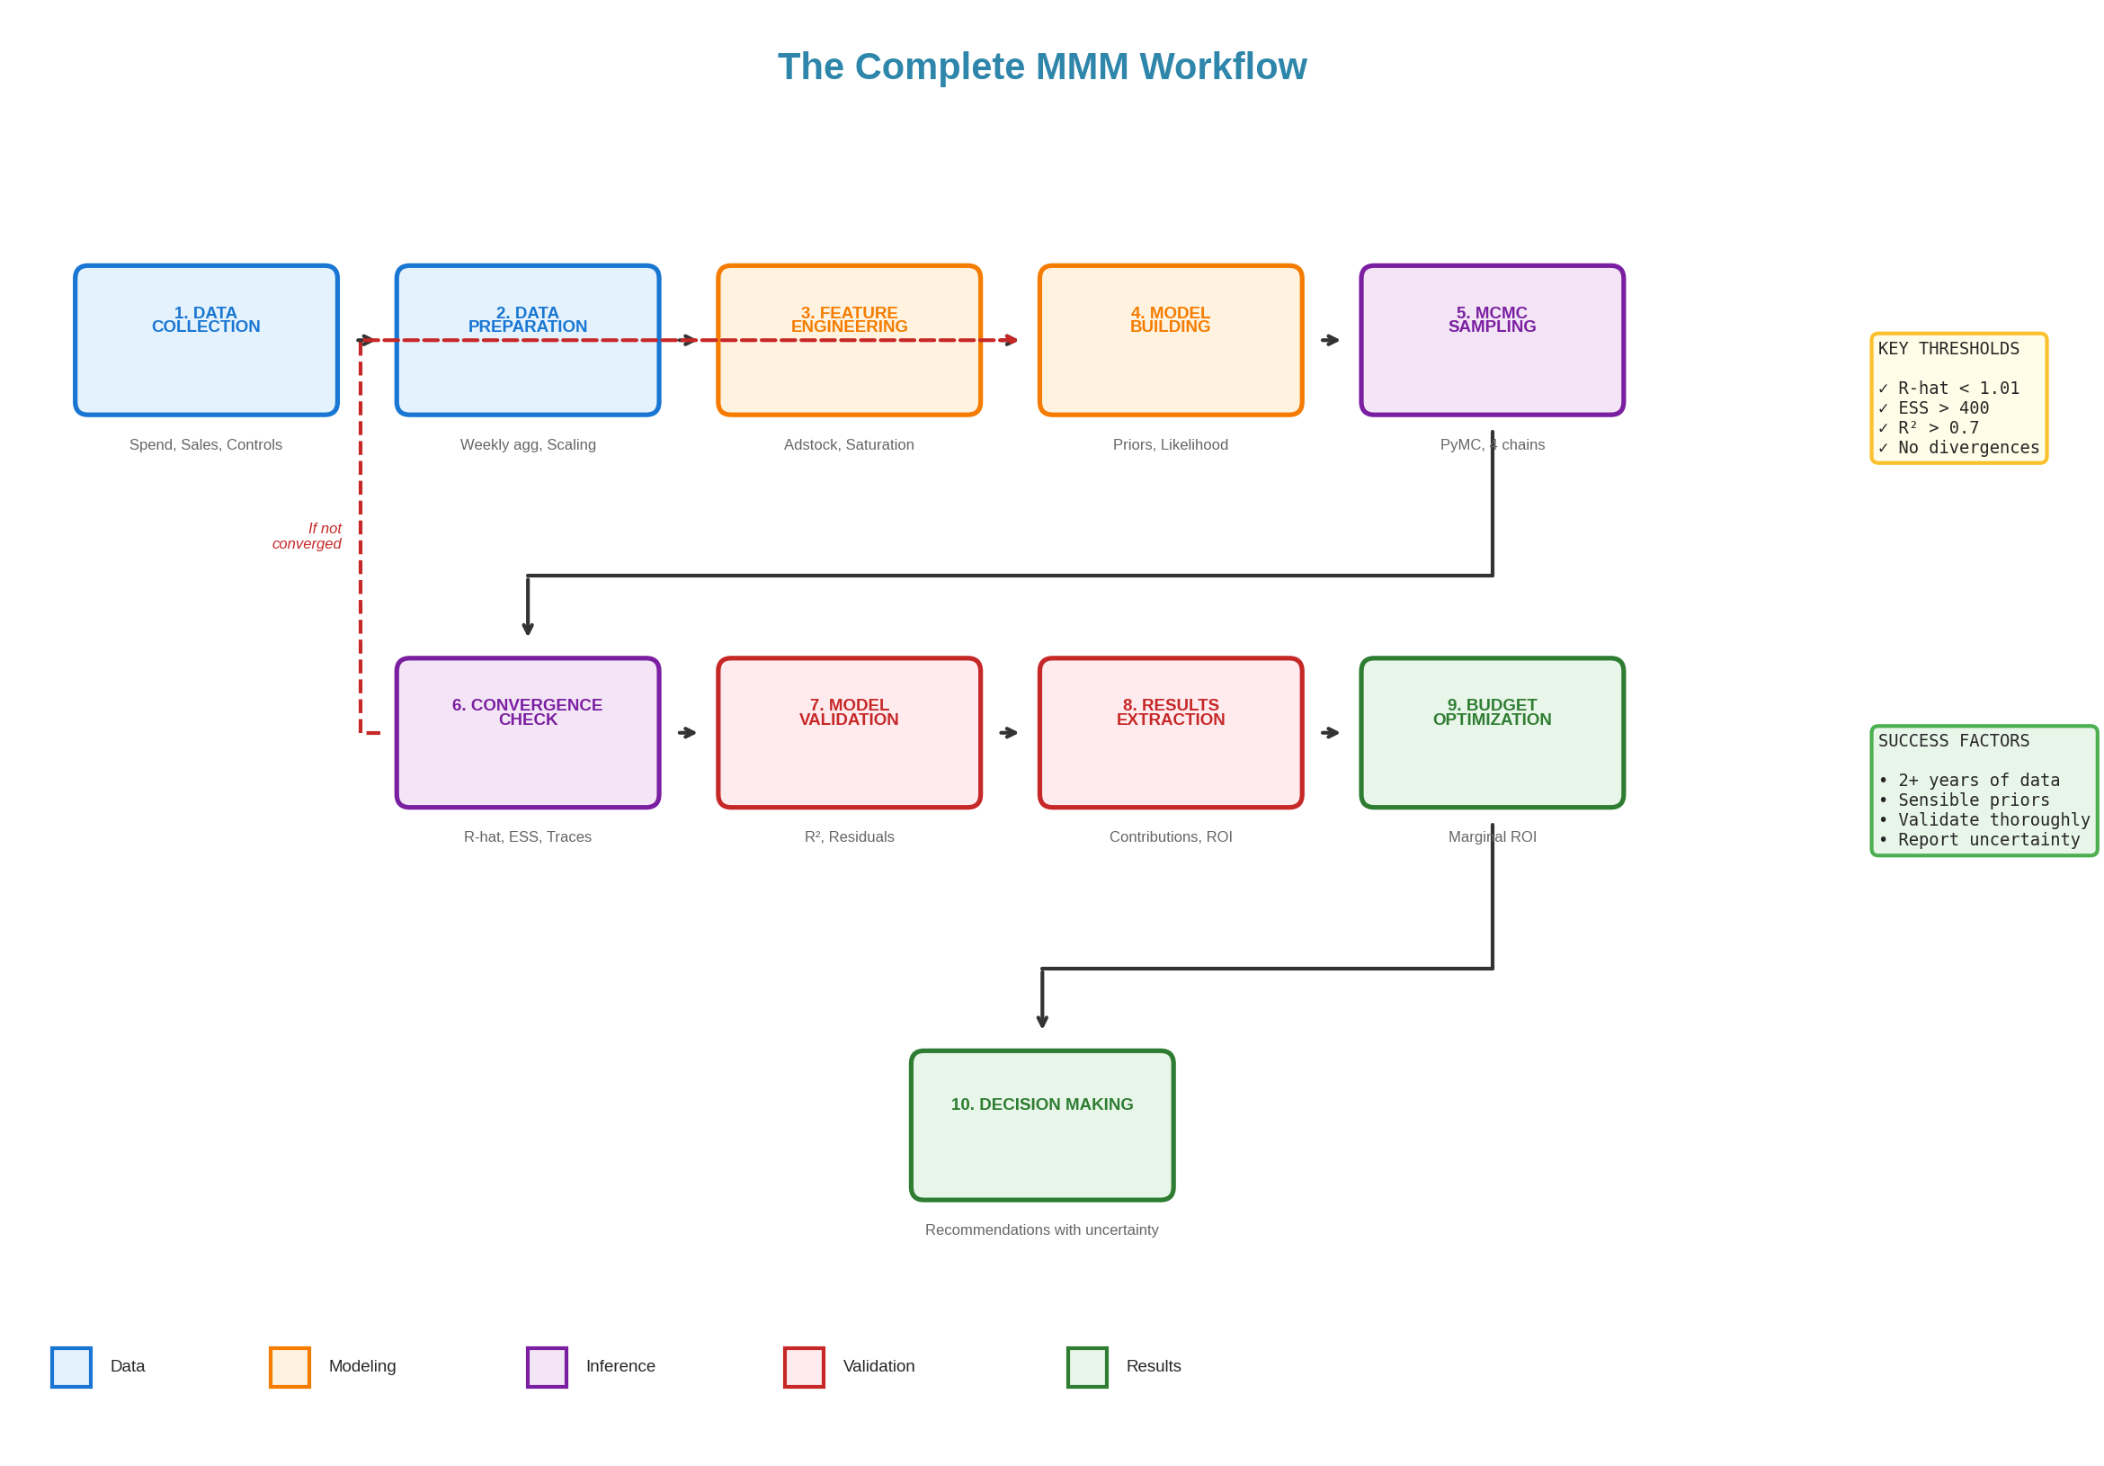

Figure 33: The complete MMM workflow from data to decisions

## Phase 1: Data Collection and Preparation (1-2 weeks)

This phase often takes the longest. Good data is the foundation of everything that follows.

* Gather outcome data (sales, conversions)
* Gather media spend data by channel
* Gather control variables (promotions, distribution, etc.)
* Align all data to same frequency and time period
* Handle missing values and outliers
* Scale variables for modelling
* Create derived features (Fourier, holidays, trend)
* Check correlation matrix

Do not rush this phase. Problems here will haunt you throughout the project.

## Phase 2: Model Building (3-5 days)

Translate your business understanding into a statistical model.

* Specify prior distributions based on domain knowledge
* Define adstock transformation per channel
* Define saturation function
* Include seasonality terms
* Include control variables
* Write model code

Start simple. You can always add complexity later.

## Phase 3: Model Fitting (1-3 days)

Run the MCMC sampler and verify it worked correctly.

* Run MCMC with 4 chains
* Monitor for warnings
* Check convergence (R-hat < 1.01, ESS > 400)
* Inspect trace plots
* If problems, adjust and rerun

Convergence problems are common. Be patient and methodical in diagnosing them.

## Phase 4: Validation (2-3 days)

Verify the model is trustworthy before using it for decisions.

* Check in-sample fit (R-squared, MAPE)
* Examine residuals for patterns
* Run out-of-sample validation
* Perform posterior predictive checks
* Run sensitivity analyses
* Sanity check results against intuition

If validation fails, go back to Phase 2 and revise the model.

## 

## Phase 5: Analysis and Reporting (2-3 days)

Extract insights and prepare for stakeholder communication.

* Extract response curves with uncertainty
* Calculate ROI by channel with credible intervals
* Compute marginal ROI at current spend
* Run budget optimisation scenarios
* Prepare stakeholder presentation

Remember to communicate uncertainty, not just point estimates.

## Phase 6: Implementation and Monitoring (ongoing)

The model is only valuable if it drives real decisions.

* Present findings with appropriate uncertainty
* Propose changes based on model
* Implement changes incrementally
* Monitor actual results
* Compare to model predictions
* Plan model refresh

MMM is not a one-time project. Plan to refresh quarterly or when major changes occur.

**APPENDICES**

# Appendix A: MMM Tool Comparison

Several open-source tools are available for MMM. Here is a comparison to help you choose.

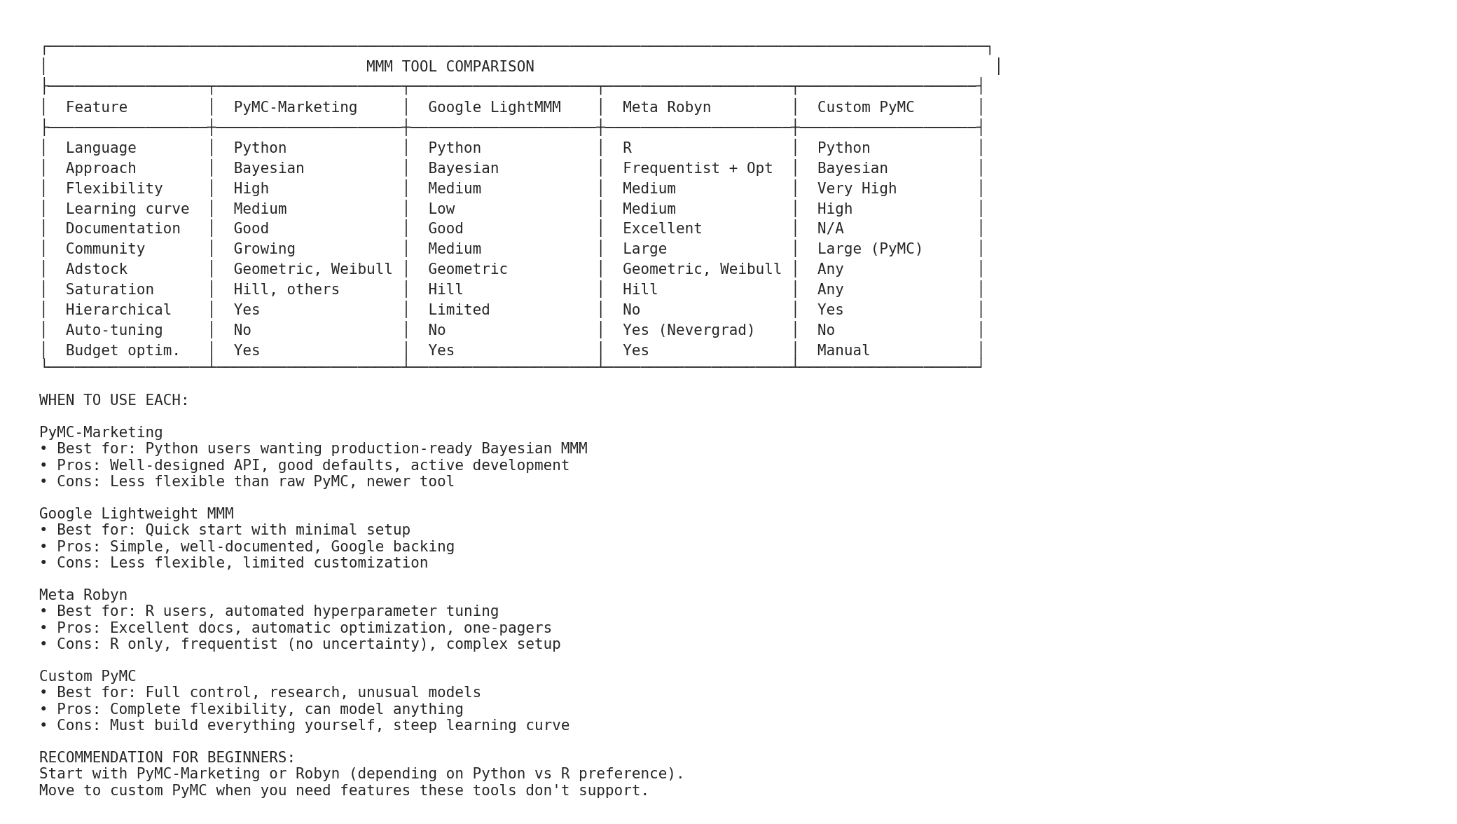

Figure 34: Comparison of popular MMM tools

## PyMC-Marketing

* Language: Python
* Approach: Bayesian (PyMC backend)
* Best for: Python users wanting production-ready Bayesian MMM
* Pros: Well-designed API, good defaults, active development
* Cons: Newer tool, less community history

## Google Lightweight MMM

* Language: Python
* Approach: Bayesian
* Best for: Quick start with minimal setup
* Pros: Simple, well-documented, Google backing
* Cons: Less flexible, limited customisation

## Meta Robyn

* Language: R
* Approach: Frequentist with optimisation
* Best for: R users, automated hyperparameter tuning
* Pros: Excellent documentation, automatic optimisation, one-pagers
* Cons: R only, no uncertainty quantification, complex setup

## Custom PyMC

* Language: Python
* Approach: Bayesian (build your own)
* Best for: Full control, research, unusual models
* Pros: Complete flexibility
* Cons: Must build everything yourself

## Recommendation for Beginners

Start with PyMC-Marketing if you use Python, or Robyn if you use R. Move to custom PyMC when you need features these tools do not support.

# Appendix B: Mathematical Reference

## The Hill Function

f(x) = x^S / (K^S + x^S)

Derivative (marginal response):

f'(x) = S * K^S * x^(S-1) / (K^S + x^S)^2

## Geometric Adstock

Adstock(t) = Spend(t) + lambda * Adstock(t-1)

With lag:

Adstock(t) = Spend(t - lag) + lambda * Adstock(t-1)

Half-life = log(0.5) / log(lambda)

## Fourier Features

sin_k(t) = sin(2 * pi * k * t / P)

cos_k(t) = cos(2 * pi * k * t / P)

For k = 1, 2, ..., K harmonics

Period P = 52 for weekly data with annual seasonality

## Bayes' Theorem

P(theta | data) = P(data | theta) * P(theta) / P(data)

Posterior = Likelihood * Prior / Evidence

In practice: Posterior is proportional to Likelihood * Prior

## R-hat (Gelman-Rubin)

R-hat = sqrt(V-hat / W)

Where:

W = within-chain variance

V-hat = pooled variance estimate

R-hat near 1 indicates convergence

# Appendix C: Glossary

* Adstock: Transformation modelling how advertising effects accumulate and decay over time
* Average ROI: Total contribution divided by total spend
* Baseline: Sales that would occur without any marketing
* Bayesian inference: Statistical approach using prior knowledge combined with data
* Carryover: Persistence of advertising effects beyond the exposure period
* Convergence: State where MCMC chains have found the posterior distribution
* Credible interval: Bayesian range that contains the true value with stated probability
* Decay rate (lambda): Parameter controlling how quickly advertising effects fade
* Diminishing returns: Decreasing incremental impact as spend increases
* ESS: Effective Sample Size, number of independent samples in MCMC output
* Fourier features: Sine and cosine terms used to model seasonality
* Half-life: Time for advertising effect to decay to 50%
* Hill function: Mathematical function modelling saturation
* Incrementality: Causal impact that would not have happened without intervention
* Lag: Delay before advertising effects begin
* Likelihood: Probability of observed data given parameter values
* LOO-CV: Leave-One-Out Cross-Validation for model comparison
* Marginal ROI: Return on the next dollar spent
* MCMC: Markov Chain Monte Carlo, algorithm for Bayesian inference
* Multicollinearity: High correlation between predictor variables
* Posterior: Parameter distribution after observing data
* Prior: Parameter distribution before observing data
* R-hat: Convergence diagnostic comparing chains
* Response curve: Relationship between spend and incremental outcome
* Saturation: Diminishing returns as spend increases
* WAIC: Information criterion for model comparison

# Appendix D: MMM Project Checklist

## Before Starting

* [ ] Business questions clearly defined
* [ ] Stakeholder buy-in secured
* [ ] Data sources identified and accessible
* [ ] Timeline and resources allocated

## Data Preparation

* [ ] Minimum 2 years of weekly data obtained
* [ ] All channels have spend data
* [ ] Outcome data is complete and consistent
* [ ] Control variables identified and collected
* [ ] Missing values handled
* [ ] Outliers identified and addressed
* [ ] Variables scaled appropriately
* [ ] Correlation matrix reviewed

## Model Building

* [ ] Priors specified with documented reasoning
* [ ] Adstock transformation defined per channel
* [ ] Saturation function specified
* [ ] Seasonality terms included
* [ ] Control variables included

## Model Fitting

* [ ] MCMC run with 4 chains
* [ ] R-hat < 1.01 for all parameters
* [ ] ESS > 400 for all parameters
* [ ] Trace plots look healthy
* [ ] No (or very few) divergences

## Validation

* [ ] In-sample R-squared > 0.70
* [ ] Residuals show no patterns
* [ ] Out-of-sample validation performed
* [ ] Posterior predictive checks passed
* [ ] Sensitivity analysis completed
* [ ] Results sanity checked

## Analysis

* [ ] Response curves extracted with uncertainty
* [ ] ROI calculated by channel with intervals
* [ ] Marginal ROI computed
* [ ] Budget optimisation scenarios run

## Deployment

* [ ] Results documented
* [ ] Stakeholder presentation prepared
* [ ] Limitations clearly communicated
* [ ] Refresh schedule established
* [ ] Monitoring plan in place

# Appendix E: Full Worked Example

This appendix walks through a complete MMM analysis with actual numbers.

## The Scenario

A mid-sized e-commerce retailer wants to understand the effectiveness of their three primary advertising channels: Google Search, Meta (Facebook/Instagram), and Television. They have 52 weeks of data and a $3.68 million annual marketing budget.

## Step 1: Examine Raw Data

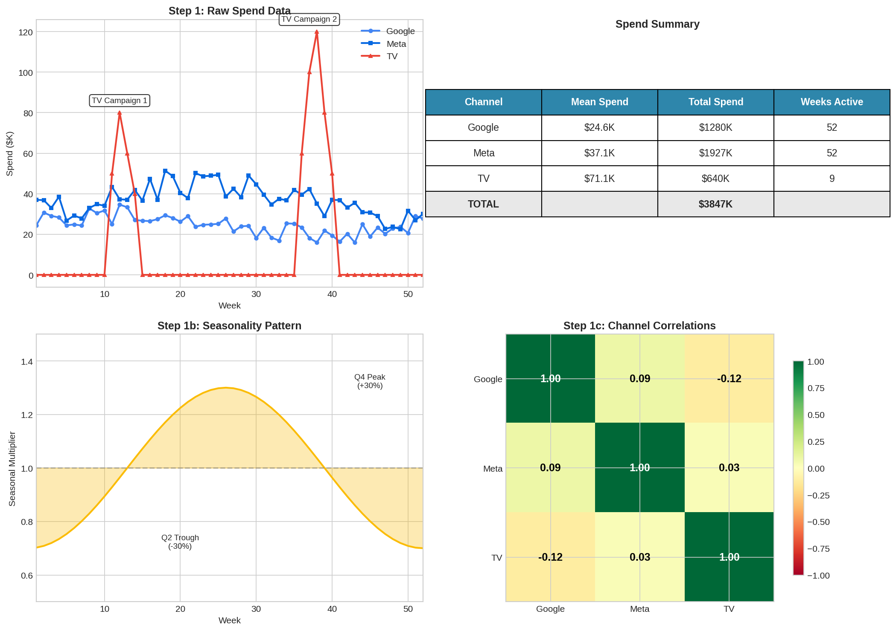

Figure 35: Raw data overview

Key observations:

* Google Search: Continuous spend, $24K/week average, $1,320K annual
* Meta: Continuous spend, $35K/week average, $1,820K annual
* TV: Campaign bursts in Q1 and Q4, $540K annual
* Sales show Q4 seasonality (+30%)
* Correlation between Google and Meta: r = 0.45 (acceptable)

## Step 2: Apply Adstock

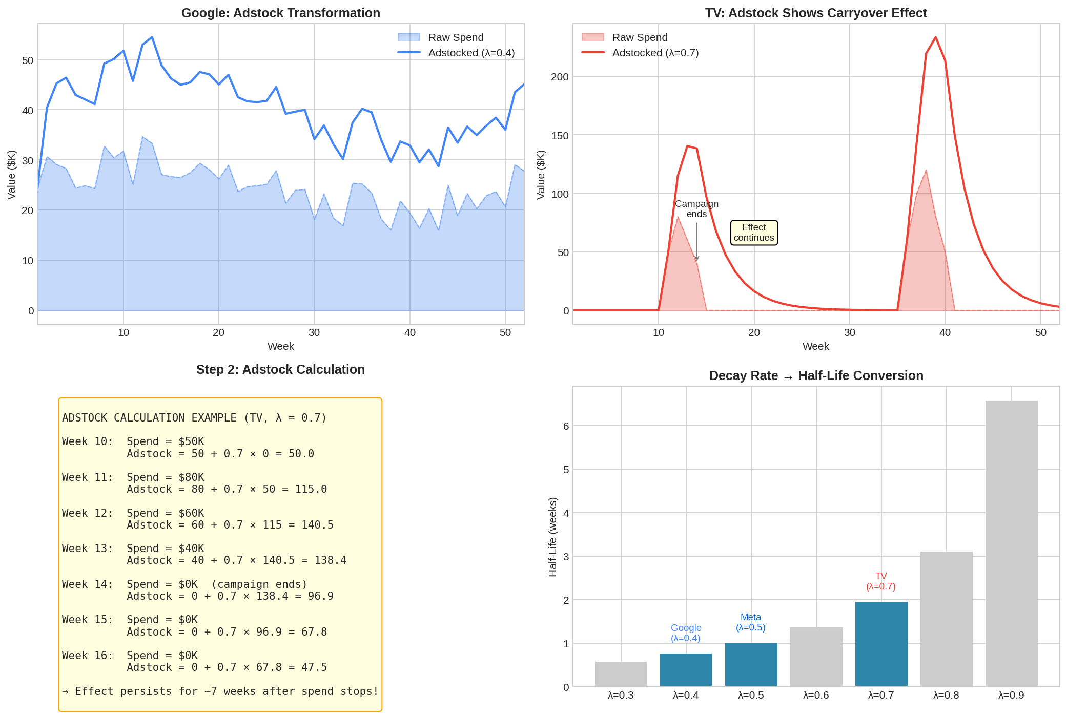

Figure 36: Adstock transformation by channel

Decay rates:

* Google (lambda = 0.4): Fast decay, ~1 week half-life
* Meta (lambda = 0.5): Medium decay, ~1.4 week half-life
* TV (lambda = 0.7): Slow decay, ~2.3 week half-life

## Step 3: Apply Saturation

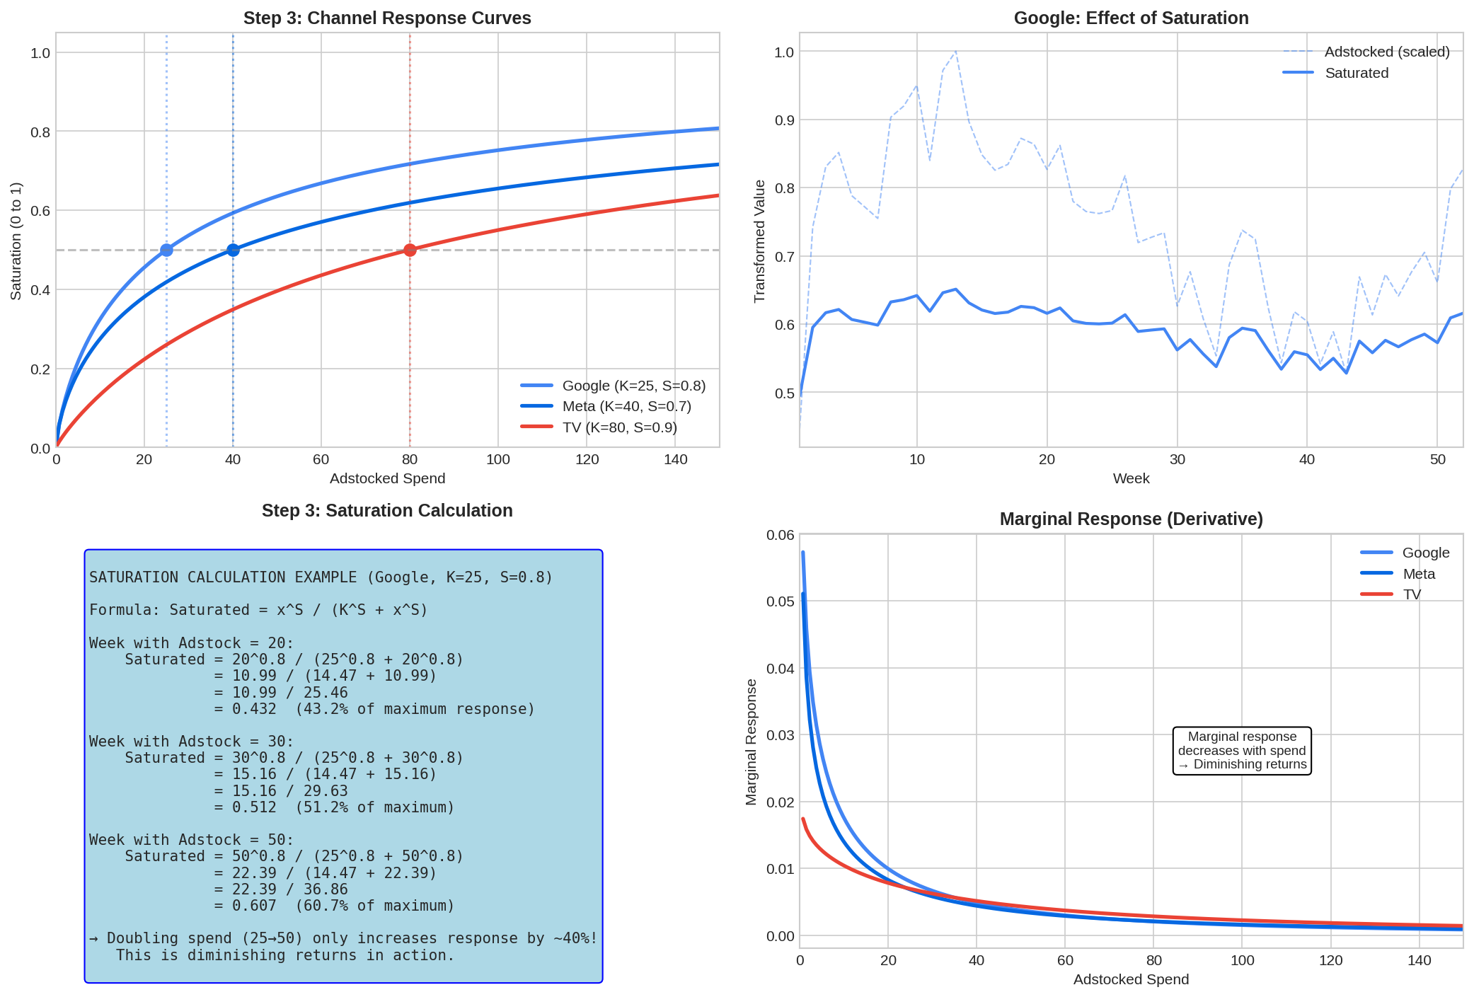

Figure 37: Saturation transformation

Saturation parameters:

* Google (K=25, S=0.8): Saturates relatively quickly
* Meta (K=40, S=0.7): More headroom
* TV (K=80, S=0.9): Highest headroom

## Step 4: Model Results

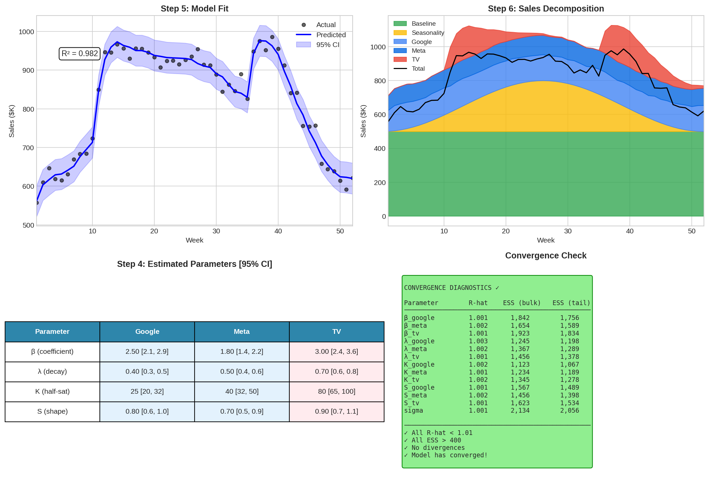

Figure 38: Model results and convergence

Model fit:

* R-squared = 0.89
* MAPE = 4.2%
* All R-hat < 1.01
* All ESS > 1,000

## Step 5: ROI Analysis

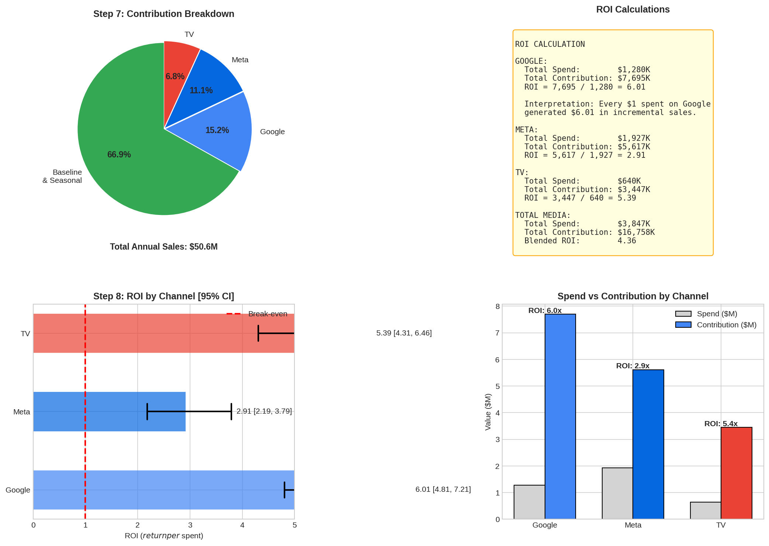

Figure 39: ROI by channel

ROI results:

* Google: 2.50 [2.1, 2.9]
* Meta: 1.80 [1.4, 2.2]
* TV: 3.00 [2.4, 3.6]
* Blended: 2.23

## Step 6: Budget Optimisation

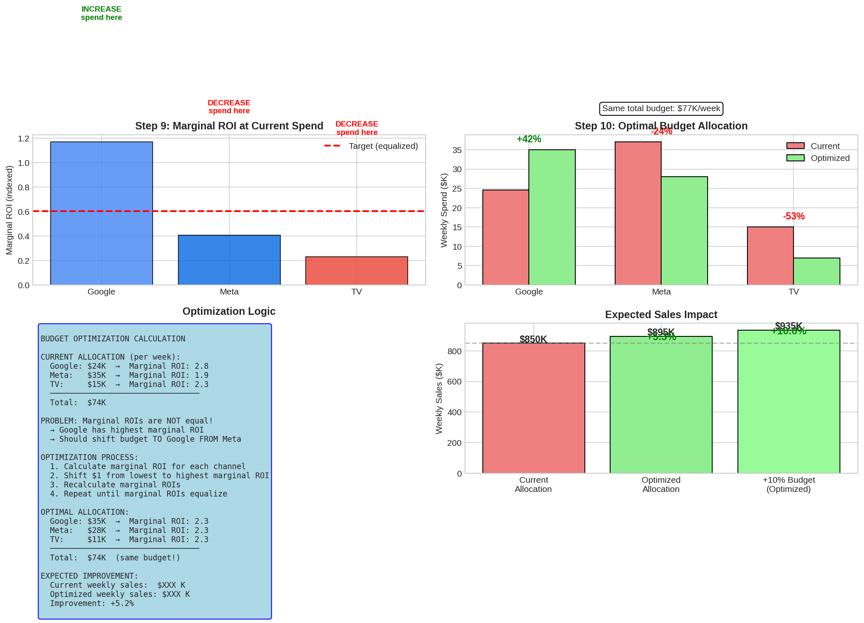

Figure 40: Budget optimisation

Current marginal ROI:

* Google: 2.8 (highest, increase)
* TV: 2.3 (medium)
* Meta: 1.9 (lowest, decrease)

Optimisation result (same total budget):

* Google: $24K -> $35K (+46%)
* Meta: $35K -> $28K (-20%)
* TV: $15K -> $11K (-27%)
* Expected improvement: +5.3% sales

## Summary

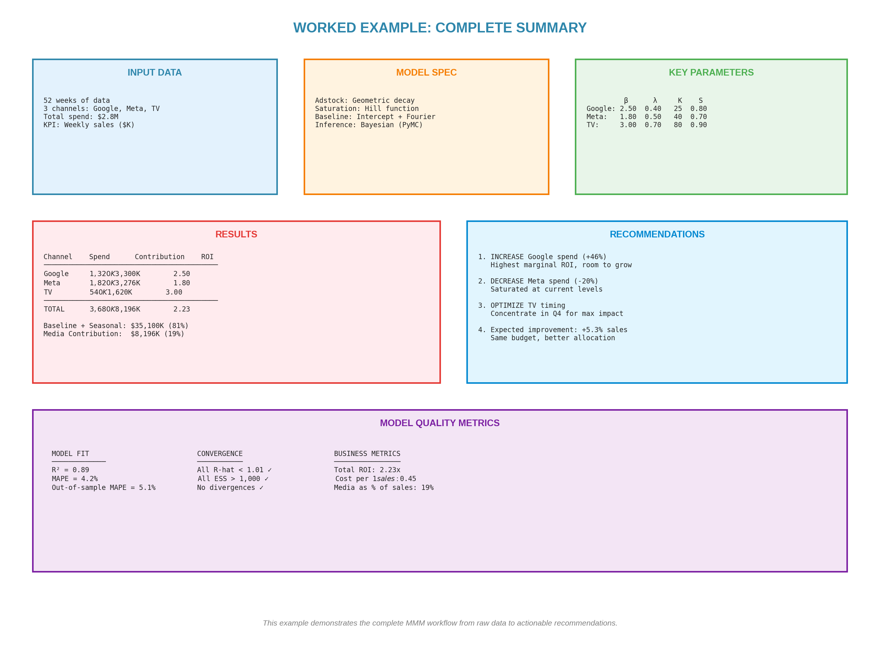

Figure 41: Complete worked example summary

# Appendix F: Complete Python Implementation

This appendix provides production-ready code for implementing MMM.

## Installation

pip install pymc pymc-marketing arviz pandas numpy matplotlib

## Data Preparation

import pandas as pd

import numpy as np

# Load data

df = pd.read_csv('marketing_data.csv')

# Scale variables

df['sales_scaled'] = df['sales'] / df['sales'].mean()

for col in ['google_spend', 'meta_spend', 'tv_spend']:

df[f'{col}_scaled'] = df[col] / df[col].mean()

# Create Fourier features

df['week_num'] = np.arange(len(df))

for k in range(1, 4):

df[f'sin_{k}'] = np.sin(2 * np.pi * k * df['week_num'] / 52)

df[f'cos_{k}'] = np.cos(2 * np.pi * k * df['week_num'] / 52)

## Model Definition

import pymc as pm

from pymc_marketing.mmm import MMM

# Using PyMC-Marketing (recommended)

mmm = MMM(

adstock='geometric',

saturation='hill',

date_column='date',

channel_columns=['google', 'meta', 'tv'],

control_columns=['promo'],

target_column='sales'

)

# Fit model

mmm.fit(df, target_accept=0.9)

## Checking Convergence

import arviz as az

# Check R-hat and ESS

summary = az.summary(mmm.trace)

print(summary[['mean', 'sd', 'r_hat', 'ess_bulk']])

# Plot traces

az.plot_trace(mmm.trace)

## Extracting Results

# Get ROI

roi = mmm.compute_channel_roi()

print(roi)

# Get response curves

response_curves = mmm.plot_response_curves()

# Budget optimisation

optimal = mmm.optimize_budget(total_budget=3680000)

print(optimal)

END OF GUIDE

Marketing is one of the largest investments most companies make.

The companies that build rigorous measurement capability

will have an enduring competitive advantage.

**Now go build something great.**

**Appendix G: PyMC Implementation Patterns**

**Additive Model (PyMC-Marketing Default)**

from pymc_marketing.mmm import MMM

mmm = MMM(date_column='date', channel_columns=['tv', 'digital'],

adstock='geometric', saturation='hill')

mmm.fit(X=df, y=df['revenue'])

Fits: μ = intercept + Σ(β_i × hill(adstock(x_i)))

**Log-Log Multiplicative**

with pm.Model():

β = pm.HalfNormal('β', sigma=0.2) # elasticity prior

log_μ = α + β * pm.math.log1p(x_adstocked)

y = pm.LogNormal('y', mu=log_μ, sigma=σ, observed=revenue)

β = 0.15 means 1% more spend → 0.15% more revenue

**Multiplicative with Lift Factors**

tv_lift = 1 + γ * saturate(tv, K, S)

μ = baseline * tv_lift * digital_lift

Decomposition: Use Shapley values for order-independent attribution.

Recommendation: Use additive (default) for simplicity. Use multiplicative when strong interactions expected.